Lower Woodard Creek Valley Bottom Reconnection Project
  - Basis of design report
Diane Hopster | U.S. Forest Service | Columbia River Gorge National Scenic Area

Paul Kolp | Lower Columbia Estuary Partnership

June 20, 2023

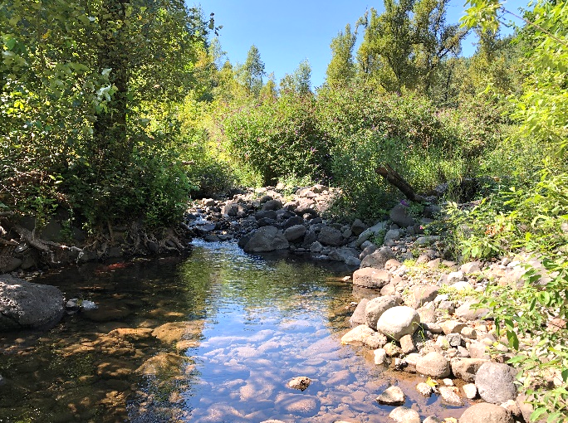

Table of Contents
Table of Contents 1
1. Project Summary 4
1.1 Project Location 4
1.2 Historical Conditions 8
1.2.1 Site Disturbances 8
1.3 Problem Statement 13
1.4 Limiting Factors 13
Habitat complexity 13
Substrate and sediment 13
Riparian Function 13
Floodplain Function 14
Water Quality – Temperature 14
1.5 Project Goals and Objectives 14
Goals 14
Objectives 14
2.0 Existing Conditions 15
2.1 Site Overview 15
2.1 Channel Migration Zone 17
2.2. Aquatics 18
2.3 Plant Communities 18
2.3 Site Surveys 19
2.4 Reach Description 20
2.4.1 Upper Reaches: RM 1.4- 2.1 20
2.4.2 Project Reach: RM 0.8- 1.4 22
2.4.3 Lower Reaches: RM 0.8- 0 23
3. Restoration Alternatives 25
3.1 Alternatives Evaluation 25
Tier 1 – Evaluation of Alternative Restoration Actions 25
Tier 2 – Selection of Structure Sizes and Large Wood Delivery Approaches 26
4. Geomorphic Model 28
4.1 Conceptual Framework 28
4.2 Relative Elevation Model 31
5.0 Hydrology & Hydraulics 35
5.1 Hydrology 35
5.2 Hydraulics 36
5.2.1 Hydraulic Modeling 36
6. Design 43
6.1 Design Recommendations 44
7.0 Opinion of Probable Construction Costs 49
8.0 Climate Change Resiliency Project Benefits 50
References 51
Appendix 1- Restoration Alternatives 52
Tier 1 – Evaluation of Alternative Restoration Actions 52
Tier 2 – Selection of Structure Sizes and Large Wood Delivery Approaches 53
Tier 3 – Selection of Structures Sites 54
Appendix 2- LiDAR vs. Ground Survey 55
Appendix 3– Field Notes 57

Table of Figures
Figure 1. Project Area location relative to the Subwatershed, Watershed and Subbasin boundaries 5
Figure 2. Map showing the Lower Woodard Creek Valley Bottom Reconnection Project site location. 6
Figure 3. Histroical aerial photo series from left to right shows the locations of the road. Photos are from 1948 (a), 1955 (b) 1967 (c) and 1973 (d). 9
Figure 4. Historic aerial photo (a) from 1948 shows a road through the valley bottom, and project reach, channelizing Woodard Creek to the east side of the valley. The photo also shows a large number of secondary roads in the project area, the presence of a mine and other large disturbance areas overlaid from the 1967 and 1973 images. The image on the right (b) shows the 2018 LiDAR basemap, the historic road, mines, disturbances, and locations of the stream channel over time. The stream has remained confined and channelized by the multitude of disturbances. 10
Figure 5. Channel cross sections using 2018 LiDAR and the digitized landscape disturbances from the aerial photos. 11
Figure 6. Woodard Creek Study Area. 15
Figure 7. Channel migration zone measured from valley wall to valley wall. The 2018 LiDAR is utilized as the base map. Channel migration zone varies from 300-600 ft. but has been artificially constrained due to anthropogenic disturbances. The location of the stream channel from 1948, 1973 and 2023 is shown. 16
Figure 8. Map and photos of the project site showing some of the existing impairments. 18
Figure 9. Woodard Creek Longitudinal Profile. This project is in Reach 3 and 4. 19
Figure 10. Plane-bed segment. 20
Figure 11. Cascade bed segment. 20
Figure 12. Split flow around mid-channel bar. 20
Figure 13. Active hillslope failure in background. 20
Figure 14. Flow split at mid-channel bar. 21
Figure 15. Dry channel due to subsurface flow. 21
Figure 16. Pool tailout below one of the few riffles. 22
Figure 17. Constructed log grade control 22
Figure 18. Confluence with the Columbia River (Tetra Tech). 23
Figure 19. Woodard Creek below Hwy 14 (Tetra Tech). 23
Figure 20. Process Domains and sediment zones in a watershed (Cluer & Thorne, 2018) 28
Figure 21. Stream Evolution Model (SEM) developed by Cluer and Thorne (2013). 29
Figure 22. Hydrogeomorphic and habitat benefits provided at each stage of the Stream Evolution Model (Cluer and Thorne 2013). 29
Figure 23. Cluer and Thorne stream evolution timescale (Modified from Pollock et al. 2014). 30
Figure 24. Map of the Relative Elevation Model (REM) for Lower Woodard Creek 32
Figure 25. Valley Cross-Section from A to A' including the REM color bands and the cross-section location. 33
Figure 26. Valley Cross-Section from B to B' including the REM color bands and the cross-section location. 33
Figure 27. Valley Cross-Section from C to C' including the REM color bands and the cross-section location. 34
Figure 28. Modeled low velocity < 1 fps (a) and inundation area (b) for pre- and post- restoration at varying discharges. 36
Figure 29. HEC-RAS 2D modeling results showing pre- and post-restoration inundation areas for 100 cfs streamflow. 37
Figure 30. HEC-RAS 2D modeling results showing pre- and post-restoration velocities in feet per second for bankfull flow of 100 cfs. 38
Figure 31. HEC-RAS 2D modeling results showing pre- and post-restoration velocities in feet per second for 100-year flow of 920 cfs. 39
Figure 32. Cross-Section A, pre and post velocities. 40
Figure 33. Cross-Section B, pre and post velocities. 41
Figure 34. Cross-Section C, pre and post velocities. 41
Figure 35. Final Design Overview map of Lower Woodard Creek Valley Bottom Reconnection Project. 45
Figure 36. Valley Cross-Section from A to A' showing design cut and fill polygons, including the REM color bands and the cross-section location. 46
Figure 37. Valley Cross-Section from B to B' showing the design cut and fill polygons, and the cross-section location. 46
Figure 38. Valley Cross-Section from C to C' showing design cut and fill polygons including the REM color bands and the cross-section location. 47

Table of Tables
Table 1. Restoration Alternatives- showing reach potential, habit lift, relation to goals and objectives, intrinsic use by salominds, benefits to non-target species, benefiot score, considerations and total score. The valley-bottom reconnection approach was selected for the project reach. 26
Table 2. Estimated stream discharge by flood recurrence interval 35
Table 3. HEC-RAS Hydraulic model inputs. 35
Table 4. Landcover and Manning’s N values (based on NLCD Spatial Layer 2011). 36

Project Summary
The US Forest Service (USFS) is partnering with Lower Columbia Estuary Partnership (LCEP) on USFS land approximately 1/4 mile upstream of the SR- 14 bridge near Beacon Rock State Park to develop the Lower Woodard Valley Bottom Reconnection Project. The overall goal of the project is to reconnect more than 1/2 mile of the historic floodplain and remove legacy berms and roads, which have substantially altered physical and biological conditions. The project will focus on restoring a 1/2-mile section of Woodard Creek that is disconnected from the floodplain using a valley bottom reconnection approach (i.e., restoration to Stage 0). The restoration project will recreate important spawning and rearing habitat for fall Chinook, coho, steelhead and lamprey. The project will build on existing design efforts and the recently completed Upper Woodard Creek restoration project (Phase I). The proposed project is the final essential project identified within the Watershed Condition Framework for the Woodard Creek-Columbia River Priority Watershed in the Columbia River Gorge National Scenic Area’s (CRGNSA) Tanner Creek/Woodard Creek Watershed Restoration Action Plan (USFS 2021).

1.1 Project Location
Two states, Washington and Oregon, divide the Woodard Creek-Columbia River subwatershed. The subwatershed is nested within the City of Washougal-Columbia River Watershed that includes many tributaries to the Columbia River located immediately downstream of the Bonneville Dam, the downstream-most dam on the Columbia River, and the Lower Columbia -Sandy Subbasin (Figure 1).
The drainage area for Woodard Creek in Washington State in the Columbia River Gorge is approximately 7.8 square miles. The creek, part of the Lower Gorge Tributaries, flows approximately 5.5 miles to its confluence with the Columbia River, about 4 miles downstream of Bonneville Dam. The USFS and Washington State Parks (WA Parks, Beacon Rock State Park unit) own nearly the entire watershed. The Woodard Creek Habitat Restoration Project Siting and Design Project Report identified Wood Creek as a high priority for restoration (Tetra Tech 2007). The 0.6-mile project site (from RM 0.8-1.4) includes approximately 21 acres of potential aquatic and riparian habitat located entirely on USFS property, beginning 900 feet (ft) upstream of SR-14 and extending upstream to where the Upper Woodard Creek Restoration Project implemented in 2021 is located (Figure 2). The project area is located within a Tier 1 reach.

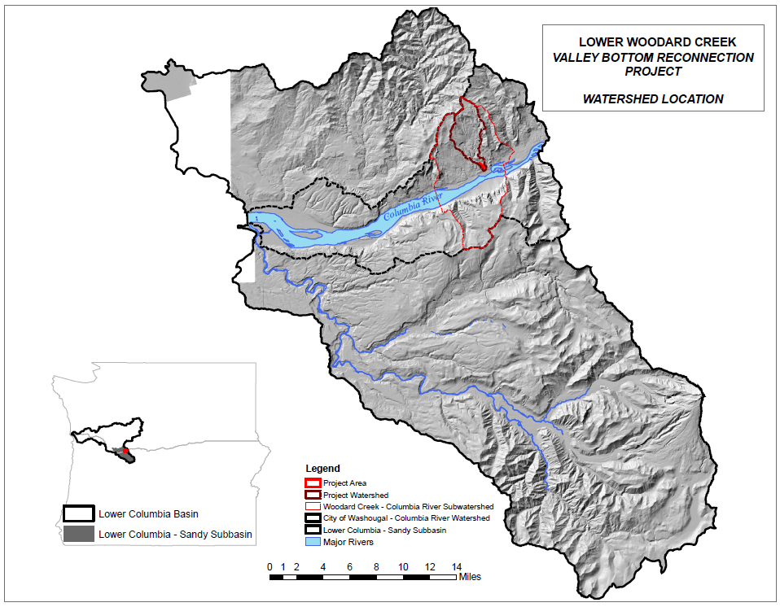
Figure 1. Project Area location relative to the Subwatershed, Watershed and Subbasin boundaries
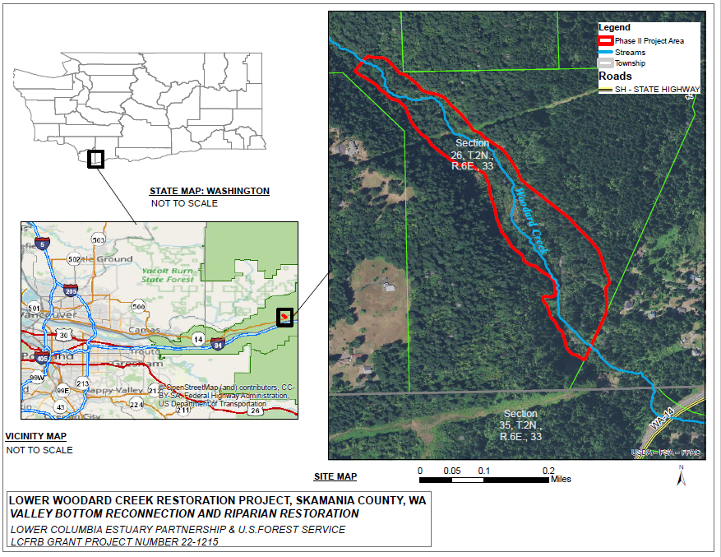

Figure 2. Map showing the Lower Woodard Creek Valley Bottom Reconnection Project site location.

Historical Conditions
Historically, Woodard Creek included a wide range of intact habitat types that allowed salmonids to express a diversity of life history strategies as they adapted to changing environmental conditions. Specific habitat features that likely occurred in the project area included a connected wetland valley bottom with multi-threaded complex habitat from valley wall to valley wall.
Mature conifers including large western cedars, would have been present within the riparian zone. Evidence from historical records and from explorations in adjacent basins by the project team suggest that cedars were present (provide photo). These trees would have exerted a dominant effect on the physical and biological site conditions. Downed large wood reduced flow energy, increased the wetted width, provided channel complexity, trapped beneficial sediments, and promoted floodplain connectivity. Wood of this size would have also provided channel grade control and helped to resist changes in the channel from perturbations.
Downed wood would have likely occurred in large amounts throughout the project reach. The estimated amount of wood for Pacific Northwest rivers in this region is expected to be approximately 55 pieces for every 300 ft. (Fox and Bolton 2007). Many of the creeks and rivers in the regions, including Woodard Creek would likely have had substantial wood within the creek, including large jams; overall it would have looked very different then today.
Based on the diverse physical characteristics throughout the watershed, there would likely have been a rich, and diverse, community of native aquatic and terrestrial species present. At the confluence of the Columbia River, and in the lower reaches, alluvial fans and the depositional environment would favor chum, Chinook and other native aquatic and terrestrial species. In the project area, with the wide valley width the site likely contained coho, Chinook, steelhead, chum, lamprey, and other native species. As the gradient increased upstream of the project area, steelhead and coho would likely be found.

1.2.1 Site Disturbances
Beginning in the late 1800’s timber harvest in the Pacific Northwest became a driving economic force for the local economy. Timber companies, including the Hudson Bay Company and Weyerhaeuser, set up operations along the Columbia River and tributaries. Clear cutting became a standard practice of harvesting timber on the steep slopes, using cables and yarding techniques. Flumes were used to transport logs down tributaries to the Columbia River, where they were then floated downstream. The Broughton Flume was used to transport logs from the Little Salmon River, approximately 30 miles upstream. It is unknown how logs might have been transported down Woodard Creek but undoubtedly the basin was clear cut for wood. Transportation corridors were established in 1926. SR-14 and BNSF railroad both have corridors that cross Woodard creek immediately downstream of the project boundary.
Historical aerial photos were utilized to gain a greater understanding of site disturbances and how the site was impacted. Using ArcGIS Pro v. 3.1, a series of aerial photos from 1948, 1955, 1967 and 1973 (Figure 3) were georeferenced against the 2018 LiDAR (WA Department of Natural Resources). Georeferencing was accomplished by selection common control points, including railways, roads, and other infrastructure in the aerial photos. Georeferencing does not produce a 1:1 agreement amongst all images spatial across the site. The 1948 and 1973 images align very closely with 2018 LiDAR and the 1955 and 1967 show a slight shift. After georeferencing, features of interest, including roads, disturbances, and Woodard Creek were digitized (using the aerial photos) to develop a lineage of the features and to evaluate them over time.
The 1948 aerial photo shows a road which begins at Hwy. 14 and travels upstream along the western valley wall and adjacent to Woodard Creek. The road was used to access a series of hillslope mines, presumably used for aggregate supply (Figure 3a and Figure 4a). There is evidence of potential instream gravel mining with exposed bare areas, and there is a vast series of connecting (secondary) roads, that travel into and adjacent to Woodard Creek (Figure 4a). The 1950s photo (Figure 4b) shows that road building continued upstream past the project area and to another potential hillslope mine that can be seen in the top right corner of the 1955 photo. The 1967 and 1973 aerial show additional road building and disturbances in the project area with additional potential instream gravel mining occurring (Figure 3c, 3d and 4a). Figure 4a shows the additional disturbances from 1967 and 1973, which are overlaid onto the 1948 aerial photo. The historical aerial photos show that the main road, and the vast array of secondary roads have channelized Woodard Creek, confined the channel, constrained the channel migration zone, and impacted overall physical conditions. Woodard Creek remained confined for many decades (Figure 4b).
Using the digitized site disturbances from the aerial photos, and the LiDAR from 2019, a series of cross sections were produced using the elevation tool in ArcGIS Pro (Figure 5). The cross sections begin (Fig. 5a) at the upstream terminus of the historic road shown in Figure 4a, which is the upstream project boundary. The cross sections continue downstream and correspond to the locations of the CMZ site shown in Figure 7. The cross sections clearly illustrate that the road and disturbances have confined the channel and these artificial surfaces are elevated 5-10 feet above the channel.
Hillslope mining and potential instream gravel mining have likely affected the project area by depriving the creek of valuable sediments. Historic clear cutting has also likely increased peak flows and stream power leading to additional mobilization of gravels. Over the last several decades the watershed appears to have partially returned to a normal hydrologic condition with the regrowth of the watershed to a mixed deciduous/coniferous mid-seral forest.

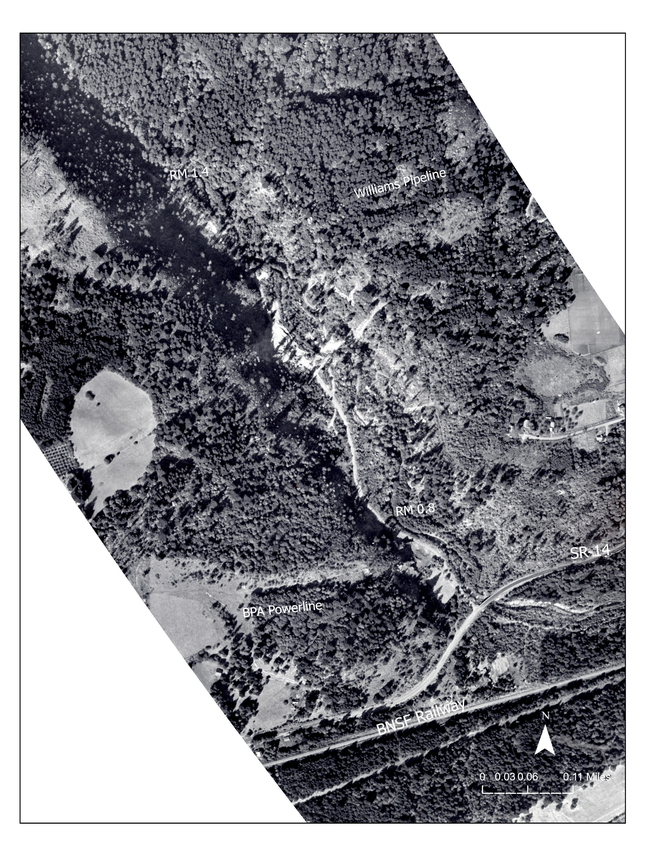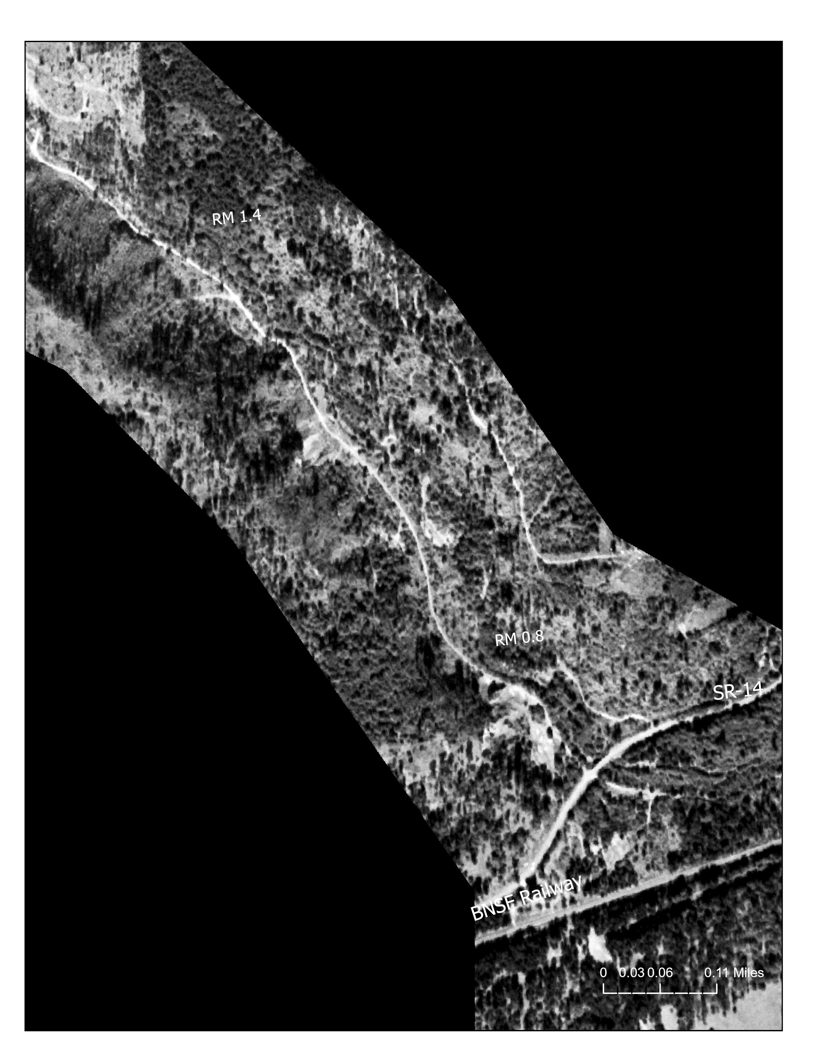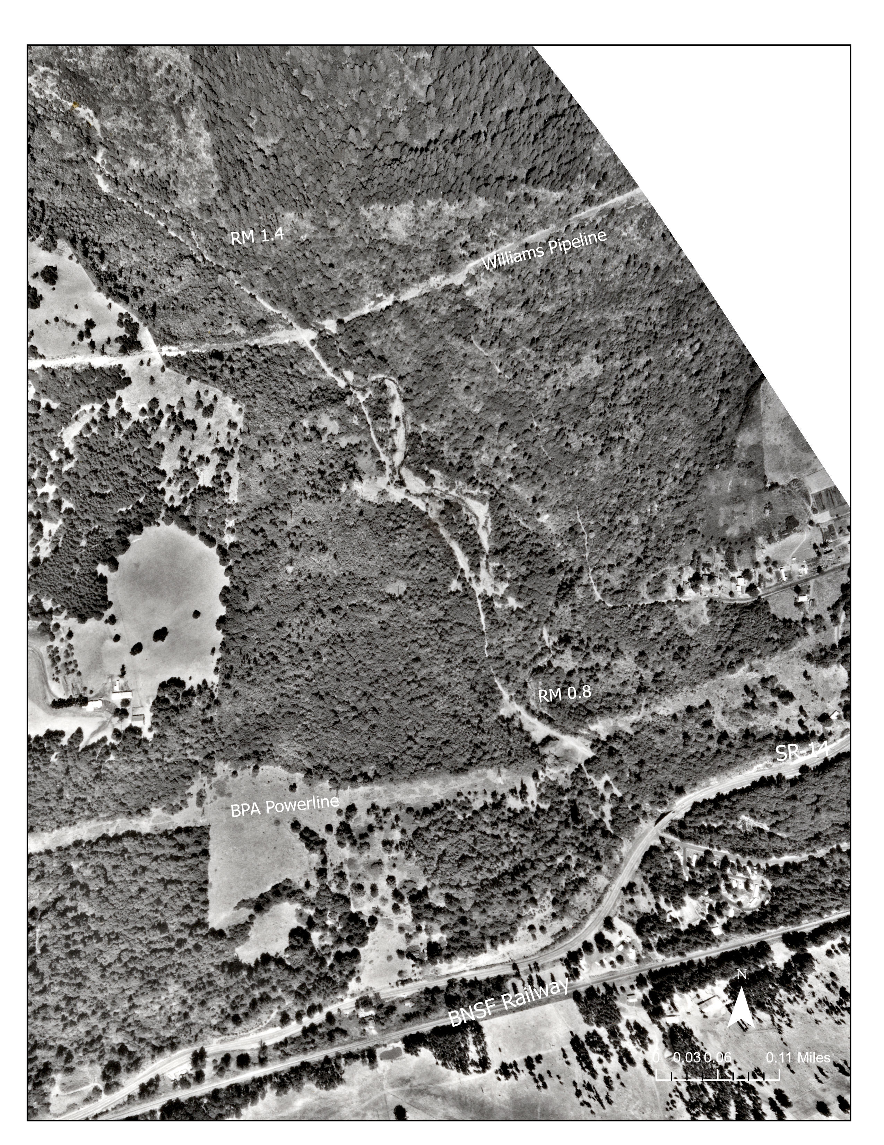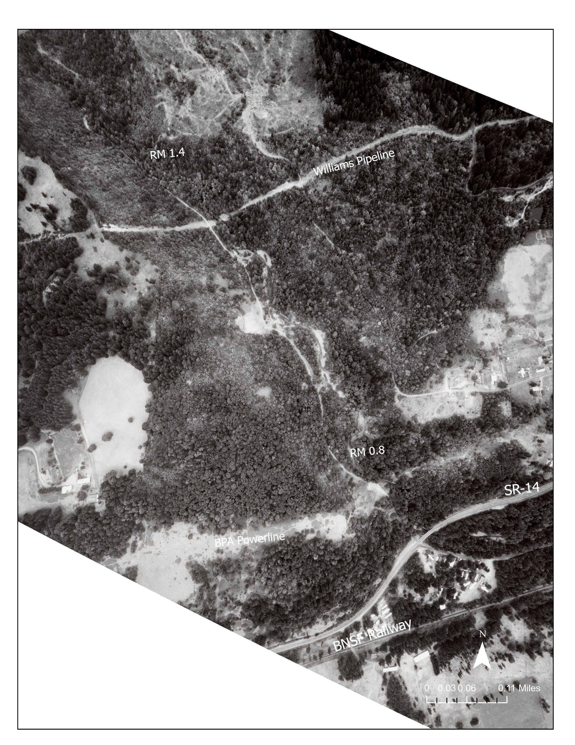
d
c
b
a
Figure 3. Histroical aerial photo series from left to right shows the locations of the road. Photos are from 1948 (a), 1955 (b) 1967 (c) and 1973 (d).

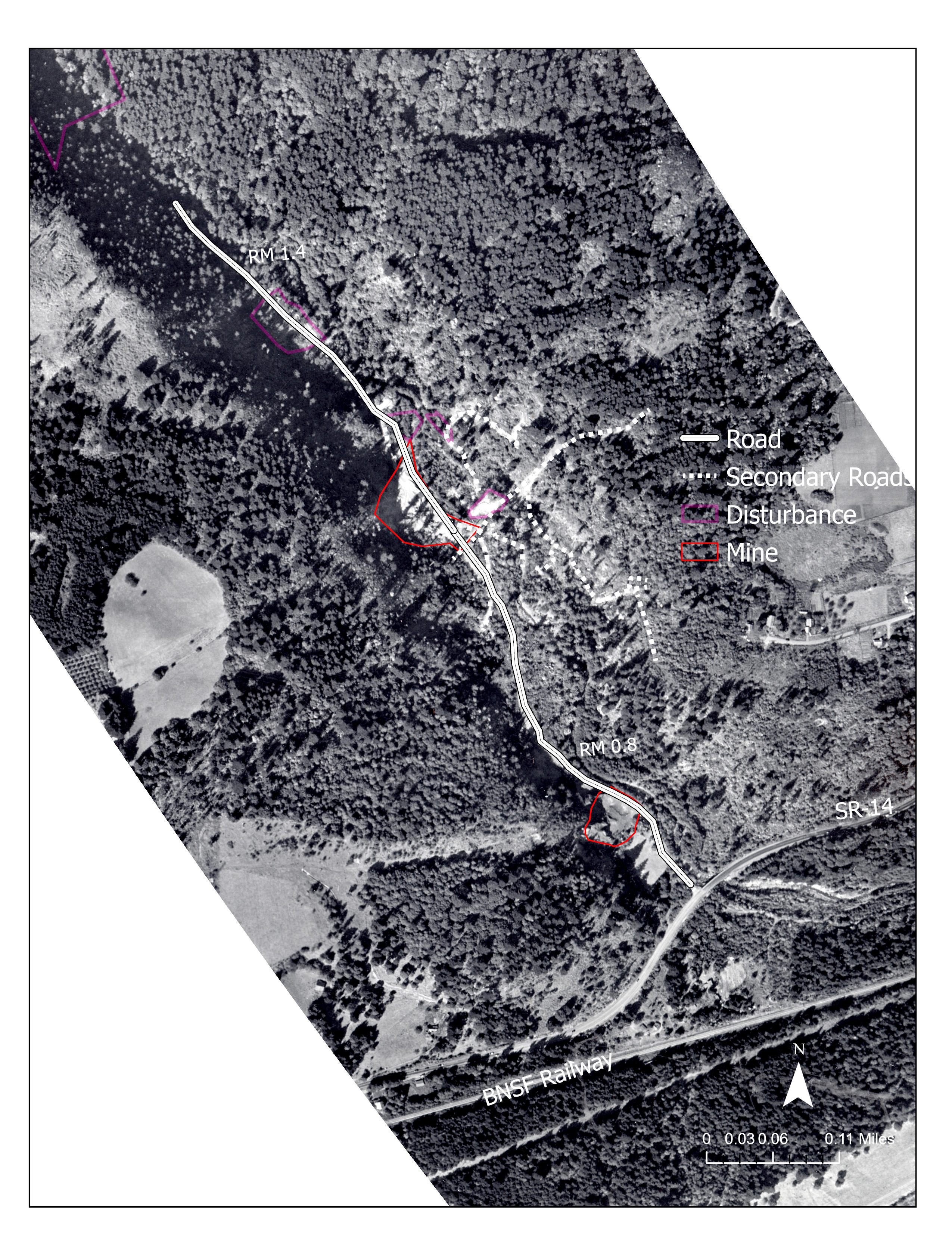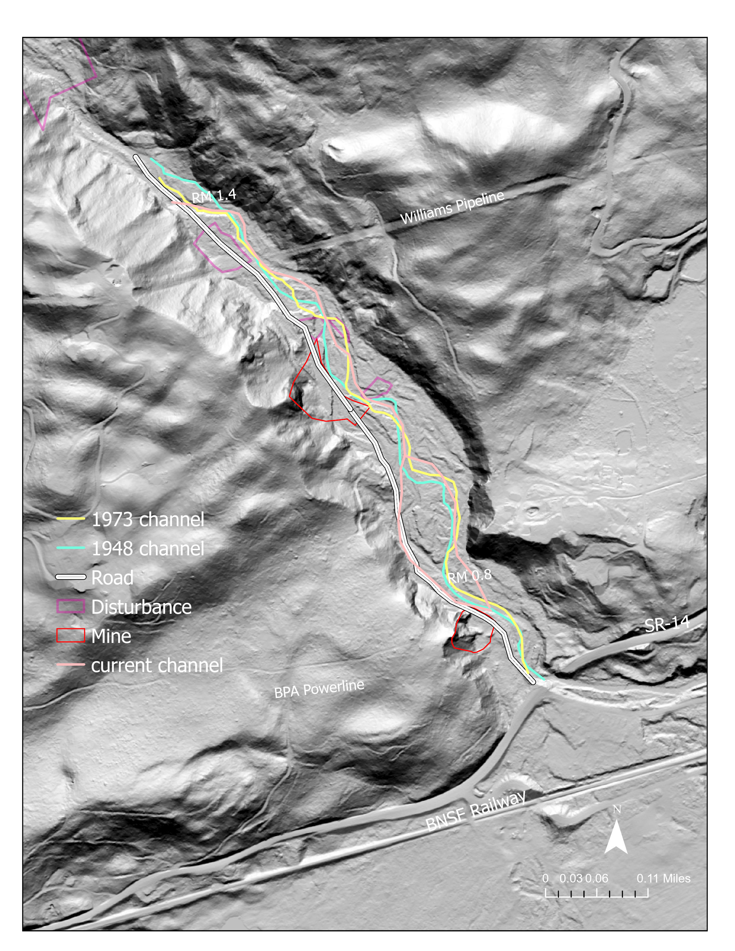
a
b
Figure 4. Historic aerial photo (a) from 1948 shows a road through the valley bottom, and project reach, channelizing Woodard Creek to the east side of the valley. The photo also shows a large number of secondary roads in the project area, the presence of a mine and other large disturbance areas overlaid from the 1967 and 1973 images. The image on the right (b) shows the 2018 LiDAR basemap, the historic road, mines, disturbances, and locations of the stream channel over time. The stream has remained confined and channelized by the multitude of disturbances.

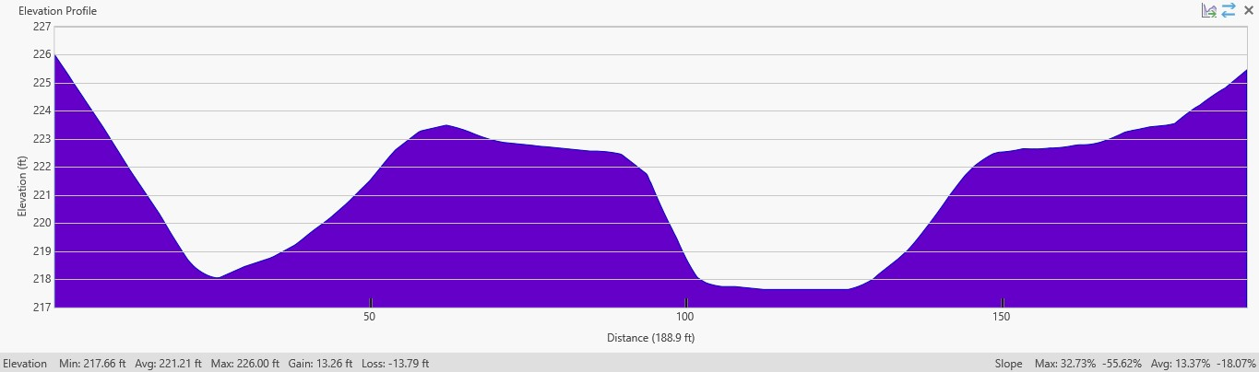
a
Road
Channel
High flow
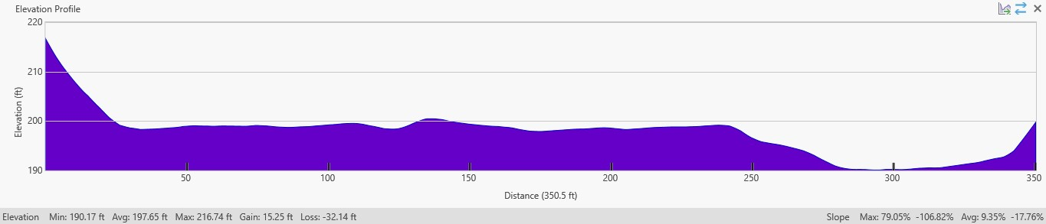
b
Road, Mine, Disturbance
Channel
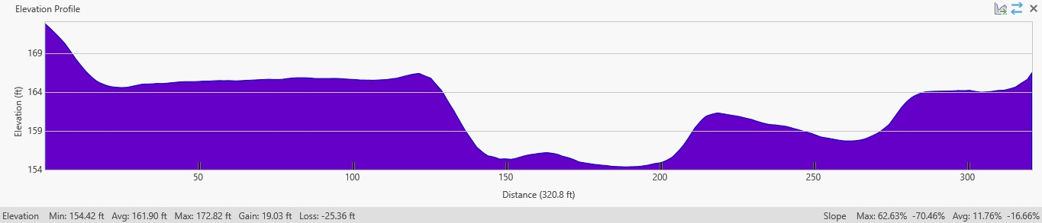
d
c
Channel
Road, Mine, Disturbance
High flow
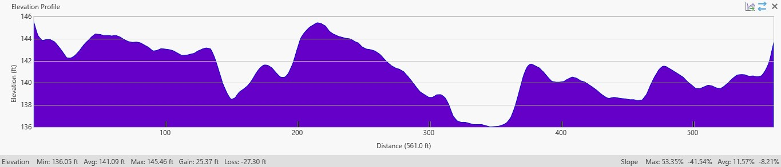
Channel
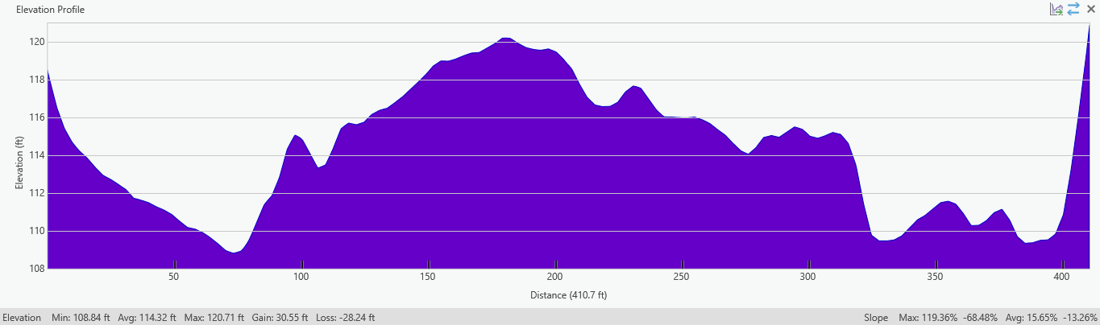
e
Channel
Channel
Figure 5. Channel cross sections using 2018 LiDAR and the digitized landscape disturbances from the aerial photos.

1.3 Problem Statement
The geomorphic and habitat characteristics of Woodard Creek have changed significantly since European settlement and the late 1800’s. Overall, aquatic habitat has been greatly simplified and significantly reduced. Anthropogenic impacts including road building, aggregate mining, clear cutting, and timber harvest have channelized the creek, reduced floodplain connectivity, and increased energy for transporting beneficial sediments out of the area as fast as they are supplied. The creek is dominated by coarse sediment load, including cobbles and boulders. Stable gravel beds for egg incubation and spawning are limited throughout the creek, significantly limiting winter steelhead, coho and Chinook salmon from expressing the full range of life history stages.

1.4 Limiting Factors
Limiting factors were initially identified by the Lower Columbia Fish Recovery Board (2010) and refined during site investigations as part of the Upper Woodard Creek project (LCFRB 2020) and this project. The project will focus on enhancing the stream reaches utilized by coho, winter steelhead, and fall Chinook. Other aquatic species the project will address are cutthroat trout and lamprey. This project will address the following limiting factors:

Habitat complexity
In the 1940-50s, a road was built up the center of the valley. Lower Woodard Creek was straightened and channelized to the east side of the valley bottom in addition to clearing valley bottom trees, simplifying the channel, and associated aquatic habitats. Channelization of Woodard Creek resulted in increased stream power and incision, further simplifying the habitat into a predominately single thread channel with limited side channel and backwater habitat (affects all species/life stages).

Substrate and sediment
As a result of the channelization of the stream channel and the extremely high stream power, the project reach was converted from a depositional reach to a transport reach. Due to the road fill berms and channel incision, floodplain disconnection in this reach also prevents fine-grained sediments from being deposited on the floodplain and are instead transported downstream to the Columbia River confluence. Smaller substrates, including spawning gravels, are limited in Lower Woodard Creek with substrates dominated by boulders and cobbles (affects all species/life stages).

Riparian Function
Disturbance and lowered water tables from road building and valley bottom clearing have resulted in substantially reduced riparian areas within the valley bottom, as well as infestations of invasive plant species, and riparian plant communities along the stream channel dominated by shrubs and deciduous trees further limiting the large woody debris recruitment potential. Food web production and cycling are impaired by poor riparian conditions and a lack of in-stream habitat structure necessary to retain organic inputs within the stream (affects all species/life stages).

Floodplain Function
Road fill berm material, channelization and subsequent incision, and the resultant lowered water table have resulted in severely reduced floodplain function in Lower Woodard Creek valley bottom. Since the 1940-50s when the road was built, two side channels of Woodard Creek have cut through sections of the road fill berm. However, both side channels and Woodard Creek remain disconnected from the floodplain. Low energy environments and off-channel habitats are limited at all flows (affects all species' juvenile life stage).

Water Quality – Temperature
Although stream temperatures are not currently impaired by inadequate riparian stream shade throughout the project site, future impacts from increasing air and stream temperatures due to climate change are expected to exacerbate this issue (affects all species/life stages).

1.5 Project Goals and Objectives
The Lower Woodard Creek Restoration Project will restore complex habitats for winter steelhead, Coho and Fall Chinook rearing and spawning by restoring the valley bottom connection, which is currently absent in the Woodard Creek drainage. More specifically, the objective is to reconnect approximately 20 acres of lower Woodard Creek, from 0.2 miles to 0.8 miles upstream of Highway 14, to its valley bottom (i.e., floodplain) by restoring the valley through aggrading the existing incised channel and removing berms and old roadbed that are channelizing Woodard Creek.

Goals
The project's overarching goal is to restore Lower Woodard Creek valley bottom processes and functions in the project reach valley bottom.
Goal 1: Restore geomorphic, chemical, and biological processes that maintain a healthy, complex, and resilient floodplain ecosystem. Increased geomorphic complexity will result in heterogeneous sediment deposition patches and a depositional environment.
Goal 2: Restore a hydrologically connected, well-functioning, complex channel network and floodplain with increased hyporheic exchange with the floodplain water table.
Goal 3: Increase habitat availability, diversity, and quality for ESA-Threatened Winter Steelhead, Coho salmon and Fall Chinook and other native aquatic and riparian species (e.g., Pacific Lamprey and American beaver).
Goal 4: Restore native plant communities and riparian function across the floodplain valley bottom.

Objectives
Objective 1: Increase sediment storage, geomorphic complexity, and dynamism by 25% within five years of project completion.
Objective 2: Increase wood abundance by at least 200% and retain at least 90% of project wood within project reach within five years of project completion.
Objective 3: Increase wetted area during annual peak flow and base flow by at least 100% within two years of project completion.
Objective 4: Increase substrate size class diversity in wetted channels at base flow by 25% within two years of project completion.
Objective 5: Increase diversity of water velocities and reduction of average water velocities by 25% within two years of project completion.
Objective 6: Increase fall Chinook salmon, coho and winter steelhead redd abundance within the project area by 25% within five years of project completion.
Objective 7: Increase macroinvertebrate taxa richness (i.e., diversity) by 10% within three years of project completion.
Objective 8: Improve riparian function by treating invasive plants and revegetating at least 10 acres of riparian area to establish a dense, self-sustaining riparian zone. Create a mature, native riparian zone across the valley bottom.

2.0 Existing Conditions

2.1 Site Overview
Woodard Creek is a tributary to the Columbia River in the Columbia River Gorge. The study reach was bounded by the downstream extents of USFS property at river mile (RM) 0.8 and the confluence with East Fork Woodard Creek at RM 2.1 (Figure 6). Woodard Creek has a watershed area of 7.7 square miles and generally flows from the northwest to southeast through the project reach. The Woodard Creek watershed extends from an elevation of approximately 3,380 feet above sea level at its headwaters to 20 feet at the confluence with the Columbia River. The project area ranges from approximately 100 to 400 feet in elevation.
Woodward Creek arises from high basalt outcrops in the Columbia River Gorge. Weathered volcanic flows are the dominant features with both colluvial and alluvial deposits. The Missoula floods from the most recent continental glaciation (approximately 10,000 years BP) extensively scoured the Columbia Gorge and left basalt outcrops exposed. Periodic landslides deposit large quantities of boulders, cobbles, and finer sediments down the slopes of the gorge. Alluvial deposition has occurred along the lower reaches of Woodward Creek. These deposits are primarily cobbles and large gravels, which do not appear to be readily transported by the Columbia River and are thus continuing to build an alluvial fan with a gradient which extends several miles up the stream.
The stream passes through moderately steep, forested terrain. Most of the reach can be characterized as an incised, single-thread channel, although the lower end of the project has more planform variation. Stream banks are often steepened with evidence of recent failures. Bed morphology is a mix of pool-riffle and small cascades. Upstream of RM 1.1, the valley walls are steep and would likely be inaccessible by heavy machinery. The streambed material gradation typically consists of gravels, cobbles, and boulders, with few finer substrates. The substrate becomes noticeably coarser above RM 1.3, and bedrock outcroppings were observed in several locations. Very few pieces of large wood were observed in the reach, but a couple constructed wood jams were observed below RM 1.25.
Much of the watershed is U.S. Forest Service timberlands or within Beacon Rock State Park; only a small portion of the watershed is privately owned residential. Existing infrastructure within the study-reach is limited to the Williams Pipeline corridor near RM 1.25. Further downstream, there are two transportation crossings. The channel first reaches the SR-14 bridge, which appears to be tall enough to avoid collecting debris on the bridge deck, although larger trees may not be able to get caught up on its somewhat narrow width. The Moorage Road crossing has minimal clearance, and the railroad also crosses at the same location.
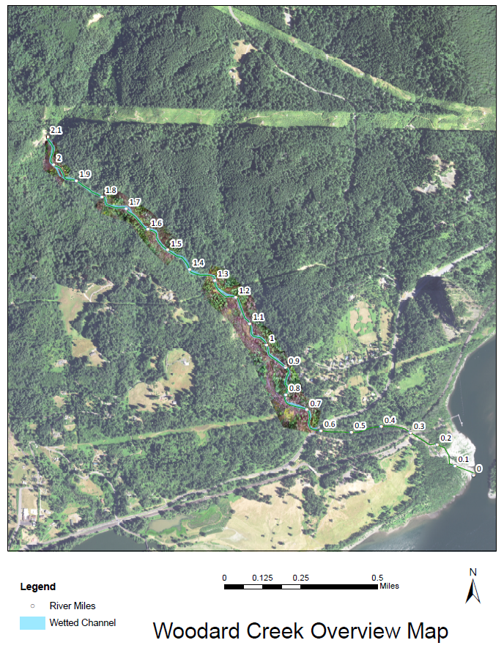
Figure 6. Woodard Creek Study Area.

2.1 Channel Migration Zone
The channel migration zone (CMZ) is the area that allows for geomorphic processes of erosion, deposition, channel migration and flooding to occur (Kondolf, M.). For the purposes of this project, and for the GIS analysis, the CMZ was defined as the unconfined space from valley-wall to valley-wall in the project area. The channel migration zone varies considerably throughout the project area from 70 ft. immediately upstream of RM 1.4 (CMZ-1 in Figure 7), 300 ft. above Williams Pipeline (CMZ-2), 320 ft. below Williams Pipeline (CMZ-3), 600 ft. in the widest portion of the valley above the mid-channel island (CMZ-4) and 325 ft. around the mid-channel island.
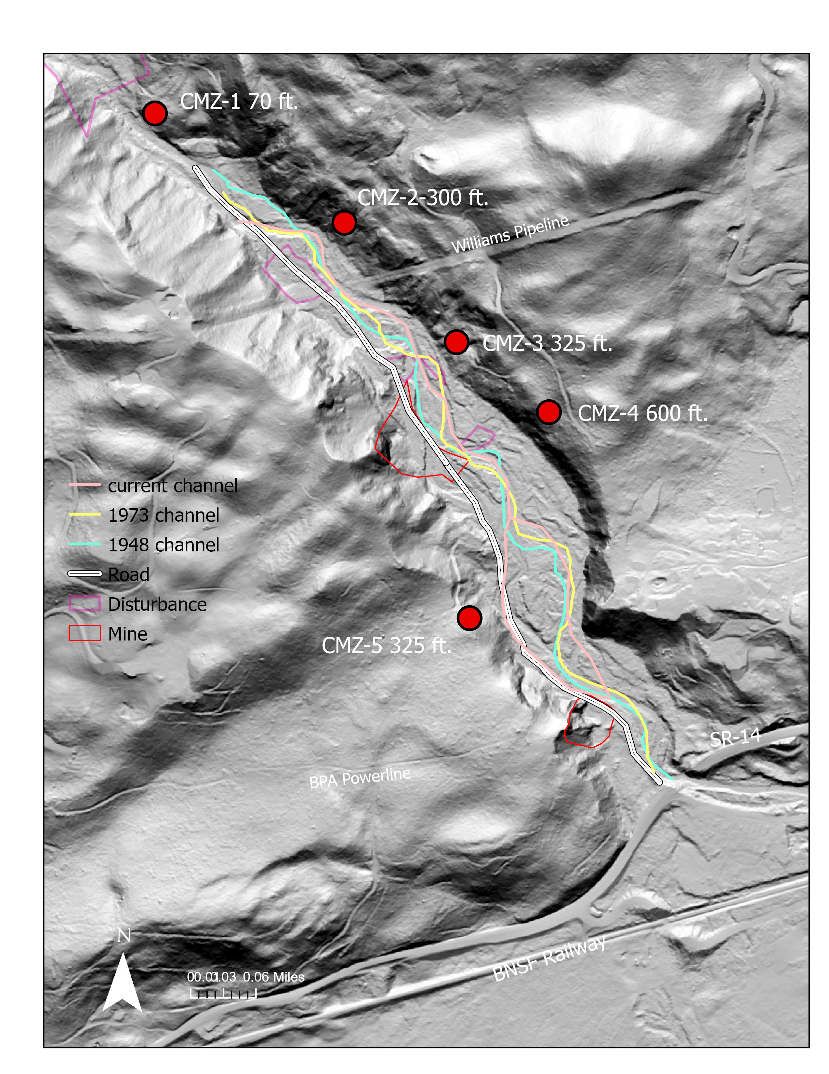
Figure 7. Channel migration zone measured from valley wall to valley wall. The 2018 LiDAR is utilized as the base map. Channel migration zone varies from 300-600 ft. but has been artificially constrained due to anthropogenic disturbances. The location of the stream channel from 1948, 1973 and 2023 is shown.

2.2. Aquatics
In Woodward Creek, the fish species that have been observed utilizing the system are fall
Chinook, coho, and winter steelhead2. Chum may occasionally be present. The following
paragraphs summarize the critical life stages and require habitats from the Recovery Plan
(LCFRB 2004) and Habitat Work Schedule (LCFRB 2007) that would be most beneficial to
restore in the Woodward Creek watershed.

The most critical life history stage for fall Chinook in the Bonneville Tributaries subbasin is spawning adults and the greatest limiting factors are high temperatures and lack of key habitat. Woodard Creek does not have high water temperatures but lacks stable spawning habitat for Chinook in the lower two reaches. Spawning habitat will be the most important habitat type to restore for Chinook salmon. The most critical life history stage for coho is 0-age summer rearing and the greatest limiting factors are high temperatures, hatchery competition, flows, food, and habitat diversity.

Woodard Creek does not have high water temperatures or competition from hatchery stocks in the juvenile rearing stage. Instream flows, primarily subsurface flows, are a problem in Woodward Creek during the summer. It is unclear whether prey resources are a limiting factor in Woodward Creek. Habitat diversity, particularly the lack of pools and cover, are limiting factors for coho rearing. A complete lack of ponded or slow moving, off-channel rearing habitat is a major limiting factor. Instream flows, off-channel rearing and in-stream habitat diversity will be the most important habitat elements to restore for coho salmon. (Tetra Tech 2007).

2.3 Plant Communities
The riparian overstory is dominated by Douglas fir and alder with a few Western red cedars. Most of the conifers have a diameter at breast height of less than 36 inches. Non-native species such as Himalayan blackberry and butterfly bush are also present. The channel is well shaded through most of the study reach. Large scale disturbances from road building and legacy timber harvest in the project area have resulted in artificially high surfaces disconnected from the floodplain water table. The result is highly altered plant communities and susceptibility to invasive plant infestation (Figure 8). Early succession deciduous canopy currently dominates the riparian areas, which are relatively small compared to the valley bottom. The project area, specifically the lower side channel, is overrun with aggressive invasive species, including butterfly bush and Himalayan blackberry, that reduce native habitat diversity, limit riparian cover, and prevent future sources of large woody debris. Poor riparian conditions also limit the amount and quality of organic matter that enters the stream, resulting in reduced food-web production and a limited prey base for juvenile salmonids.
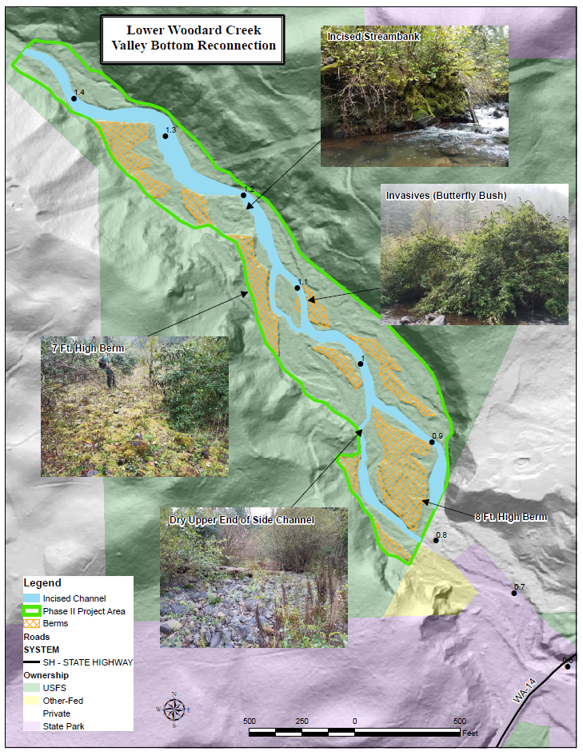
Figure 8. Map and photos of the project site showing some of the existing impairments.

2.3 Site Surveys
Initial surveys of the project area were conducted in October 2019 and in September 2020 to document physical and habitat conditions and serve as a basis to evaluate alternatives and implementation strategies. Additional site reconnaissance was conducted in 2022 and 2023 to survey existing plant communities, ground truth the 2018 Lidar, conduct ground based topographic survey, to identify field indicators for the geomorphic model and to discuss restoration actions. Suitable locations for large wood placements were identified as well as identifying potential areas to develop floodplain reconnection. Potential sites were photographed. The current condition of past restoration work at the confluence of the Columbia River was also observed to understand stream channel response and inform designs.
During the 2019 investigations, topographic cross-sectional surveys were collected at one or more representative sites within each reach to support the design. The cross-section surveys extended across the valley bottom. A local longitudinal survey was also performed at each representative site to document the local channel gradient. The surveys were not tied to a vertical datum, but GPS points were collected so the data could be mapped and compared to cross-sections generated from LiDAR.
Subsequent field surveys in 2022 and 2023 were conducted to further evaluate the existing topography and bathymetry and to compare against LiDAR. GPS survey grade equipment, including a base and rover set-up, and total stations, were utilized to map the project reach. Overall, data collected during ground surveys, including cross sections, compared favorably to LiDAR (see Appendix A). Site assessments were also conducted by the USFS Enterprise Team, and other USFS technical experts, in 2022 and 2023 to refine the relative elevation model (see Section 4).

2.4 Reach Description
Four distinct geomorphic reaches were identified based on changes in valley confinement, channel slope, and bed morphology. The reach extents are shown on the longitudinal profile of Woodard Creek (Figure 9). This profile was generated from available LiDAR data (Washington Department of Natural Resources 2018). It illustrates that the average longitudinal gradient is from 2.9% to 3.5% at the upper end of the project.
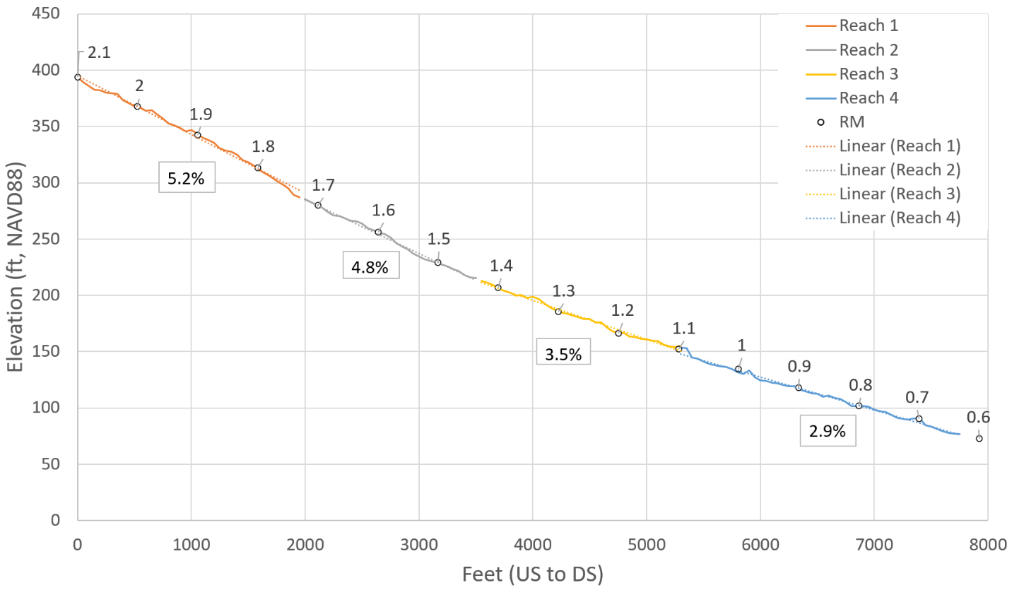
Figure 9. Woodard Creek Longitudinal Profile. This project is in Reach 3 and 4.

2.4.1 Upper Reaches: RM 1.4- 2.1
In Reaches 1 and 2, the channel steepens and becomes more confined with little or no floodplain adjacent to the active channel margins. The channel is primarily controlled by large boulders forming small steps and cascades. The stream can be characterized as having a cascade/plane-bed channel morphology (Figure 10 and Figure 11), with few pools observed. Large wood was largely absent. The riparian zone is more mature than the further downstream reaches with significantly more conifers and dense canopy over most of the channel.
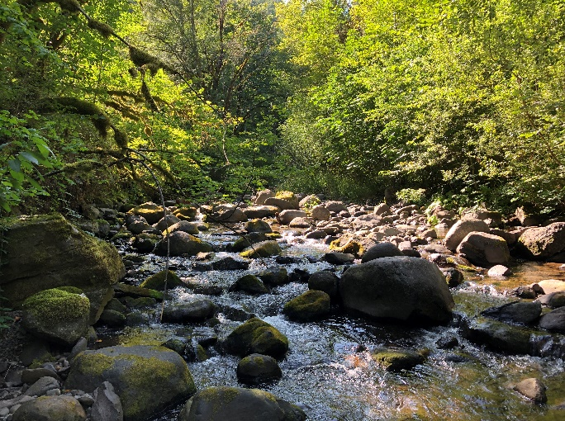  Figure 10. Plane-bed segment. | 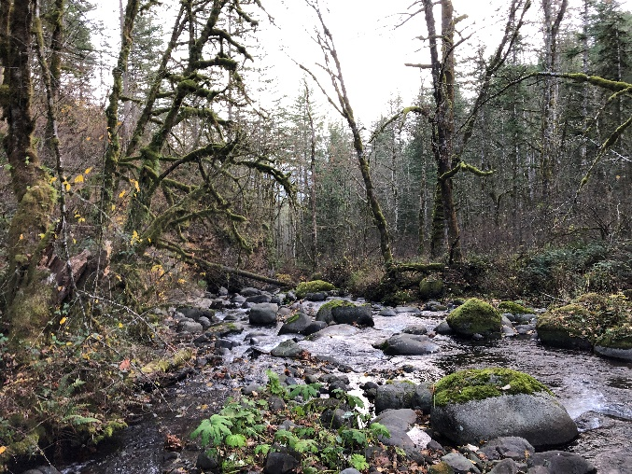  Figure 11. Cascade bed segment.
This floodplain remains partially disconnected through this reach which has the steepest bed slope in the study area. The channel can be characterized as a mix of plane-bed and riffle-pool morphologies. Pool habitat and the few large pieces that were observed are mostly disconnected at low flow. The channel substrate ranges from small cobbles and gravels to finer sediments suitable for spawning in a few locations such as boulder shadows. At the top of the reach, below the confluence with the East Fork, the floodplain widens and flattens out creating a bench. Split flow paths were observed in this section with gravel bars (Figure 12) and high-flow channels where there is a documented groundwater source which provides cold water inputs to the stream. A seemingly active large hillslope failure at the upper end of the reach continues to have the potential to deliver a large amount of sediment to the system (Figure 13).
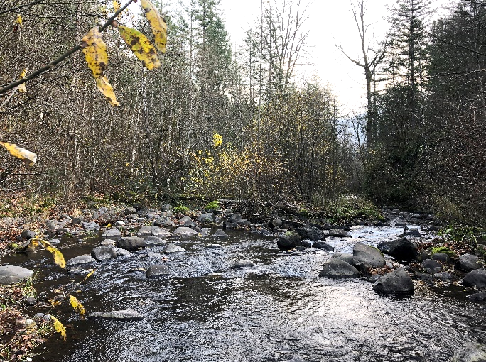  Figure 12. Split flow around mid-channel bar. | 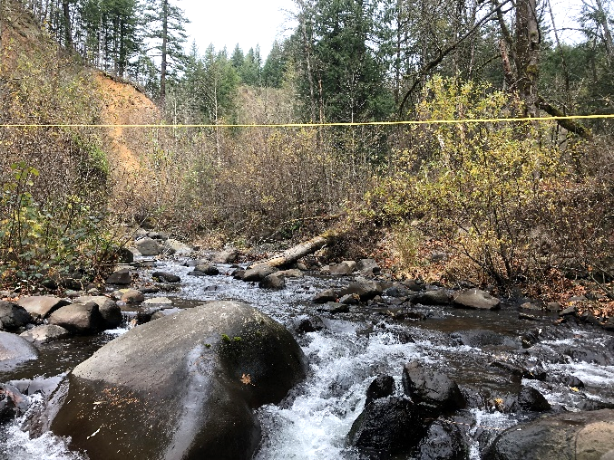  Figure 13. Active hillslope failure in background.

2.4.2 Project Reach: RM 0.8- 1.4
Reach 3 and 4 is characterized by a low gradient channel within a wide valley. The channel has segments of plane-bed and pool-riffle morphologies. Mid-channel and lateral gravel bars are evidence that this is a depositional area (Figure 14). Segments of the channel has a braided planform. An 800-foot-long seasonal side channel passes through the right floodplain. The substrate is dominated by large cobbles and gravel with a few smaller boulders. The flow has been observed going subsurface in late summer through a portion of this reach (Figure 15). The reach lacks channel structure and LWD both in the stream and on the bank. In March 2018, LCEP staff found only three large pieces, and four small pieces of woody debris in the lower side-channel. The reach has documented historic beaver use, and while beaver activity was observed throughout the reach, no significant beaver dams exist at this time. This reach also lacks pool habitat, and the riparian zone is dominated by invasive butterfly bush and Himalayan blackberry, though willows, alder, cottonwood and a limited number of conifer trees exist.
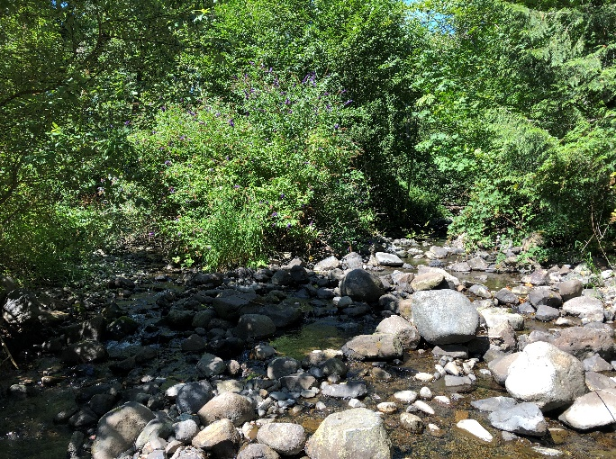  Figure 14. Flow split at mid-channel bar. | 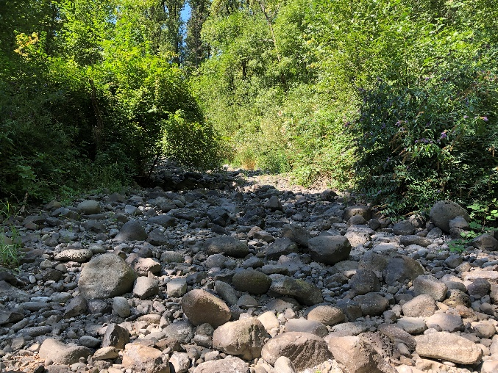  Figure 15. Dry channel due to subsurface flow.
The valley begins to narrow at RM 1.1 and the floodplain becomes less connected. A single-thread channel is situated near the river-left valley wall, and the bed can be characterized as having a plane-bed channel morphology with a few short, steep riffles (Figure 16). The substrate material is uniform with a high porosity, allowing it to be more easily transported. The reach lacks sufficient large wood, off-channel habitat, and pool habitats. This segment is bisected by the Williams Pipeline which is just upstream of a series of constructed log grade controls (Figure 17).
Figure 16. Pool tailout below one of the few riffles. | 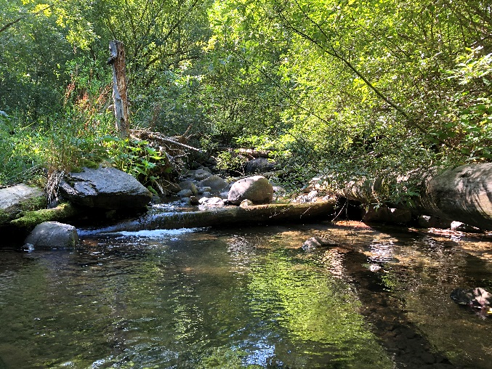  Figure 17. Constructed log grade control

2.4.3 Lower Reaches: RM 0.8- 0
This reach extends from the railroad crossing up to the bridge at SR-14 (Fig. 18 and 19). This reach is highly channelized between the left naturally high bank and a dike along Moorage Road on the right bank. The SR-14 bridge opening is about 40 feet in width, which is about half the width of the channel in the upstream Reach 3. The channel was directed to this left side of the floodplain more than 60 years ago. The upper portion of the reach transports sediment quite effectively, whereas the lower portion of the reach widens out somewhat at the end of the dike and must enter the culvert at an angle. The widened channel and debris deposition at the culvert has caused sediment deposition 200 feet or so upstream of the culvert. During the flood in November 2006, the sediment build-up caused the creek to jump out of the channel and flow down Beacon Rock Moorage Road. The culvert and channel are a maintenance problem for the park, and the debris may block fish passage after large depositional events. This reach is dominated by large cobbles and has essentially no pools or other habitat diversity. The riparian zone is in good condition with mature trees and good canopy cover except near the confluence of Little Creek (RM 0.25) and in the immediate vicinity of the culvert where frequent maintenance occurs. The channelization of this reach limits restoration opportunities in the short term. The immediate problems are the constriction of the culvert and the deposition of sediment and debris at its upstream end.

Figure 18. Confluence with the Columbia River (Tetra Tech).
Figure 19. Woodard Creek below Hwy 14 (Tetra Tech).

3. Restoration Alternatives
Prior design efforts, including the Woodward Creek Habitat Restoration Project Siting and Design Project (Tetra Tech 2007) and the Upper Woodard Creek Habitat Enhancement Basis of Design Report (Inter-Fluve 2022), produced restoration alternatives.
During the preliminary design phase, representatives from Inter-Fluve, LCEP, and CRGNSA held two design workshops to perform a three-tier process of: 1) evaluating alternative restoration actions for each of the project reaches, 2) identifying wood sourcing and delivery methods, and discussing the appropriate size of large wood structure, and 3) selecting the specific restoration site locations. A summary of the tiers are shown in Section 3.1. and in Appendix A.
This project evolved out of the restoration alternatives that were developed from RM 0.8-2.1. During the development of restoration alternatives, the project team concluded that the physical setting of the reach above SR-14 (RM 0.8-1.4) was very different from upstream reaches (RM 1.4- 2.1). Therefore, Lower Woodard Creek (this project) was separated from the initial Upper Woodard Creek restoration project (completed). The team came to consensus that the upstream project should focus on large wood augmentation from River Miles (RM) 1.4-2.1, while this project should center around valley bottom reconnection.
Four alternatives were identified: vegetation enhancement, supplemental large woody-debris (LWD), riparian enhancement, and valley bottom reconnection. Our technical group concluded that the approach with the maximum benefits for this project site, was to utilize a valley bottom reconnection approach (Table 1).
The reach from RM 0.8-1.4 is in a less confined valley, resulting in the potential for it to be restored to a depositional valley type as opposed to the upstream transport reach (RM 1.4-2.1- narrower section of the valley) where adding large woody debris was the best alternative. Additionally, large wood augmentation in the absence of valley bottom reconnection in this lower reach of Woodard Creek would likely result in a higher risk to downstream infrastructure. By converting the existing incised, high-energy lower reach of Woodard Creek from a transport reach back to a depositional, low-energy environment, the risk to downstream infrastructure is reduced, and benefits to aquatic species are maximized.

3.1 Alternatives Evaluation

Tier 1 – Evaluation of Alternative Restoration Actions
A suite of potential alternatives actions was developed for the project site based on the results of the field investigations and in consideration of the project objectives and constraints. The alternatives evaluation matrix for Tier 1 is shown in Table 1.The following restoration actions were considered to determine the best approach for each reach:
- Vegetation enhancement
- Placement of supplemental large wood
- Vegetation enhancement and placement of supplemental large wood
- Valley bottom reconnection
These alternatives were evaluated for each reach and assigned a “total benefit score” based on the following criteria:
- Anticipated benefit to goals and objectives
- Intrinsic usage by target species aquatic species
- Benefits to non-target aquatic and terrestrial species
The “total benefit score” for each alternative restoration action was then scaled based the following other considerations:
- Probability of success
- Risk to infrastructure
- Constructability
- Relative cost
- Anticipated life-span
The highest scoring restoration actions for each reach were as follows:
- Reach 1 – Valley bottom reconnection
- Reach 2 – Valley bottom reconnection
- Reach 3 – Vegetation enhancement and placement of supplemental large wood
- Reach 4 – Vegetation enhancement and placement of supplemental large wood

Tier 2 – Selection of Structure Sizes and Large Wood Delivery Approaches
One of the primary considerations in the alternative’s evaluation was site access and material sourcing. The various large wood material sources considered were:
- Felling of Trees in the Stream Corrido
- Delivered by Ground-based Heavy Equipment
- Delivery by Helicopter
- Mix of two or more of the above options
The Project Team preferred the structure sizes and delivery approaches listed below. The alternatives evaluation matrix for Tier 2 is included in Appendix A.
- Reach 1 – Ground delivery
  - Structure size was not scored for this reach since CRGNSA was committed to exploring a valley bottom reconnection through this reach
- Reach 2 – A mix of ground delivery and helicopter placed medium-sized structures
  - CRGNSA was also interested in pursuing a valley bottom reconnection for this reach, but the Team discussed preferred structure sizes anyhow because CRGNSA was not yet sure if a Stage 0 design would need to extend this far upstream.

Table 1. Restoration Alternatives- showing reach potential, habit lift, relation to goals and objectives, intrinsic use by salominds, benefits to non-target species, benefiot score, considerations and total score. The valley-bottom reconnection approach was selected for the project reach.

4. Geomorphic Model

4.1 Conceptual Framework
The Lower Woodard Creek Restoration Project will restore complex habitats for winter steelhead, Coho and Fall Chinook rearing and spawning by restoring the valley bottom connection, which is currently absent in the Woodard Creek drainage. More specifically, the objective is to reconnect approximately 20 acres of lower Woodard Creek upstream of Highway 14, to its valley bottom (i.e., floodplain) by removing anthropogenic features including berms and old roadbed that have channelized Woodard Creek.
Woodard Creek has an alluvial sediment supply zone higher in the basin and mid-basin along hillslopes and streambanks, a transport zone, and alluvial fans both high and lower in the basin. In a properly functioning system that is undisturbed, Stage 0 conditions can exist in any of the above-mentioned zones and throughout a watershed (Figure 20). These areas exist when transport is limited or when supply and capacity is balanced with strong particle exchange and sorting (Cluer and Thorne, 2013). Disturbances throughout the Woodard Creek watershed have masked areas where Stage 0 conditions could occur due to high degree of incision, floodplain disconnection and artificially elevated surfaces adjacent to the creek.
Field observations confirmed LiDAR observations. Incision in this reach of Woodard Creek is approximately 6 feet or more, making it a Stage 3 (Figure 21) according to the Stream Evolution Model (SEM) developed by Cluer and Thorne (2013). Much of the valley bottom in the project area has been manipulated, resulting in a highly disturbed system. As shown in Figure 10, roads, mines and other disturbances coincide with berm areas (i.e., anthropogenically created high elevation surfaces) in much of the project area, with some road locations subsequently scoured out by either the mainstem Woodard Creek or one of its side channels. The disconnection of Woodard Creek from its historic floodplain is a result of a combination of channelization resulting in incision, reduction in the channel migration zone and artificially high “berm” surfaces. Restoration actions in the project reach will facilitate greater deposition and move the area towards Stage 8.
Figure 20. Process Domains and sediment zones in a watershed (Cluer & Thorne, 2018).
The stage of the SEM that Woodard Creek currently exhibits, Stage 3, provides only minimal hydrogeomorphic and habitat benefits, approximately 25% of the potential benefits (Figure 21). Based on the predicted environments expressed in the Relative Elevation Model (REM) for the Woodard Creek valley at this location, the historic condition at least for the lower reach of the project area, appears to have been closer to Stage 0 in the SEM (see Section 4.2). Stage 0 is more resilient and has greater geomorphic and biological benefits (Figure 22). As seen in Figure 23, given current incision and historic disturbances, without intervention, it can take centuries to recover connection to the valley bottom floodplains surfaces.

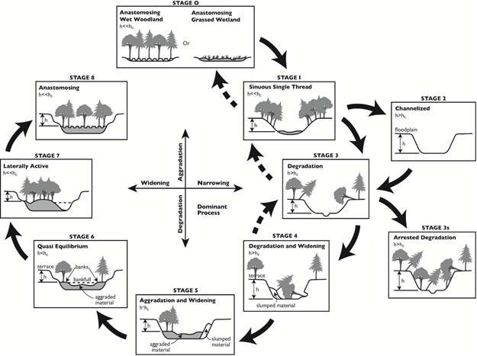
Figure 21. Stream Evolution Model (SEM) developed by Cluer and Thorne (2013).
Figure 22. Hydrogeomorphic and habitat benefits provided at each stage of the Stream Evolution Model (Cluer and Thorne 2013).

Figure 23. Cluer and Thorne stream evolution timescale (Modified from Pollock et al. 2014).

4.2 Relative Elevation Model
Before the September 2020 field visit that included the USFS Region 6 Restoration Assistance Team for Stream Restoration, LiDAR data was used to assist with the evaluation of geomorphic features. An initial Relative Elevation Model (REM) based on the Geomorphic Grade Line (GGL) of the valley was modeled from LiDAR data for Woodard Creek (Helstab 2018, Powers et al. 2018). The Geomorphic Grade Line (GGL) refers to the expected historic valley slope that spans the extent of the valley between geomorphic controls. A map of the REM using a 3rd-order polynomial trendline fit was symbolized to distinguish target surfaces above and below the GGL. Ultimately field observations including surface targets (2002 and 2023) were fed back into the model to derive an updated REM. The GGLREM for Woodard Creek within the project area shows a valley bottom transitioning from a transport reach to an unconfined depositional valley that has been converted into a transport reach through the disconnection of Woodard Creek from the valley bottom. The depositional valley bottom associated with Woodard Creek at this location is approximately 0.6 miles long from upstream valley control to downstream valley control.
After further investigation and analysis, including multiple separate trips to ground truth the initial geomorphic grade line, and subsequent GGL model runs, the GGL REM modeling approach was modified to fit to target surfaces identified in the field. Target surfaces included a combination of features identified in the field, including native vegetation, substrate, and relict floodplain surfaces and other relict features of interest. After consultation with USGS Geologists, the group also revisited grading the lower-most mid-channel island and decided to leave it intact. This caused us to alter the REM.
Ultimately, the final REM used to assist with design and to generate target GGLs throughout the project area, was generated by snapping target surfaces to cross-sections generated perpendicular to the valley walls through the project area. Based on the target surface elevations along the cross-sections, these values were interpolated by generating a series of different (Helstab, M). Matt Helstab was the creator of the initial GGLREM software, and his expertise was pivotal in developing this modification. This TIN method also allowed the new surface to work seamlessly with HEC-RAS 2d. The updated REM (Figure 24) and associated cross-sections (Figure 25, Figure 26 and Figure 27) can be found below.
The surface at the contact of the color bands represented as light blue and light green in the REM represents likely-target elevation. The target elevations represent the baseflow water table in a fully connected valley bottom. In a functioning and connected valley bottom, the light blue areas indicate shallow water/target surfaces; light green areas indicate inundated, emergent vegetation areas; dark blue indicates deeper wetted areas, pools or ponds; pink areas indicate deep wetted areas or incised channels; dark green indicates water-loving shrubs, like willow areas; yellow represents more transitional riparian vegetation (less obligate and more facultative).

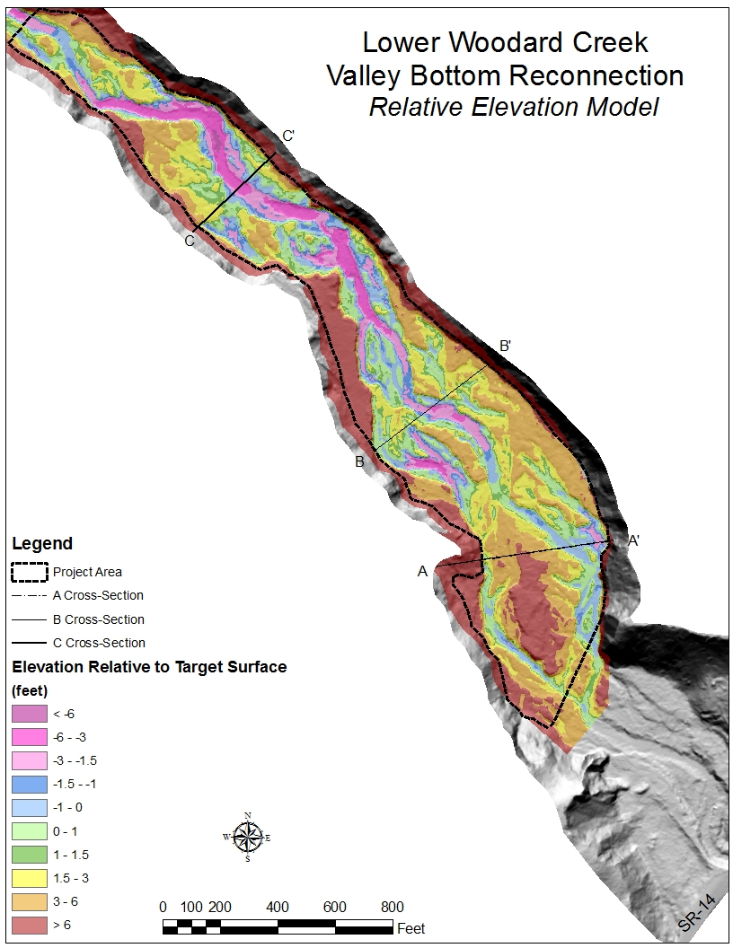
Figure 24. Map of the Relative Elevation Model (REM) for Lower Woodard Creek

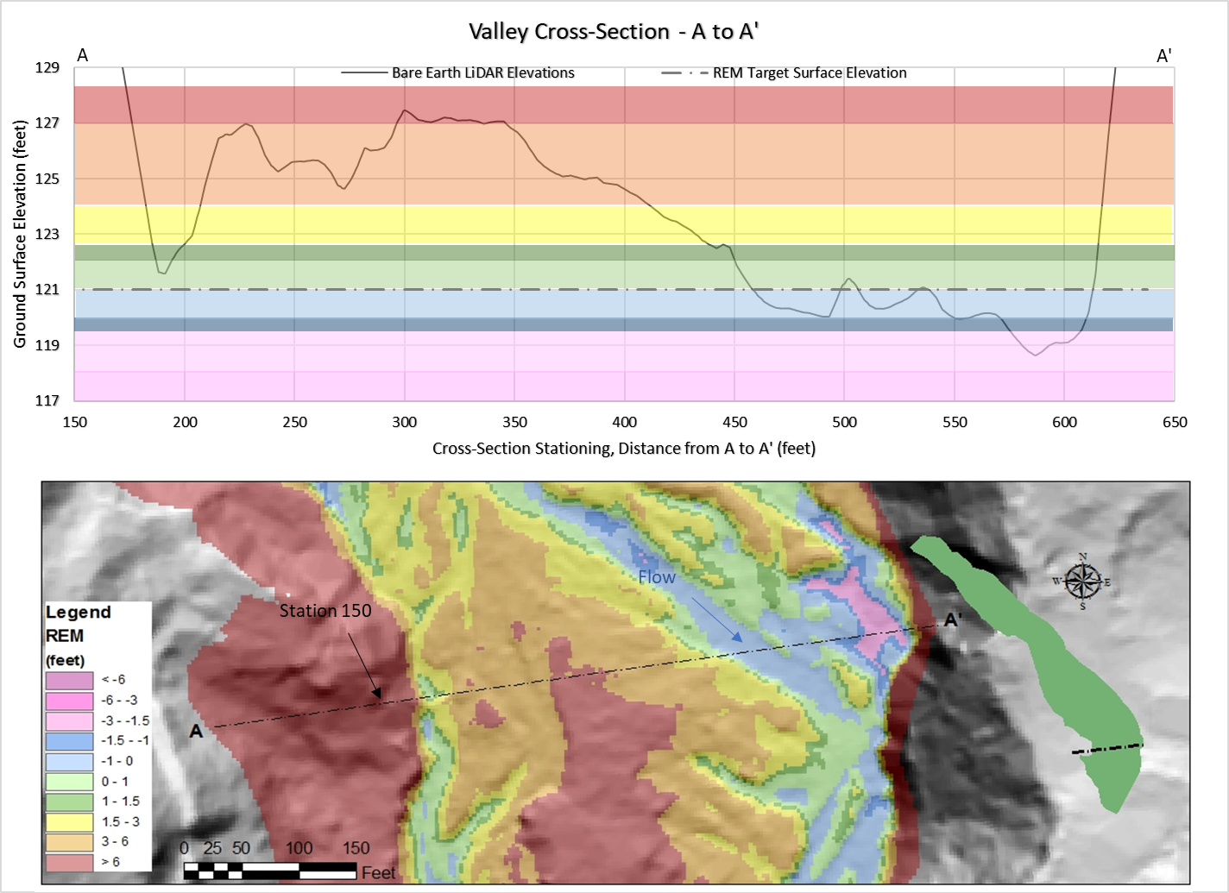
Figure 25. Valley Cross-Section from A to A' including the REM color bands and the cross-section location.
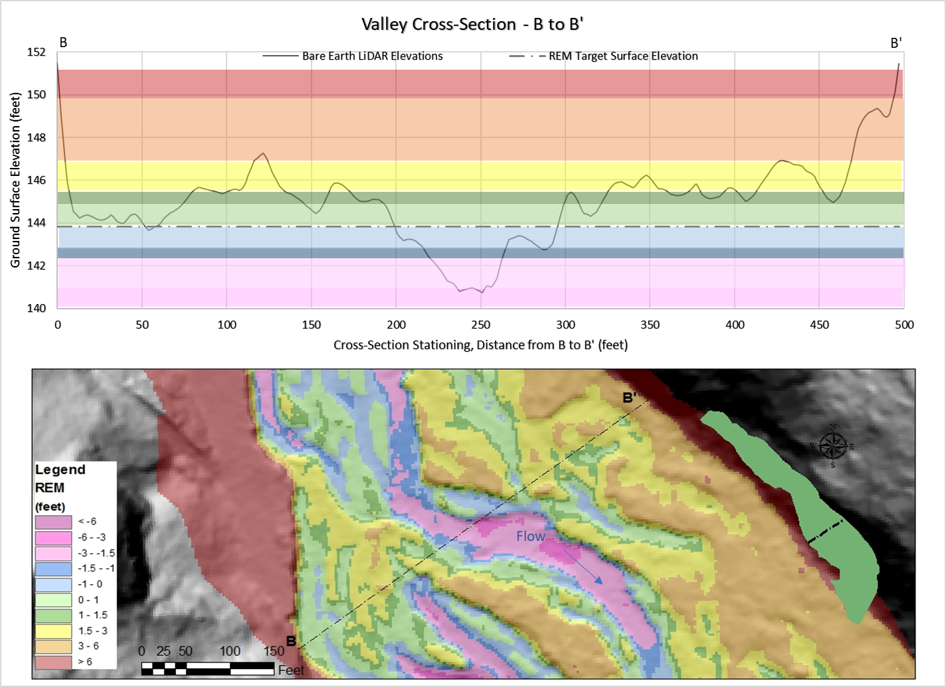
Figure 26. Valley Cross-Section from B to B' including the REM color bands and the cross-section location.

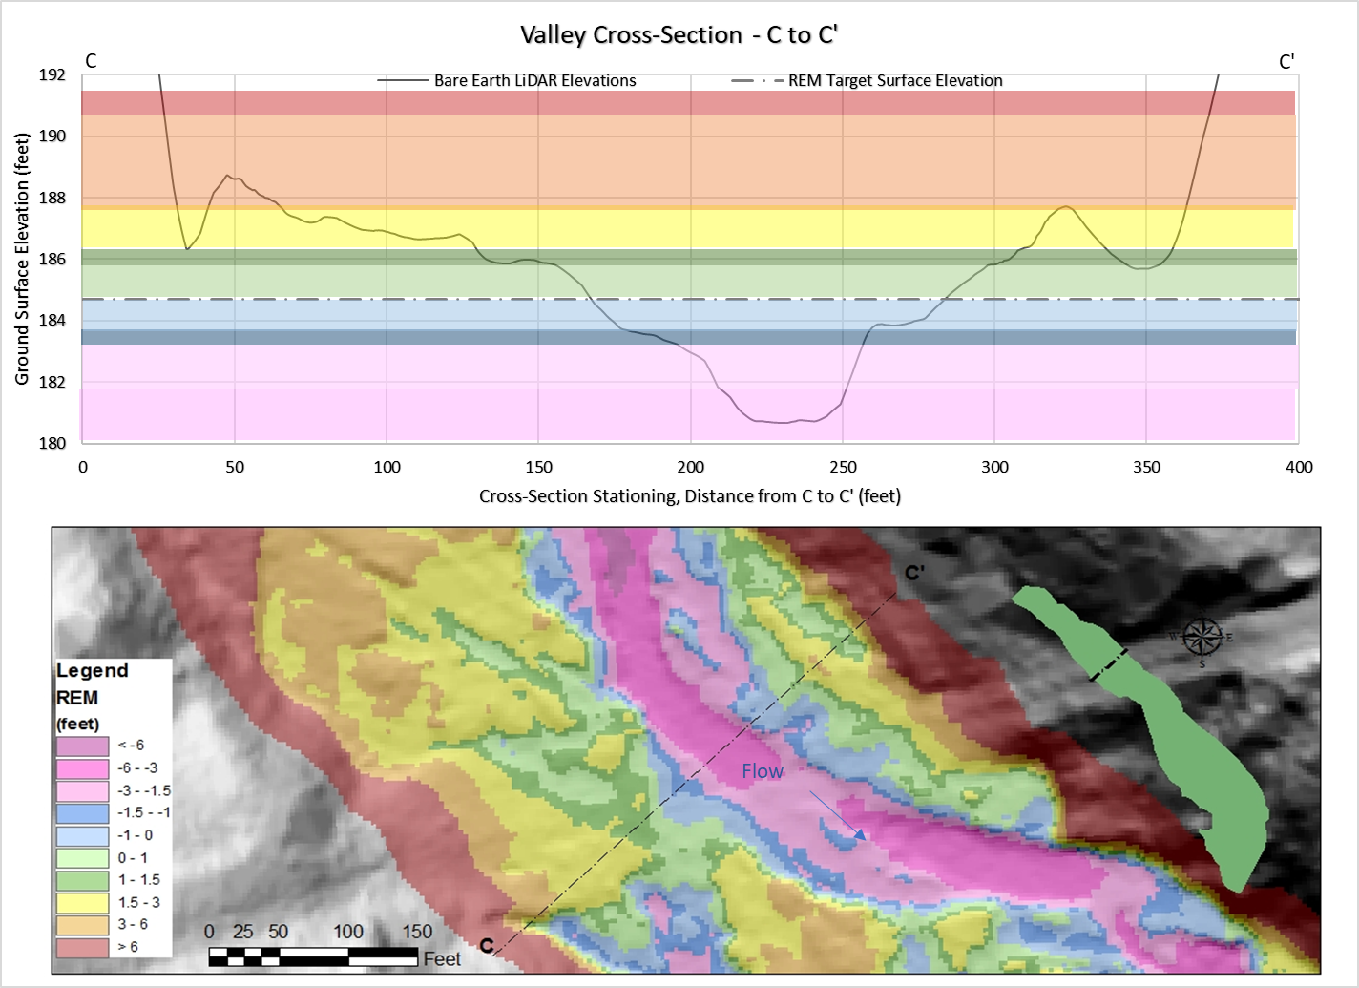
Figure 27. Valley Cross-Section from C to C' including the REM color bands and the cross-section location.

5.0 Hydrology & Hydraulics
Hydrologic and Hydraulic analyses were performed to gain insights into the existing conditions at the site and to predict the effects of the proposed project. The results were also used to inform the large wood stability evaluations.

5.1 Hydrology
The Woodard Creek watershed receives 93 inches of rain annually on average. Snowfall is typically light to moderate due to mild winters and the relatively low elevation of this watershed, but rain on snow events do occasionally occur.
Since Woodard Creek is an ungaged system, a hydrologic analysis was conducted in order to estimate the magnitude of flow events for several standard recurrence intervals (low flow, 1.5 (bankfull) and Q100-year. Peak flow estimates were generated for several recurrence intervals (Table 2). A standard method of peak flow estimation in ungaged systems is regional regression curves that estimate stream discharge for several recurrence intervals based on multiple basin characteristics. The USGS StreamStats web interface was utilized to determine basin characteristics and to compute the regression curves. Washington StreamStats uses the regression equations developed by Mastin et al. (2016). These values were compared to the estimated peak flows from the 2007 Woodard study (Tetra Tech), and the StreamStats values were typically 30-50 percent higher and adjustments were made. Based on professional judgement and modeling of bankfull flows, these flood flow predictions appear to be higher than thought by professional hydrologists and geomorphologists familiar with the site (USFS, Tetra Tech and Estuary Partnership). Therefore, the Q1.5 and Q100 were adjusted lower.
Table 2. Estimated stream discharge by flood recurrence interval

Flood Recurrence Interval (Years) | Stream Discharge (cfs)
7-Day 10 Year Low | 3
Bankfull flow/Q1.5 | 100
Q100 | 920

5.2 Hydraulics

5.2.1 Hydraulic Modeling
The existing condition (i.e., pre-restoration) and the preliminary project design conditions for Lower Woodard Creek were modeled in two-dimensions (2D) using HEC-RAS version 6.2 using flows from Table 2, including 3 cfs, 100 cfs and 920 cfs. Additional hydraulic model inputs are shown in Table 3. Channel, streambank, and overbank roughness was adjusted using available landcover data for the project site (Table 4). The existing 2019 LiDAR was used to represent topography and bathymetry of the project site. The LidAR was validated for bathymetry during low water field surveys in 2023 (Appendix B). Hydraulic outputs
Table 3. HEC-RAS Hydraulic model inputs.

Table 4. Landcover and Manning’s N values (based on NLCD Spatial Layer 2011).
Hydraulic modeled outputs are shown in Figure 28, Figure 29, Figure 30, and Figure 31. Figure 27a below shows that under restored conditions low velocity areas conducive to fish passage, and holding increased by approximately threefold. Figure 27b shows that restored conditions also increased inundated acres by two-to-threefold. Restoring Woodard Creek back to velocities within the depositional range would provide excellent rearing habitat at low and average flows. At bankfull flows under restored conditions flows within the project reach show much greater extension across the valley with multiple split flows (Figure 29). Velocities also decrease substantially within the channel for restored conditions vs. existing conditions (Figure 30). At the bankfull flow restored conditions show that the channel velocities are approximately 1 fps, while existing conditions show that the velocities are approximately 3-6 fps. At the 100-year flow restored conditions velocities are generally between 3-4.5 fps, while existing conditions show that the velocities are greater then 7.5 fps (Figure 31).
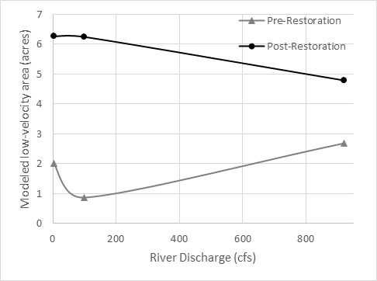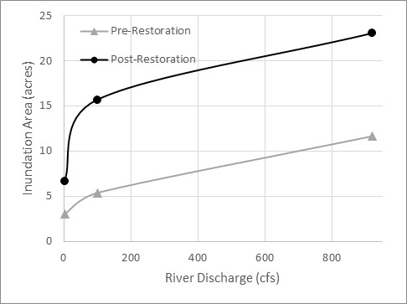
a
Figure 28. Modeled low velocity < 1 fps (a) and inundation area (b) for pre- and post- restoration at varying discharges.
b

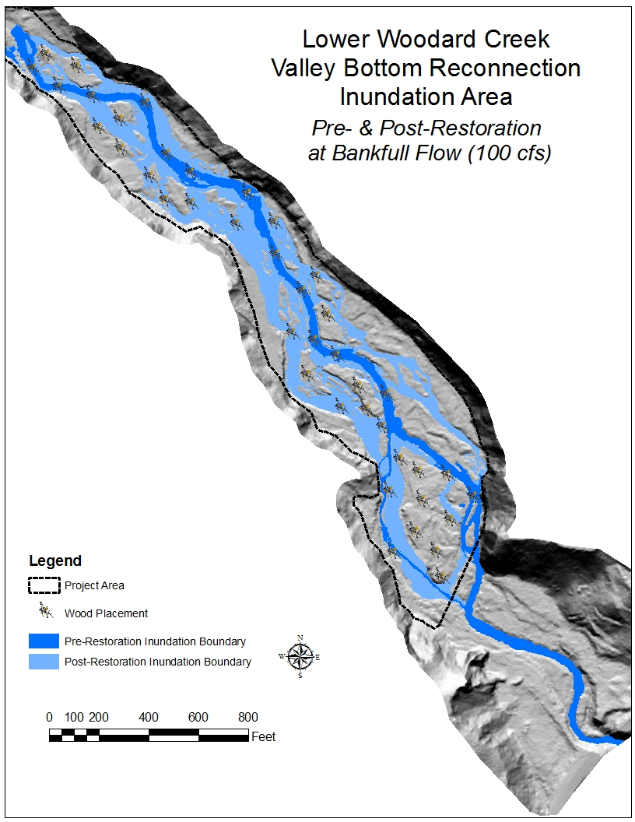
Figure 29. HEC-RAS 2D modeling results showing pre- and post-restoration inundation areas for 100 cfs streamflow.

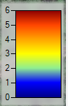
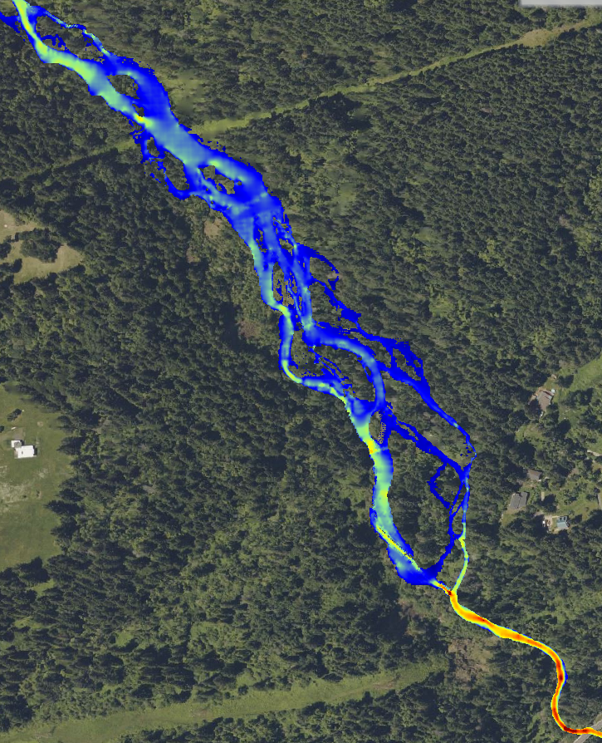
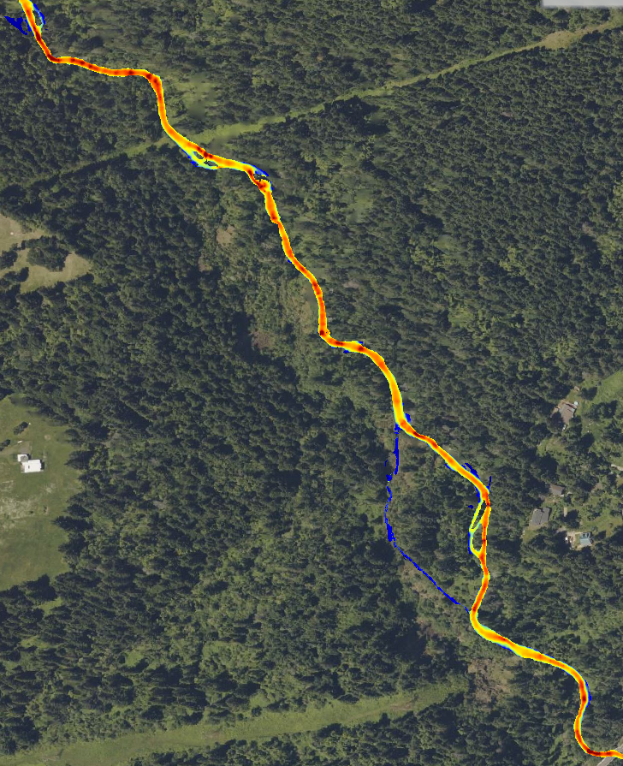
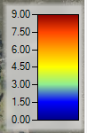
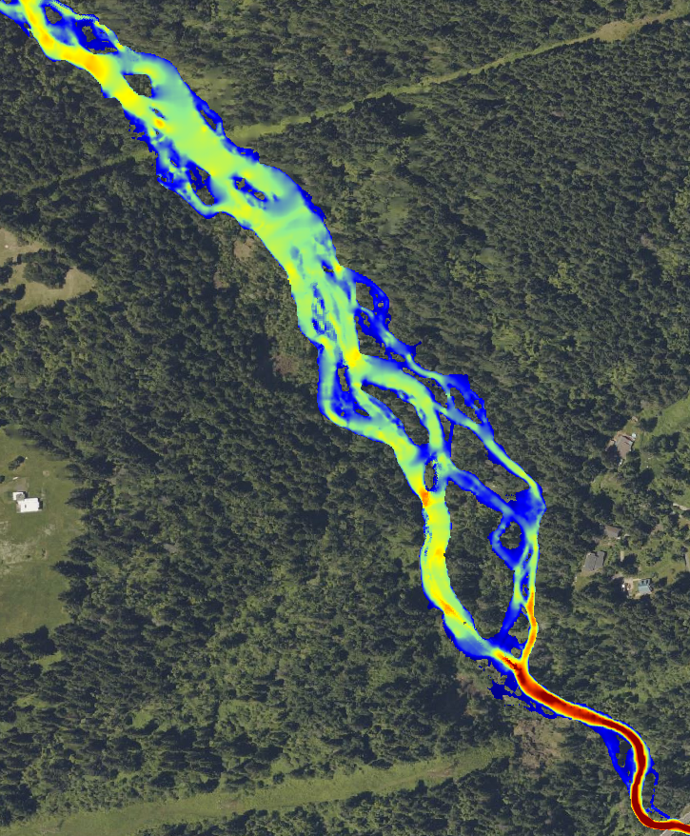
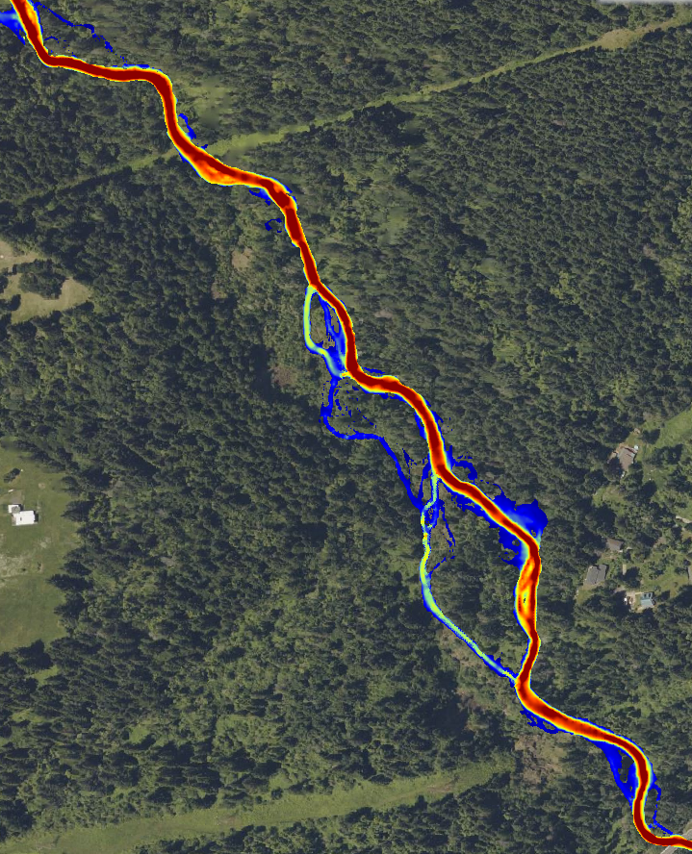
Figure 30. HEC-RAS 2D modeling results showing pre- and post-restoration velocities in feet per second for bankfull flow of 100 cfs.
Pre-Restoration
(18 cfs /0.5 cms)
Post-Restoration
(18 cfs /0.5 cms)
Pre-Restoration
Post-Restoration
Figure 31. HEC-RAS 2D modeling results showing pre- and post-restoration velocities in feet per second for 100-year flow of 920 cfs.
Post-Restoration
Pre-Restoration
Post-Restoration
(55 cfs / 1.6 cms)
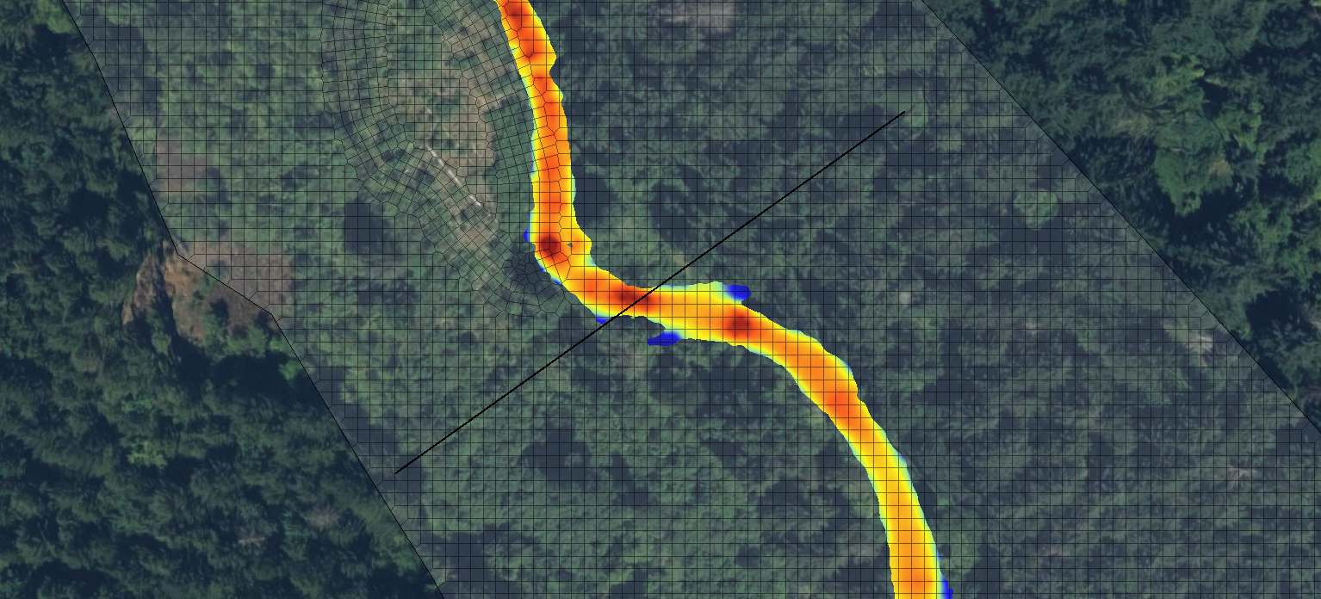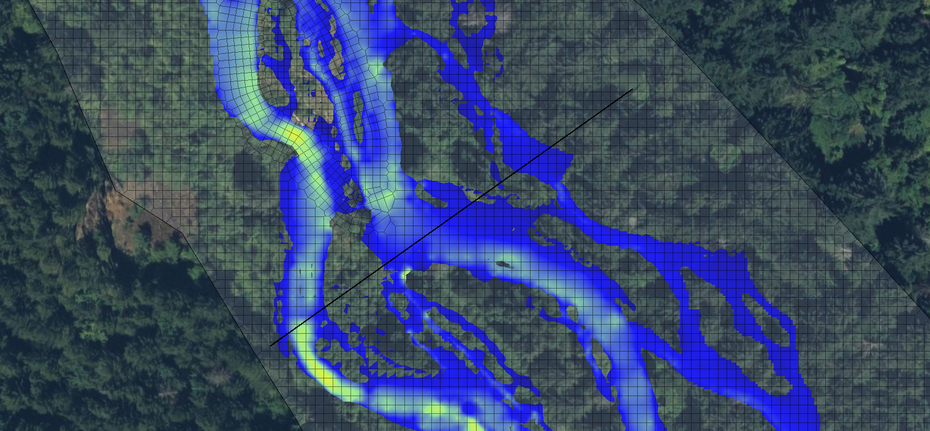
Figure 32. Cross-Section A, pre and post velocities.
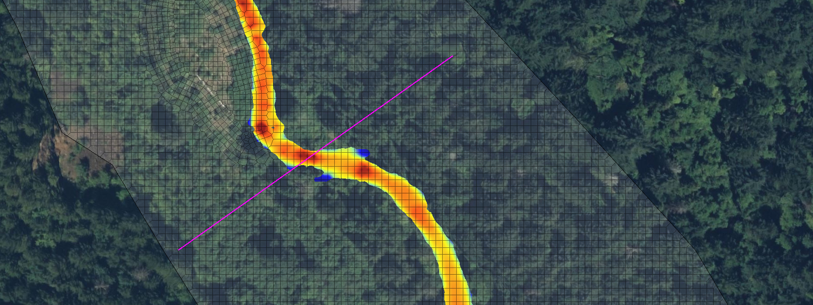
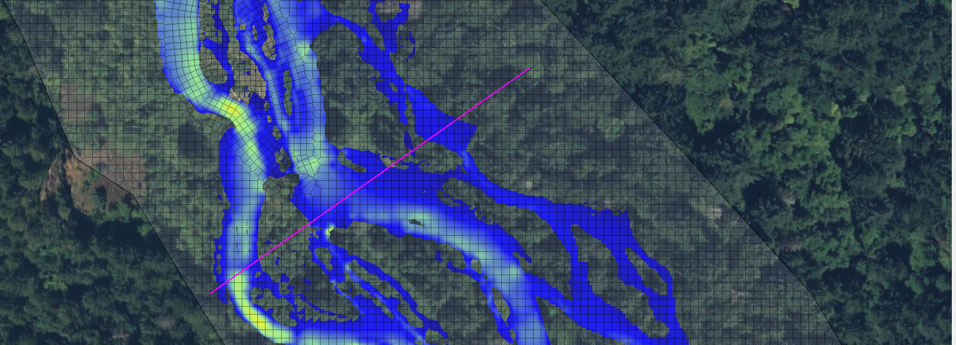
Figure 33. Cross-Section B, pre and post velocities.
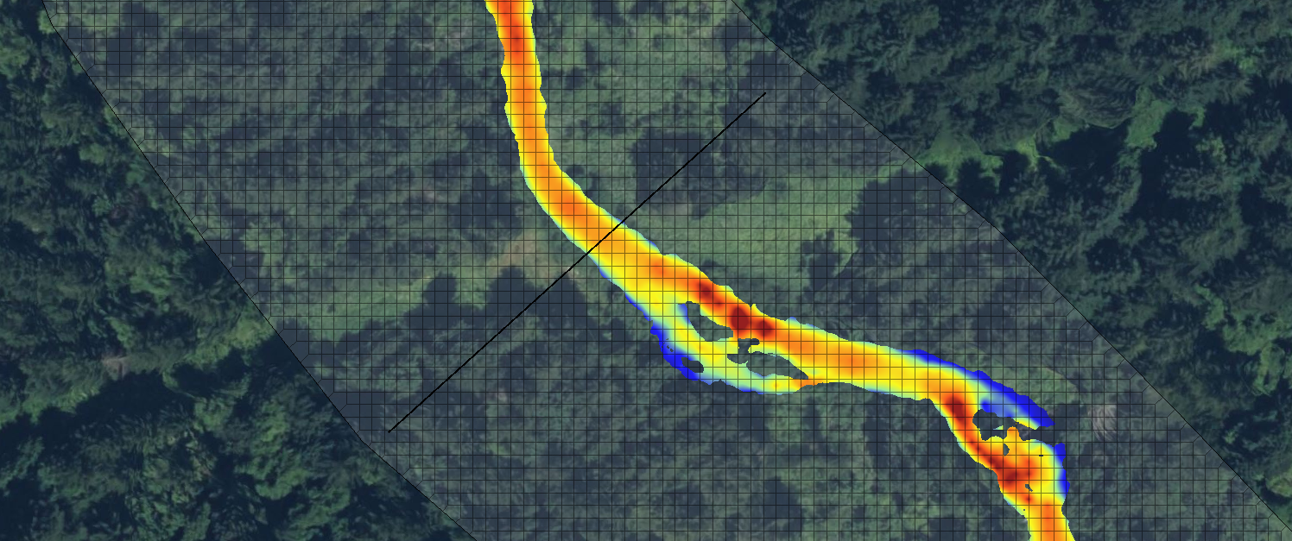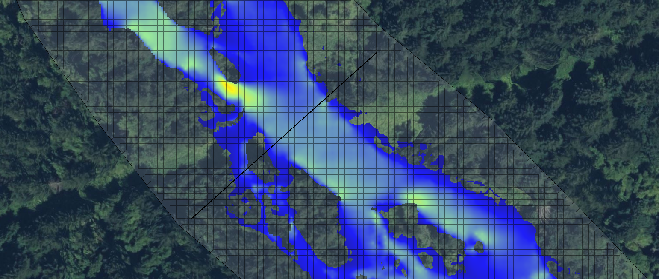
Figure 34. Cross-Section C, pre and post velocities.

6. Design
Large scale landscape disturbances have artificially constrained the channel and artificially raised surfaces above the current stream channel. There was a vast array of roads that were used to mine gravels along hillslopes within the project area and upstream and appeared to also be used to mine instream gravels and relict disturbances continue to exert a dominant control on the landscape and project site.
The designs will leave the lower mid-channel island intact and will focus on areas upstream of the island. To reconnect the incised channel to the valley bottom, areas below the target surface will need to be lifted with fill material to the target elevation. Fill polygons (shown in the red dotted area) indicate the areas we recommend filling with material obtained from the black crosshatched areas (Figure 35, Figure 36, Figure 37 and Figure 38). The design includes cutting approximately 21,427 cubic yards of material from road fill berms, and artificial surfaces, and filling the existing incised channel with approximately 16,000 cubic yards of material to restore the valley bottom floodplain connection. Initially cut-fill was balanced on site, however due to the expected nature of compaction we identified an additional 5,327 cubic yards of material from an artificial surface located near the old mine.
To achieve project objectives, the downstream end of the restoration reach must be tied into a geologic grade control. The natural geologic grade control for this site is a natural pinch point. Due to stream channelization downstream and levees built on Washington State Park property to protect SR-14 from flooding, Woodard Creek is incised downstream of the project area requiring tying the project into a lower base level than under pre-anthropogenic conditions. Additionally, partially buried large wood will need to be placed in and along this transition area to add more roughness and provide a more gradual pool sequence down to the more incised channel in this transport zone downstream. A mix of substrate materials and trees with rootwads attached should be incorporated at this location as well during the wood placement process.
The valley bottom reconnection will address multiple limiting factors identified above. The design also includes restoring native vegetation in the project valley bottom by treating invasive plants, including butterfly bush, Reed Canary Grass and Himalayan Blackberry, as well as subsequent riparian planting. Transplanting the willows into low areas will provide instant roughness and facilitate the spread of willows once the water table is restored to the valley's surface. Willows should be stockpiled in an area where their root masses are kept moist and transplanted when finish graded is achieved.
The project will need to be accomplished in phases, working from upstream to downstream where access to SR-14 is located. This will require diverting flow away from the active construction area and allowing water to spread in valley reach phases. Before dewatering, aquatic organisms should be relocated outside of the restoration reach, including attempts to relocate lamprey.

6.1 Design Recommendations
The current designs confirmed our belief in the valley-bottom reconnection approach and evolved to focus our efforts largely upstream of the mid-channel island. A summary of design efforts include:
- A combination of large and small wood spread across the valley floor will provide the temporary roughness necessary in the absence of riparian plants to encourage deposition, localized scour, and channel development.
- A diversity of wood sizes will be used to increase the roughness of the wood on the valley floor. Combining tops and brush with placed rootwad pieces and buried wood will help slow water and create slow velocity rearing areas for fish and other aquatic organisms and depositional areas for fine sediments and nutrient retention.
- Roughly 30% of the wood should be formed into jams to induce deposition, providing finer grained features to be planted or naturally revegetated, forming into islands of sorts between anastomosing channels. The remaining wood should be scattered across the valley bottom, adding roughness in the absence of riparian vegetation roughness.
- Up to 500 pieces of wood have been identified as part of this project. Minimum dbh sizes for key pieces of wood for whole trees should be 16-35” dbh, greater than 100 ft a. Minimum dbh sizes for partial trees should be 16-30” dbh, greater than 50ft and with rootwad. Minimum dbh sizes for partial trees without rootwads should be 16-25” dbh and 40-50ft.
- Large wood structure design will follow analysis outlined as part of the Upper Woodard Creek BOD Report (2022), including:
  - In general, there is a layering concept to most proposed structure configurations. The first layer is composed the smaller pieces of wood. Next, the helicopter will place larger whole trees that are being sourced from an adjacent upland location. The intent is to leave as many branches intact as is practicable, and to the extent possible, leave rootwads attached. The third layer includes placement of slash or smaller trees on top, within, and on the upstream face of the structure, which would likely occur using a combination of helicopter placements and hand-crew adjustments. At some sites, a fourth layer consisting of one or more whole fir trees will be felled on top of the structures or immediately downstream. In general, the largest pieces dropped by helicopter and felled whole riparian trees will be expected to improve the stability of the entire structure. The smaller material will add complexity and help “seal” the structure to further enhance its hydraulic effects. This construction approach is intended to minimize both cost and disturbance to the streambed and riparian zone.
  - Adding key pieces of large wood and log jam structures will create instream structure and habitat complexity that mimics the historic conditions to which local fish populations have adapted. Logs placed in the channel will be both on the channel margins and span the channel to slow water, promote sediment aggradation, and create habitat. Log structures are expected to trap gravel and gradually raise the channel grade to address existing incision and floodplain disconnection. Some of the structures may create multiple flow paths where there is now just one. There are several opportunities for activating and re-connecting off-channel habitat including wall-based channels, backwater alcoves, and flow-through side-channels so that they are more frequently inundated and accessible to fish.
  - Logs will increase floodplain roughness to emulate historical conditions and will help to limit the potential of future channel incision should the channel avulse and change course into the floodplain. As an added safety precaution, several larger structures featuring multiple key members have been designed with configurations that would be expected to trap wood that mobilizes and moves downstream.

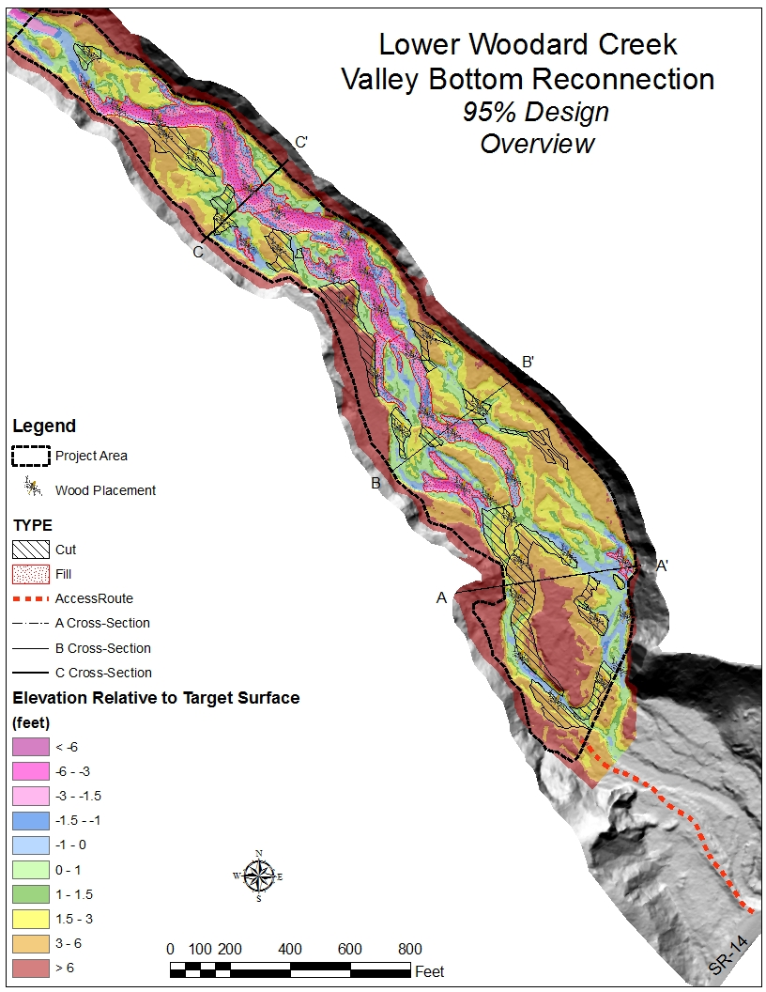
Figure 35. Final Design Overview map of Lower Woodard Creek Valley Bottom Reconnection Project.

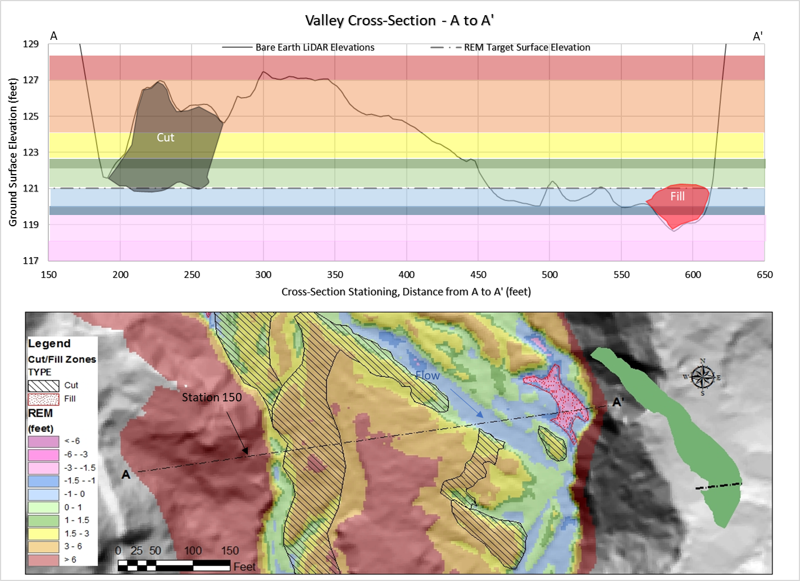
Figure 36. Valley Cross-Section from A to A' showing design cut and fill polygons, including the REM color bands and the cross-section location.
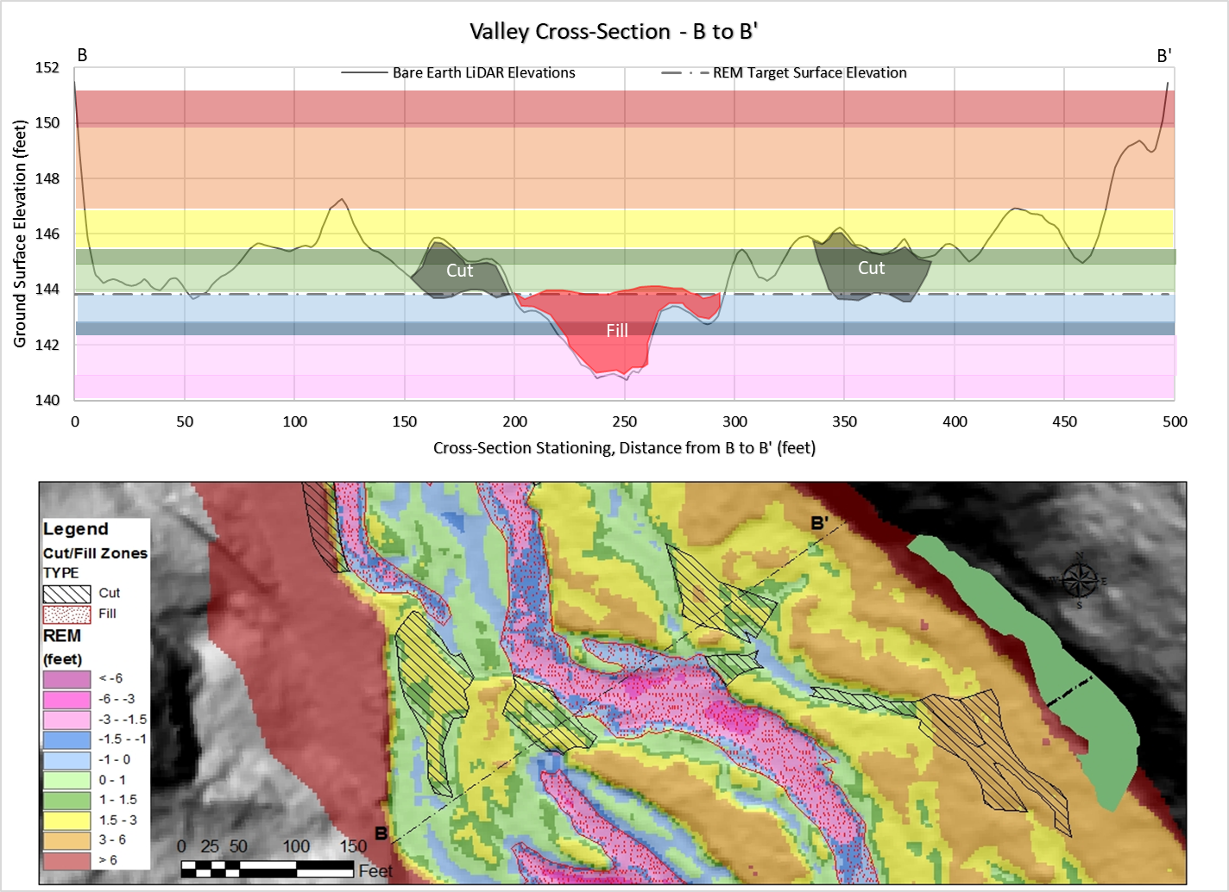
Figure 37. Valley Cross-Section from B to B' showing the design cut and fill polygons, and the cross-section location.
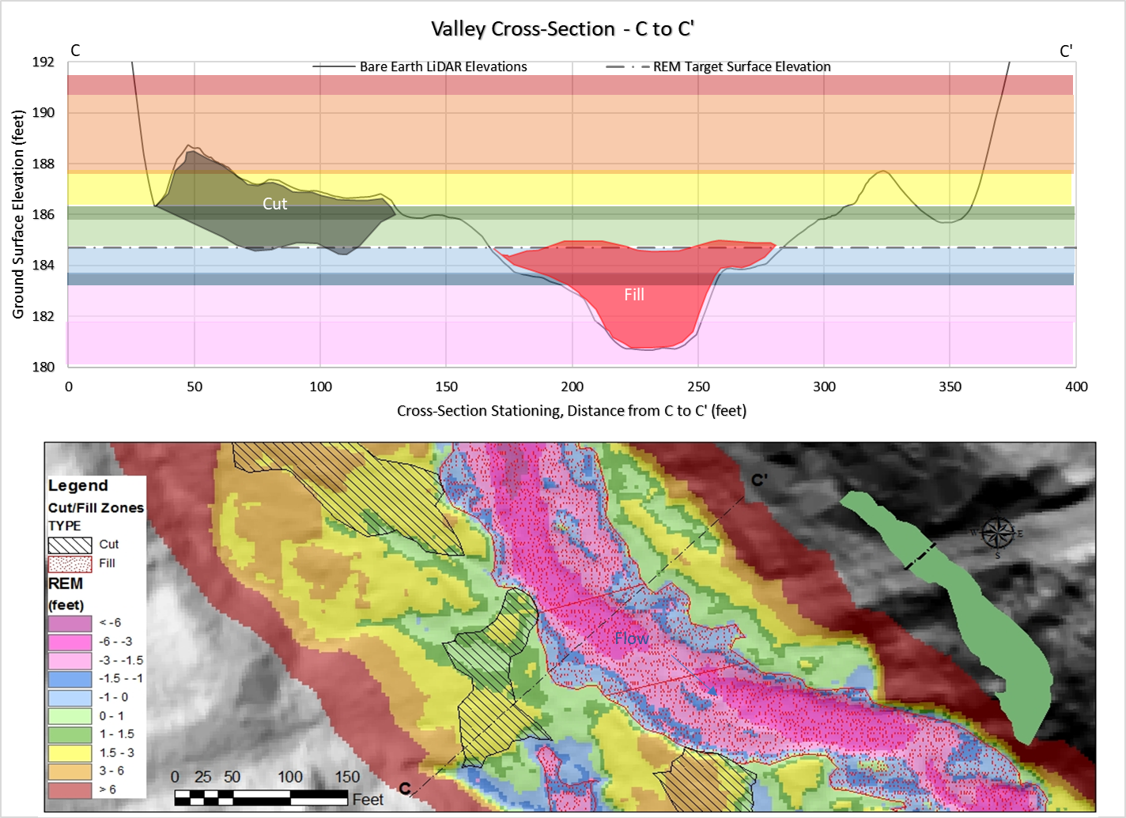
Figure 38. Valley Cross-Section from C to C' showing design cut and fill polygons including the REM color bands and the cross-section location.

7.0 Opinion of Probable Construction Costs

8.0 Climate Change Resiliency Project Benefits
Climate change impacts will likely negatively impact Woodard Creek water quality and habitat. Warming air temperatures and the creek’s poor riparian cover and floodplain disconnection will increase average and peak water temperatures. Increased winter flow magnitude and frequency, and decreased summer flows will likely further exacerbate impacts from floodplain and off-channel disconnection. Research shows water temperatures in Woodard Creek are 2-4°C colder than the Columbia River and quality restored habitats have the potential to offer cold water refugia as stream temperatures increase with changing climates (Marcoe at al. 2018).
By restoring a higher water table through filling the incised, straightened channel with artificially high berm material, more floodplain storage and hyporheic exchange will sustain the hydrograph and provide a buffering effect with more water at baseflow when temperatures are typically the highest. Additionally, by restoring the water table and the depositional environment, much of the valley bottom will be restored to wetland conditions providing increased carbon storage through accumulation of fine detritus, carbon-rich soil formation and anerobic subsurface conditions resulting in long-term carbon storage.

References

Cluer B. and C. Thorne. 2013. A stream evolution model integrating habitat and ecosystem
benefits. River Research and Applications 30: 135-154.
Helstab M. 2018 Geomorphic Grade Line Relative Elevation Model Python Toolbox,
GitHub repository, https://github.com/helstab/GGLREM
Inter-Fluve. 2022. Upper Woodard Creek Habitat Enhancement Basis of Design Report.
Submitted to Lower Columbia Estuary Partnership, Final – June 2022. 52 pp.
Marcoe, K., C. Collins, C. Corbett, M. Burke, M. Schwartz, P. Kolp and A. Hanson. 2018.
Lower Columbia River Thermal Refuge Study, 2015-2018. Report of research by Lower Columbia Estuary Partnership for United States Environmental Protection Agency, October 2018.
Pollock, M.M., Beechie, T.J., Wheaton, J.M., Jordan, C.E., Bouwes, N., Weber, N., and C.
Volk. 2014. Using beaver dams to restore incised stream ecosystems. BioScience 64: 279-290.
Powers, P., M. Helstab and S. Niezgoda. 2018. A process-based approach to restoring
depositional river valleys to Stage 0, an anastomosing channel network. River
Research and Applications 2018: 1-11.
Tetra Tech & Anchor Environmental 2007. Woodward Creek Habitat Restoration Project
Siting and Design Project.
Final Report. November 2007. Prepared for: Lower Columbia Fish Enhancement
Group and Lower Columbia Fish Recovery Board. 73 pp.
USDA Forest Service, Columbia River Gorge National Scenic Area. 2021. Watershed
Condition Framework, Watershed Restoration Action Plan for Tanner Creek and
Woodard Creek – Columbia River. September 2011 (Updated June 2021). 42 pp.
USGS. 2022. StreamStats: https://streamstats.usgs.gov/ss/

Appendix 1- Restoration Alternatives
During the design phase for Woodard Creek, representatives from Inter-Fluve, LCEP, and the USFS Columbia River Gorge National Scenic Area (CRGNSA) held design workshops, and field visits to evaluate alternative restoration actions project reaches and to identify wood the appropriate size of large wood structure. Ultimately, after evaluating the alternatives the site was split into two distinct projects; Upper Woodard Creek (completed) and Lower Woodard Creek (this project).

Tier 1 – Evaluation of Alternative Restoration Actions
A suite of potential alternatives actions were developed for the project site based on the results of the field investigations and in consideration of the project objectives and constraints. The following restoration actions were considered to determine the best approach for each reach:
- Vegetation enhancement – Treat invasives, plant native species, enhance forest succession, and provide long-term large wood loading.
- Placement of supplemental large wood – Install large wood at an appropriate scale and configurations to achieve specific habitat objectives for the mainstem.
- Vegetation enhancement and placement of supplemental large wood – Combined benefits of both of the above alternative actions.
- Valley bottom reconnection – Reset valley to Stage 0 of the channel evolution model to reconnect the floodplain and create complex habitat
  - Note: While it was recognized that valley bottom restoration action was beyond the scope of the Upper Woodard Creek project, this restoration action was added at the request of CRGNSA’s desire to consider a longer-term restoration project that might best meet the project objectives. This action would be not be implemented by this project because it would require a different permit pathway and possibly more funding for implementation.
These alternatives were evaluated for each reach and assigned a “total benefit score” based on the following criteria:
- Anticipated benefit to goals and objectives
  - Increase/enhance in-stream complexity
  - Capture spawning gravels
  - Increase/enhance off-channel habitat
  - Enhance food sources
  - Enhance riparian forest
- Intrinsic usage by Target Species
  - Steelhead
  - Coho
  - Chinook
- Benefits to non-target aquatic and terrestrial species
  - Note: This evaluation criteria was added at the request of CRGNSA based on their holistic habitat goals for the project site
The “total benefit score” for each alternative restoration action was then scaled based the following other considerations:
- Probability of success
- Risk to infrastructure
- Constructability
- Relative cost
- Anticipated lifespan
The highest scoring restoration actions for each reach were as follows:
- Reach 1 – Valley bottom reconnection
- Reach 2 – Valley bottom reconnection
- Reach 3 – Vegetation enhancement and placement of supplemental large wood
- Reach 4 – Vegetation enhancement and placement of supplemental large wood

Tier 2 – Selection of Structure Sizes and Large Wood Delivery Approaches
The Project Team also discussed the preferred structure sizes and material sources for the large wood. The structure sizes considered were:
- Small (less than 5 logs) – This approach would result in more structure sites that are spaced closer together. The aim would be to spread the benefits through the entire project reach, rather than focusing too heavily on a few sites.
- Medium (6 to 20 logs) – This approach would provide habitat at fewer sites than the small structure approach, but perhaps with more geomorphic response.
- Large (greater than 20 logs) – This approach would result in fewer structures that are spaced further apart. The aim would be to maximize the habitat complexity and geomorphic response at select locations that have the best potential to meet project goals and objectives.
One of the primary considerations in the alternative’s evaluation was site access and material sourcing. The various large wood material sources considered were:
- Felling of Trees in the Stream Corrido
- Delivered by Ground-based Heavy Equipment
- Delivery by Helicopter
- Mix of two or more of the above options
A ground-based approach would be challenging, and perhaps not feasible within Reaches 3 and 4. If the site were accessed SR-14, there would likely need to be multiple stream channel crossings by an excavator to access the full length of the site and to deliver logs throughout the work area. There would also be significant impacts to riparian vegetation associated with the access routes. The Williams Pipeline corridor would be another potential access route into the stream valley, but this route wouldn’t be straightforward as it traverses challenging terrain, and would have its own suite of impacts to existing vegetation and the wetted channel, and it would also have potential landowner constraints.
In contrast, the helicopter approach allows for the placement of larger whole trees. Placing larger trees, combined with hand-felling of site trees (as approved by CRGNSA), eliminates the need for artificial anchoring, reduces impacts during construction, and in many ways allows for a more streamlined, quicker, and possibly more cost-effective approach. The types of jams that can be constructed using the helicopter approach also help to directly achieve the habitat and geomorphic objectives of the project, which are focused primarily on complexity and floodplain/off-channel habitat reconnection. This approach would ideally include finding an upland site that is close to the project site to harvest and stage trees for helicopter delivery.
The Project Team preferred the structure sizes and delivery approaches listed below. Reach 1 – Ground delivery
  - Structure size was not scored for this reach since CRGNSA was committed to exploring a valley bottom reconnection through this reach
- Reach 2 – A mix of ground delivery and helicopter placed medium-sized structures
  - CRGNSA was also interested in pursuing a valley bottom reconnection for this reach, but the Team discussed preferred structure sizes anyhow because CRGNSA was not yet sure if a Stage 0 design would need to extend this far upstream.
- Reach 3 – A mix of riparian tree felling and helicopter deliver consisting of both medium- and large-sized structures.
- Reach 4 – A mix of riparian tree felling and helicopter deliver of large-sized structures.

Tier 3 – Selection of Structures Sites
During the second design workshop, the Project Team referenced ground photos and drone imagery collected during the field investigation phase to guide the selection of 6 sub-reaches for large wood placements in Upper Woodard Creek. The group also developed target wood loading estimates for the preferred number of pieces of large wood at each site. Since CRGNSA preferred to pursue valley bottom reconnection through Reaches 1 and 2, these two reaches were removed from this phase of project development. The following locations were selected for design advancement:

Appendix 2- LiDAR vs. Ground Survey

Appendix 3– Field Notes

10-1-2019
Diane Hopster
USFS- Columbia River Gorge National Scenic Area

- BERM Reach: The is a very large berm confining the channel and resulting in a substantial invasive plant infestation of butterfly bush, scotch brome, Himalayan blackberry, etc. (Sarah can fill in the etc. if she likes) just upstream of highway 14. This reach, with maximum impairment relative to being confined by a berm, exhibiting most invasives and with the highest potential to be restored back to a depositional, low gradient reach extends up to almost the pipeline crossing location.
- Past Restoration Efforts: There is evidence of previous stream restoration efforts in the form of log jams and cross-vanes. The remaining portions of log jams are either cabled and/or are not instream any longer, it appears the instream wood has mainly washed out. All instream wood that remains almost all have rootwads that are stabilizing them in place. In addition, areas where wood has stayed in place and resulted in aggradation appears to have induced creation of steep cut-off channels, which do at least temporarily add complexity, but may only be temporary with the newer, steeper channel likely becoming the new mainstem and the previous channel with wood being left high and dry. This points to the need for valley spanning large wood augmentation should we go that route.
- Pipeline Reach: There appears to have been some instream structures placed along the pipeline reach likely to add grade control to the channel where the pipeline crosses underneath the channel. The pipeline corridor appears to be covered in a monoculture of Himalayan blackberry and the streambanks are dominated by reed canary grass at this location as well. If the pipeline were to be used for equipment access, the approach from the east is less steep and would likely be preferable from a terrain perspective. The pipeline does meet up with Kueffler Road ~ 2000 feet upslope almost the entirety of which appears to be NFS lands.
- General Geomorphology/Hydrology comments: The entire Woodard Creek that we walked, is currently acting as a high gradient transport stream channel (sediment transport that is for non-aquatic folks). Based on the field and lidar evidence, I believe that the mouth of Woodard Creek was an active depositional alluvial fan and the lower reach of Woodard Creek that we walked was also depositional. The middle and upper reaches that we walked (i.e. pipeline and upstream) appear that they once had depositional reaches that were connected by transport reaches and upstream of the confluence with the East Fork, both forks are and were steep, transport reaches. My guess is that ~100 years ago when the gorge was logged out that Woodard Creek was essentially ditched and possibly splash dammed, resulting in up to 15’ of incision in places and the existing condition of steeper, transport stream reaches. This high energy system with no relief (i.e. lower gradient, depositional reaches) has resulted in a stream channel with very little to no large wood and complexity. So I think we need to have a hard look at how far we are willing to go to restore Woodard Creek and how likely other adjacent landowners/partners (i.e. WA State Parks & WA DOT & the RR) may be willing to go in the name of Woodard Creek habitat and process restoration.

