February 7, 2021

TOG Update

Greetings TOG group members. I promised the group that I would try and do more frequent updates as we continue to make progress. As you will recall we had a robust discussion during the last full group meeting, as well as also on the modeling presentation in early January, about changes to Alternative 3. The conclusion was that we needed to look at reducing the amount of channel and side-channels that we presented initially as part of Alternative 3.

Over the last month we have been focused on developing the Alternative 3 hybrid surface (topographic model). The surface model provides the foundation for hydraulic modeling efforts. To develop the new surface there a variety of factors that must be considered including, but not limited to- channel planform, channel top-widths, bank heights, slope, roughness, water surface elevations. We started by looking at existing conditions and Alternative 3 starting and ending stations, the longitudinal profile and bank heights. The upstream and downstream stations for the channel along a longitudinal profile starts just above Pit 1 and terminates at the riffle above Powerline Bend (Figure 1).

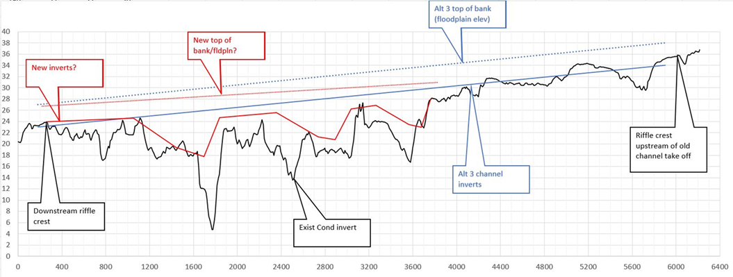 Figure 1.

We utilized a spread sheet model to begin to predict initial channel depths and when overbank flows would occur. Several iterations were performed using the recommended design discharge to ensure overbank and floodplain engagement. ArcGIS was then used to make changes to the Alternative 3 surface model and to develop the new Alternative 3 hybrid surface.

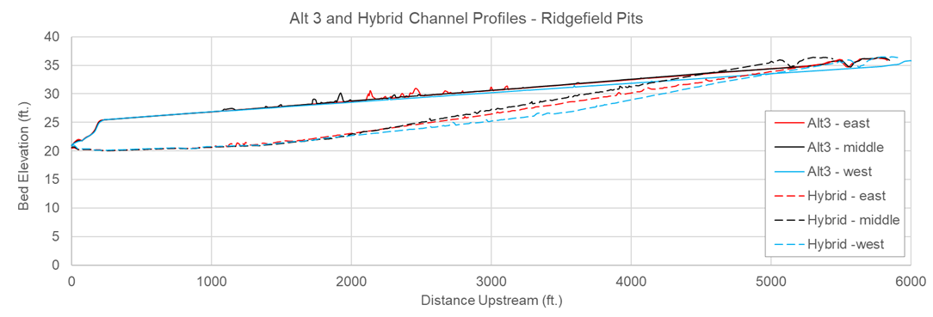 Figure 2.

The new Alternative 3 hybrid includes 2-3 dominant channels and eliminates several other channels and side-channels. The hybrid surface also leaves the developing bar above Pit 1, which includes wood accumulation and sediment suitable for spawning. The hybrid alternative also will preserve the cold water refuge areas at Pits 8 & 9 (closer to the Daybreak Pits). The current thought is to partially fill them to make them resemble the other adjacent beaver ponds as opposed to deep pits.

Keith has been running a series of low and high-water discharges through the hydraulic model. Depending on the results we may need to make slight adjustments to the hybrid surface before re-running the model. We anticipate having the results of the hybrid model in the next week or two. With that in mind, I am hoping to have the next meeting at the end of February/early March. The purpose of the meeting will be to go over the results of the hydraulic analysis.

What else???