
Request for Design-Build Proposals
Hamilton Creek
Final Design and Construction
Mandatory Pre-proposal Meeting: May 31, 2016 at 10:00 am
Proposal Submittal Deadline: June 14, 2016 at 4:00 pm

I. INTRODUCTION
The Lower Columbia Estuary Partnership (Estuary Partnership) requests proposals to review existing studies and designs, develop final design plans, provide technical support for project permitting, and construct the Upper Hamilton Creek Restoration Project – an aquatic habitat enhancement project located in the Columbia River Gorge near the town of North Bonneville, WA. The Estuary Partnership developed this Request for Proposals (RFP) because it seeks to work with a single engineering/construction team that will oversee a design‐build approach for the project. The Estuary Partnership is using a design‐build approach to enhance overall project cost efficiency through collaboration between the project team, design team, and implementation contractors. To emphasize and promote cost effectiveness, the Estuary Partnership seeks an engineering/construction team that will employ a progressive design‐build methodology to iteratively evaluate project implementation costs in coordination with design development.
The following is intended to be a full explanation of the Estuary Partnership’s request and evaluation of competitive sealed proposals.

II. ANTICIPATED SCHEDULE
Mandatory Pre-proposal Meeting: May 23, 2016 at 10:00 am
Proposal Question Period Closing: June 8, 2016 at 4:00 pm
Proposal Closing: June 15, 2016 at 4:00 pm
Opening of Proposals: June 15 at 4:00 pm (immediately after proposal closing)
Notice of Award: June 24, 2016
Contract Executed: July 5, 2016
Design Period: July 5, 2016 – September 28, 2016
Permitting Support: July 28, 2016 – May 30, 2017
Proposed in-water construction window: July 15, 2017 – September 15, 2017
Planting: October 1, 2017 – February 1, 2018

III. PRE-PROPOSAL MEETING AND SITE VISIT
A pre-proposal meeting will be held on May 23, 2016 from 10:00 am until approximately 1:00 pm. The meeting will start at the Chevron Station in North Bonneville, WA. It is mandatory that one member of each proposal team attend this meeting, which will include a site visit. The site visit will include hiking for approximately 1-mile over difficult terrain and, if conditions warrant, also include crossing Hamilton Creek. It is strongly advised that individuals bring waders or other appropriate gear.

IV. QUESTIONS AND ASSOCIATED RESPONSES/CLARIFICATIONS
Proposers shall direct all questions regarding this RFP to the Estuary Partnership’s Finance Manager, Tom Argent, via email: targent@estuarypartnership.org by 4:00 pm on Wednesday, June 1, 2016. Questions directed to other project team members, not submitted via email, or submitted after the question deadline will not be answered. Interpretations or clarifications considered necessary by the Estuary Partnership in response to such questions will be issued in writing and emailed to all parties. Only questions answered by a formal RFP amendment will be binding, i.e., written amendments are the only means for changes to this RFP. Oral comments, statements, instructions and other interpretations or clarifications made by the Estuary Partnership or other project partners will be without legal effect. Proposers shall acknowledge receipt of any amendments in their cover letter.

V. BACKGROUND
Hamilton Creek, which is part of the Lower Gorge Tributaries watershed, flows nine miles southeast from its headwaters before entering the Columbia River approximately three miles downstream of Bonneville Dam. The project site is within the Columbia River Gorge National Scenic Area (CRGSA) and is located near the town of North Bonneville, Washington. The project site includes Hamilton Creek, riparian buffers, and side-channel habitats and is located on U.S. Forest Service (USFS) property. The site is utilized by an array of Endangered Species Act (ESA) listed native fish and other native fauna. Specifically, two Lower Columbia Evolutionary Significant Units (ESUs) (coho and winter steelhead) are documented as using the site for spawning and rearing. Although sampling for lamprey has not occurred at the site, lamprey have been documented spawning and rearing in similar sites in the Columbia River Gorge. Other native species known to be on-site include red-legged frogs, sculpin, and American beaver.
Prior to settlement and landscape disturbances (e.g. fires) the Hamilton Basin was heavily forested. Prominent topographic features at the site included alluvial fans formed where Hamilton Creek emerged from the valley slope to the Columbia floodplain and where tributaries entered Hamilton Creek. Alluvial fan features along the Columbia floodplain are apparent in aerial photos from 1935. Primary disturbances include: timber harvest and associated activities (road building, land clearing) and railroad), construction of transportation corridors (Washington State Route 14 (SR-14), the BNSF Railroad), fires and housing development.
During the site assessment, the project team collected and reviewed extensive site data and identified the following limiting factors:
- Key habitat quantity is impaired:
  - Off-channel habitats during high-flow conditions are generally not available.
  - Pools (> 3 feet) with overhead cover for rearing/pre-spawn holding occur in low densities.
  - Structural diversity, particularly in the form of Large Woody Debris (LWD) that can provide cover and hydraulic refugia, occurs in very low densities.
- Key habitat diversity is impaired and suitable gravel patches for spawning/egg incubation occurs in very low frequencies.
- Riparian health is moderate to poor due primarily to heavy colonization by shrubs and deciduous trees that is inconsistent with the mid- to late-seral conifer plant communities that historically occurred in the riparian area at the site.
- Food web production and nutrient cycling is impaired by lack of organic materials (wood).
- Stream temperature may be moderately impaired by inadequate shade throughout the site.

VI. PROJECT OBJECTIVES AND GOALS
The Upper Hamilton Creek Restoration Project will address critical and declining fish resources in Hamilton Creek. Current production of naturally spawning salmonids is “far below historical numbers” (LCR Subbasin Plan, Lower Columbia River Fish Recovery Board). The overall objective of this project is to address degraded instream and riparian conditions by developing management actions that balance ecological enhancement, i.e., addressing the limiting factors identified above. The project will place LWD structures and plant conifers along a 1- mile section of Hamilton Creek. The LWD will be strategically placed to address limiting factors, primarily improvement of rearing and holding habitat, creation of spawning habitat and high-flow and off-channel refugia through activation of side channel habitat. The plantings would re-establish the conifer component of the site’s riparian forests, which was lost due to timber harvest and wildfires. Reestablishment of native conifers has been patchy within the riparian zones. New conifers will provide critical functions, such as shade and a source of long-term LWD recruitment to the creek. Specific project objectives include:
1) Beneficial sediments: increase the quantity, quality, and spatial diversity of suitable spawning substrate by installing LWD jams that promote well sorted gravel patches.
2) Low-flow rearing habitat for Lower Columbia River coho and steelhead: increase the amount of pools and depth of scour pools to a residual depth > 3.0 feet through LWD placement.
3) High-flow rearing habitat for Lower Columbia River coho and steelhead: install LWD jams in low gradient reaches that have the potential to provide high-flow rearing habitat, particularly in association with deep pools (>3.3 feet) and two side channels that could be activated at a greater range of flows.
4) Riparian function: reestablish a self-sustaining riparian zone consistent with a mid-seral hemlock, fir, and cedar plant community. Create a self-sustaining native riparian zone that is at least 200 feet wide (100 feet on each side of the creek) to provide LWD recruitment, shade, and organic inputs.
5) Food production: increase the prey base for juvenile salmonids by planting riparian buffers with native trees to increases organic inputs critical to food production.

VII. SITE DESCRIPTION
The project will take place on USFS property along a 1-mile section of Hamilton Creek upstream of the Bonneville Power Administration (BPA) powerlines (Attachment 1: Figure 1). The lower boundary of project is within the historic alluvial fan (Attachment 1: Figure 2) and the upper boundary stretches upstream into the canyon section above Cedar Creek (Attachment 1: Figure 3). There is a decommissioned road that parallels the alluvial fan section and ends approximately 400 feet into the canyon section. The canyon section is remote and there is limited/no access for ground equipment to this area. Within the active channel and streambanks both the alluvial and canyon sections are largely comprised of bedrock, steep valley walls, clays and consolidated soils and large boulders. Due to these factors and the lack of a road, travel is difficult in the canyon section. These factors will contribute to challenges during the construction phase.

The Estuary Partnership has identified restoration actions within the 1-mile section and led development of a preliminary design report and engineering drawings (Attachments 2 & 3). The primary restoration project action is to install approximately 200 pieces of LWD using an engineered log jam approach along Hamilton Creek to influence physical processes and to improve ecological conditions. The second restoration project action is to plant conifers over 30 acres to help restore the native plant community within the riparian zone. Wood harvesting, construction activities, and the project schedule will occur under regulations for spotted owl habitat as part of the Aquatic Restoration Biological Opinion (ARBO, U.S. Fish & Wildlife Service).

VIII. RELEVANT EXISTING INFORMATION
The Estuary Partnership completed a Preliminary Design Report in 2014. The design report includes a feasibility investigation, alternatives analysis and preliminary design plans. In addition to the preliminary design report and plans, the Estuary Partnership updated potential planting locations. These documents and other applicable information are listed below.
- Preliminary Design Report (Attachment 2)
- Preliminary Design Plan Set (Attachment 3)
- Updated Planting Locations (Attachment 7)
The Preliminary Design Report and Design Plan Set are attached to this RFP.

IX. ESTUARY PARTNERSHIP RESPONSIBILITIES
The Estuary Partnership will be responsible for the following work during the Project (subject to modification based on negotiations with the selected engineering/construction team):
- Coordinate project activities and necessary approvals with the USFS.
- Provide all background information available for the project, including GIS shapefiles.
- Help collect topographic survey data.
- Provide existing available data including 30% design and CADD drawings and 30% design report.
- Conduct sediment budget analysis.
- Review and provide feedback on project designs (60% level of design) prior to submittal of permit applications.
- Prepare and submit all required permit applications, including, but not limited to, the following:
  - Section 404 of the Clean Water Act (including the wetland delineation)
  - SEPA Permit
  - Washington Removal/Fill Regulations
  - Hydraulic Permit Application
  - Endangered Species Act
  - Columbia River Gorge National Scenic Area Act
  - National Environmental Policy Act
  - Grading and Erosion Control
  - Floodplain Development
Note: The engineering/construction team will provide the Estuary Partnership with the technical/design information necessary to complete these applications and reviews.
- Provide all aspects of fish salvage/isolation during construction.
- Assist with construction oversight.
- Assist with identification of stockpiling/decking areas for wood at project site.
- Review planting plan.
- Provide all post-construction reporting to grant funders and regulatory agencies.

X. ANTICIPATED STATEMENT OF WORK
The statement of work includes review and analysis of the 30% design report and design plans, development of final (60%) design plans and report, permitting support, and construction. This statement of work will be executed via the sample contract provided as Attachment 4. The anticipated contract period will be July 2016 – March 2018. The Contractor shall implement the statement of work in accordance with the project goals and objectives outlined in Section VI.

The anticipated design and construction elements of the project include:

Task 1. Prepare 60% Design Plans, Design Report, and Cost Estimate
- Contractor shall review and assess all components of the 30% design plans and report (Attachments 2 and 3). Contractor shall provide a brief written summary of recommendations for developing the 60% design plans in light of available materials, access constraints, project objectives, equipment constraints, and river energy and sediment dynamics.
- Survey – The Contractor shall conduct a topographic survey within the project area to assist in 60% designs and to prepare engineering drawings.
- Hydraulics – The Contractor shall perform hydraulic analysis to determine effects of restoration actions on water surface elevations in the project area and risks to downstream infrastructure.
- Existing infrastructure – The Contractor shall determine locations of existing surface and subsurface infrastructure and incorporate into those locations into project designs.
- Construction plans – The Contractor shall prepare and submit a Draft Design Plan, and then incorporate Estuary Partnership comments and submit a Final Design Plan. The Draft and Final Design Plans (60% level of design) shall include the following project elements:
  - LWD structures – including locations, configurations, and quantities for logs and snags, as well as cabling, and anchoring methods;
  - Grading plans and excavation quantities;
  - Site access, staging areas, dewatering, erosion and sediment control, and materials disposal
  - Materials volumes and specifications;
  - Construction timing and duration;
  - Tax lot boundaries, Ordinary High Water, 100-year floodplain, and other details required for project permitting.
- The Contractor shall develop draft and final cost estimates.
- The Contractor shall develop a Draft Design Report, and then incorporate Estuary Partnership comments into a Final Design Report. The Final Design Report shall include the the basis of design criteria for project elements.
- Permitting support – The Contractor shall provide technical information required for the Estuary Partnership to complete and submit project permit applications.

The Estuary Partnership will provide one staff person for two-days to help the Contractor with topographic surveying. The Estuary Partnership will coordinate and summarize stakeholder comments on the draft and final plans. The Estuary Partnership will provide electronic versions of all project materials, including, but not limited to, preliminary design report and CAD drawings.

Schedule: July 5 2016 – November 28, 2016.
Deliverables: A memorandum detailing recommendations for developing the 60% design plans. Draft and final versions of 60% Design Plans, Design Report, and cost estimates. The Estuary Partnership will provide one round of edits/comments to the draft Design Plans and one round of edits/comments to the Draft Design Report before the plans and report are finalized.
Deliverables Due: Memorandum due July 19, 2016. The Draft Design Plans are due August 22, 2016. The Final Design Plans are due September 22, 2016. The Draft Design Report is due October 24. The Final Design Report is due November 28, 2016.
Task 2. Construction
    - Equipment/Operators/Materials: Contractor shall provide all equipment, operators, and materials (except provided materials outlined above and in Attachment 5) to implement the project as designed and specified, including, but not limited to, mobilization, access, control of water, erosion control, site security, implementation, and site reclamation. Site assistance by a ground crew, including hand manipulation or excavator placed logs will be necessary. Project construction elements are detailed below as Part of Task 3. Additional information related to general construction, equipment and LWD construction can be found in Attachments 5 and 6.
    - Wood Quantities and Locations: The project will use 205 pieces of wood. Of the 205 pieces, the Contractor will harvest 105 on-site from three different areas (Areas 1-3). The Contractor will transport 100 trees from Area 4, an off-site location near Wyeth, Oregon. The four areas have been mapped and can be found in Attachment 5 (Figures 1-3). The wood at Areas 2 and Area 3 will be marked prior to construction by the USFS. The location of wood, estimated physical properties of the wood and other important information is provided below in Table 1
Table 1. Wood quantities and estimated physical characteristics for Areas 1-4. Note: Only the “existing wood” in Area 4 has been harvested. The rest of the wood will be harvested from Herman Creek and moved to Area 4 by the USFS as part of this project.

c. Site Access: Contractor shall improve the existing decommissioned road to allow access to the project site. The Contractors improvements will include removing a barrier at the entrance to the decommissioned road, and selectively removing large rocks, alders and shrubs as necessary to allow equipment access. The Contractor shall side-cast any brushed material to allow equipment access. The Contractor shall re-install the constructed barrier upon completion of the project or as otherwise directed by the USFS.
d. Off-Site Wood Transport and Stockpiling: Contractor shall transport 100 pieces of wood from Area 4, located approximately 10 miles away near Wyeth, Oregon, and stockpile the wood at the project site. The Estuary Partnership will specify stockpile locations before the wood is moved. Likely stockpile locations include Area 1 and several sites within the active stream channel. If required, the Contractor shall seek and receive approval from the Estuary Partnership for one additional wood stockpile location. The Contractor shall receive approval and flag the area prior to any ground disturbances or wood stockpiling.
e. On-Site Wood Harvest and Decking: The Contractor shall harvest 65 pieces of wood from Areas 1 and 2 and 40 pieces of wood from Area 3. All wood to be harvested will be marked prior to harvest. The Contractor shall harvest wood as best as possible to retain all limbs and branches. The Contractor shall deck wood in a way that does not require additional clearing of standing timber. The Contractor shall cut wood and pull trees over in ways that keep the rootwads intact. The Contractor shall retain the number of rootwads as outlined in Table 2 below. Contractor shall provide up to three shovel trails (50-150 feet long) that will be used to transport harvested wood and decked wood from Areas 1 and 2 to the creek.
Table 2. Wood totals, number of rootwads, standing length and wood locations.

f. LWD Structures: Contractor shall construct approximately 25 LWD structures of varying sizes at distinct locations (see Attachments 2 and 3). The Contractor shall utilize appropriate LWD installation methods appropriate to the site. Installation methods may include streambank, bar jam and apex jam approaches. The Contractor shall design and construct all the log structures to remain stable during large flood events. The Contractor shall anchor each structure and use the best anchoring method based on location, availability of materials and permitting requirements. Anchoring methods shall include burying wood were feasible below the streambed, trenching wood into the stream banks, or anchoring the wood using other methods as outlined in the design plans (Attachment 2). The Contractor shall consider the quantities outlined in Table 2 for number of rootwads to be minimum criteria.
- LWD Specifications – The Contractor shall use largest wood as key/anchor pieces and the smaller wood pieces for support. Wood in the LWD structures shall have a minimum length of 45-50 feet. The Contractor shall use approximately 7 to 12 pieces of wood per structure depending on the structure type and location. In addition, Contractor shall consider employing channel spanning structures when feasible.
- LWD Locations – Contractor shall ensure that the wood structures will be strategically located within the 1-mile project area to accomplish restoration objectives. Contractor shall retain LWD features located at two side-channels as well as within the alluvial fan and canyon sections. The Contractor shall construct most of the structures along the edges of the current stream channel or in the middle of the channel. The Contractor shall receive Estuary Partnership approval to any changes to the location or number of wood structures prior to construction.
g. Contractor shall manage and oversee all construction activities to complete the project and shall coordinate construction activities with the Estuary Partnership’s Principal Restoration Ecologist and, as necessary, USFS staff.
h. Post-Construction Reporting: Contractor shall review the Estuary Partnership’s post-construction report and provide written comments. Contractor also shall submit electronic copies of all photos taken during construction.

Estuary Partnership will lead all elements of fish salvage and author and submit all post-construction reporting. Estuary Partnership will provide assistance with construction oversight.
Schedule: July 15, 2017 – September 15, 2017. Contactor may mobilize equipment and materials on-site no earlier than July 15, 2017. Contractor shall complete all in-water work between July 15, 2017 and September 15, 2017. Permitting support to take place from July 28, 2016 – May 30, 2017.

Deliverables: Construction of the project, as detailed in 60% plan set.
Deliverables Due: In-water construction completed by September 15, 2017.

Task 3. Planting within Riparian Corridor
- The Contractor shall plant approximately 9,000 plants using a mix of native, coniferous species (western red cedar, western hemlock, and grand fir) on both sides of the creek using container plants. The Contractor shall provide large container plants greater than 24 inches tall above the root crown, with well-developed roots. Contractor shall be responsible for transporting plant material from an approved source location. The Contractor shall install the plants at locations in the Upper Hamilton Creek Restoration Project site. Specifically, the Contractor shall install plants within the 30-acre Contractor Planting area, as described below or as otherwise directed by the Estuary Partnership. The Contractor will not need to provide site preparation or weed management prior to planting. The Contractor shall complete the majority of the planting above Cedar Creek in the canyon section. Planting areas and required plant species are in the design report and design drawings (Attachment 2 and 3). Note: The Estuary Partnership has updated potential planting locations above Cedar Creek. This updated planting information can be found in Attachment 7.
- Acquire Native Plants
- The Contractor shall provide all plant material for this task according to the plant list in the design drawings.
- The Contractor shall ensure all plant material comes from local genetic sources. Local genetic source refers to the specific location of seed or plant material collected from wild populations of native plants that are genetically appropriate for planting at the site.
- Contractor is responsible for inspecting plants upon pickup to verify plants are in good health. The Contractor may substitute alternative species/stock only with prior approval from the Estuary Partnership. The Contractor shall provide an itemized invoice for all plants purchased to the Estuary Partnership within two weeks of plant purchase.
- Install Native Plants
- The Contractor shall store and transport plants to the project site. The Contractor shall protect all plant material from loss, destruction or damage of any kind, including physical injury, freezing, heating or drying. Contractor shall be responsible for all loss, destruction or damage to plant material that occurs from the time Contractor takes possession of the plant material until the plant material is planted.
- The Contractor shall carry plants by their containers to project site without damaging stems or leaves. Contractor shall not prune roots or stems.
- The Contractor shall plant container plants at various densities that are consistent with site conditions.
- The Contractor shall prepare a planting hole that is twice as wide and the same depth as the plant root ball. If root bound, Contractor shall break up roots and eliminate any circling roots prior to planting. Each plant shall be set firmly in the ground, with moist soil filled in and placed firmly around the roots.
- The Contractor shall plant during a time when there is a high likelihood that the plants will not be subjected to prolonged periods of heat stress or dry conditions. Contractor shall plant after construction has been completed and will submit the proposed planting locations to the Estuary Partnership prior to planting.
- The Estuary Partnership may suspend planting work if Estuary Partnership determines that weather conditions could damage plant material even if the material is handled in accordance with this Contract. Estuary Partnership may also suspend planting work at any time if Estuary Partnership determines that Contractor is not handling plants or planting in

Schedule: October 1, 2017 - February 1, 2018.
Deliverables: Plants (species, type, size, and number) as described in this Task and the design report and drawings. An inventory of all plant species, the location of their genetic source, and an itemized invoice of plant purchase. A one page narrative summary report of where and when the plants were installed.
Deliverables Due: Purchase native plants by November 15, 2017. Install native plants by February 1, 2018.

XI. SPECIAL REQUIREMENTS

1. FURNISHED MATERIALS
The USFS will supply the contractor with the logs for harvest and transport identified in the scope of work.

2. EMERGENCY & FIRE CONTROL
- Immediately extinguish without expense to the Government all fires on or in the vicinity of the project which are caused by the Contractor's employees, whether set directly or indirectly as a result of construction operations, with or without direction by the USFS. The Contractor may be held liable for all damages and costs of additional labor, subsistence, equipment, supplies, and transportation deemed necessary by the Government resulting from fires set or caused by Contractor's employees or resulting from construction operations.
- Contractor's Responsibility for Controlling Other Emergencies: When requested by the Contracting Officer, the Contractor shall allow the Forest Service to temporarily use employees and equipment for emergency control work. USFS payment will be made at not less than the current area rate established by the USFS.
- The Contractor shall properly install and constantly maintain in serviceable condition all exhaust equipment described in this Subsection, including spark arresters and mufflers.
- The Contractor shall equip each unit of mobile or stationary power equipment, including trucks, with one shovel, and at least one fire extinguisher meeting one of the following specifications:
1. 2-1/2 pound size or larger dry chemical type.
2. 4-pound size or larger carbon dioxide type.
3. The Contractor shall test or check each extinguisher for proper functioning prior to the beginning of fire precautionary period.
- The Contractor shall provide each gasoline power saw with one chemical-pressurized fire extinguisher of not less than 8-ounce capacity by weight. The Contractor shall maintain the extinguisher in good working order at all times.

3. CONDITIONS OF WORK
Additional conditions of work are outlined in Attachment 8 related to: general requirements, equipment, access, sanitation requirements, additional fire protection measures and other requirements.

XII. PROPOSAL REQUIREMENTS
Proposals shall adhere to the following outline and include all information detailed below. Proposals also shall strictly adhere to the prescribed page limits. One page equals one side of a single piece of paper. Failure to submit any of the required information or adhere to the page limits will render the proposal non-conforming, and the proposal will be rejected. Note: In order for a proposal to be considered, it must include proposed construction costs for the project design presented in the 30% plan set.
- Project Team, Qualifications, and References (10 pages maximum)
  - Project Team (one-page narrative, six pages maximum including resumes)
- Identify lead design firm and lead construction firm.
- Design firm project manager and lead technical staff (maximum of three individuals). Include hourly billing rates and availability.
- Construction contractor project manager and lead staff (maximum of two individuals).
- Lead contractor’s Washington Construction Contractors Board license number.
- List of all subcontractors and services provided.
- Discuss the participation of minority, women owned and emerging small businesses in the Proposal
- Include one-page resumes for no more than five personnel.
  - Qualifications (three pages narrative)
- Description of lead design firm and lead construction contractor qualifications and experience.
- Brief profiles of key staff not included above.
- History of project team working together on similar projects.
- Team experience with innovative LWD design and construction.
- Team experience with stream restoration design and construction, particularly in challenging environments, including canyons and in close proximity to powerlines.
  - References (one page total)
- Three client references for similar projects completed within the past five years. For each reference, please include client contact information and project details (name, location, brief description, etc.). References for the project team as a design/build unit are preferred, but not required.

- Project Approach (three pages narrative)
Narrative detailing the following:
- Approach to restoration design and construction, including, but not limited to, the following:
  - Understanding ecosystem processes and developing restoration designs that work in concert with those processes and project objectives.
  - Placing LWD in remote, difficult to reach environments.
  - Understanding and developing restoration approaches that limit construction disturbances to the site.
  - Tailoring designs to the site and to downstream safety concerns.
- Proposed approach to each element of the statement of work. Briefly describe how the work will be broken down among your team. Define subtasks as necessary.
- Proposed revisions or additions to the statement of work and/or design. Proposers are encouraged to propose alternative design and construction methods they think will increase the likelihood of the project meeting the stated objectives, increase cost-effectiveness, or otherwise benefit the project.
- Construction approach.
- Approach to identifying opportunities to realize cost savings through the design, budgeting, and construction process. Identify how the construction process could be adaptively managed to capitalize on cost-savings and convert them to added on-the-ground restoration.
- Budget (two pages total (one page tabular budget; one page narrative))
- Provide a budget for each element of the statement of work using the MS Excel spreadsheet provided. All project costs must be included in the spreadsheet.
- Provide a brief narrative for each budget item.
- Schedule (one page)
- Narrative detailing the project team’s ability to meet the proposed schedule, particularly completing all design elements by October 28, 2016 and all in-water construction by September 15, 2017.
- Provide additional narrative detailing the availability of key personnel during the proposed schedule.
- Additional materials (one page)
- The proposer shall attach a cover letter, not to exceed one page in length. The cover letter must be signed by an authorized representative of both the engineering and construction firms. The cover letter also shall contain an acknowledgement of receipt of all amendments, the numbers of which must be written on the cover letter.
- No additional materials should be submitted with the proposal. The project team will review only the materials identified above and will not consider additional materials in their evaluation.

XIII. ANTICIPATED BUDGET
Based on existing information (including the 30% plan set), the Estuary Partnership anticipates final design and construction costs to be $271,183.

XIV. PROPOSER’S RESPONSIBILITIES
It is the responsibility of each proposer before submitting a proposal to:
- Examine and carefully study the RFP and other related data identified in the RFP;
- Visit the site to become familiar with and satisfy proposer as to the general, local, and site conditions that may affect cost, progress, performance, or furnishing of the work;
- Become familiar with all federal, state, and local laws and regulations that may affect cost, progress, performance, or furnishing of the work;
- Study and carefully correlate proposer’s knowledge and observations with the RFP and other related data; and,
- Promptly notify the Estuary Partnership of all conflicts, errors, ambiguities, or discrepancies that proposer has discovered in the RFP.
By submitting a proposal, proposer confirms that he/she has completed the above. Neither the Estuary Partnership, the USFS, nor any project partner assumes any responsibility for errors or misinterpretations resulting from use of the RFP or associated documents.

XV. PROPOSAL SUBMITTAL, DEADLINE, AND REVIEW
Proposals shall be submitted electronically, as a single PDF file, attached to an e-mail message sent to Tom Argent at targent@estuarypartnership.org. Proposals must be received no later than June 14 at 4:00 pm; proposals received after this date/time will not be considered. The Estuary Partnership will provide an email confirmation receipt for all submittals received prior to the deadline. All proposals are firm, binding, and irrevocable for thirty (30) days after opening of the proposal.
Proposals will be reviewed immediately after the submittal deadline. Proposals will not be considered if they fail to contain any documentation required by the instructions and materials herein. The Finance Manager will notify all proposers of the Estuary Partnership’s decision on or before June 17, 2016.

XVI. SELECTION PROCESS
Proposals will be reviewed by the project team, including representatives from the Estuary Partnership and the USFS. The selection team will consider the following criteria in their evaluation of proposals:
- Qualifications
  - Design and construction experience relevant to the project in scope, scale, location, and setting. Particular attention will be given to experience designing and constructing LWD structures in remote areas.
  - Experience and design philosophy of the project manager and key staff.
  - Experience working together as a design/build team.
  - References. Evidence of good working relationship and flexibility between project team and clients
- Project approach
  - Approach to working in concert with predominate ecosystem processes including locating LWD structures within hydro-geomorphic framework.
  - Approach to addressing safety concerns and risk factors.
  - Process for reviewing existing project documents and proposing modifications.
  - Approach to design/build process and clarity of proposed deliverables (including proposed approach to working with project team to control costs throughout the design process).
  - Alternative designs/approaches proposed.
  - Approach to construction, including approach to controlling costs and converting savings to added on-the-ground work.
- Cost/Budget
  - Cost for each task.
  - Proposed approach for realizing cost efficiencies through the design-build process and translating them to additional on-the-ground work.
  - Ability to provide all scoped services within the proposed budget.
- Schedule/Availability
  - Ability and commitment to provide all scoped services within the design and construction schedules outlined.
  - Availability of key project personnel.
- Proposal presentation
- The participation of minority, women owned and emerging small businesses in the Proposal.

During its evaluation, the Estuary Partnership reserves the right to contact references related to past performance of similar services. The Estuary Partnership also reserves the right to accept or reject any and all of the proposals received as a result of this RFP, including without limitation non-conforming, non-responsive, unbalanced, or conditional proposals. The Estuary Partnership further reserves the right to reject the proposal of any proposer whom it finds, after reasonable inquiry and evaluation, to be non-responsible. The Estuary Partnership may also reject the proposal of any proposer if the Estuary Partnership believes that it would not be in the best interest of the project to make an award to that proposer. The Estuary Partnership also reserves the right to request the selected proposer negotiate and submit a revised statement of work, proposal, and cost estimate.
The Estuary Partnership is not obligated to pay any costs incurred by proposers in responding to this RFP.

XVII. ATTACHMENTS
- Location Map & Photos
- 30% Design Drawings
- 30% Design Report
- Sample Contract
- Wood Collection & Transport, Locations and Photos
- LWD Construction & Equipment Details
- Updated Planting Areas
- U.S. Forest Service (USFS) conditions of work

Attachment 1: Location Map and Photos

Figure 1. Location Map.
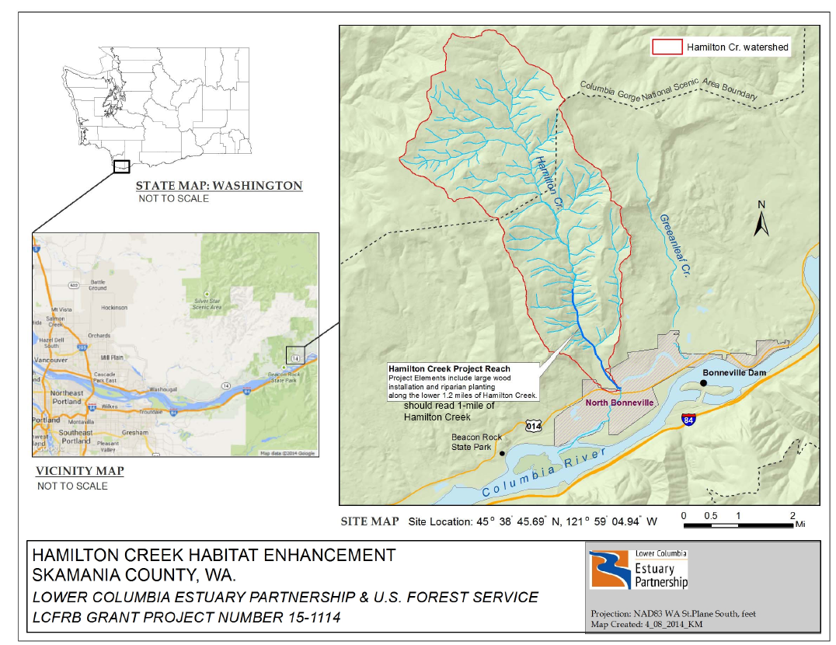
Cedar Creek
Figure 2. Alluvial Fan Section Photos: Photos A-C show typical site conditions within the alluvial fan section of the site where wood placement will occur. The alluvial fan section begins above the BPA powerlines and ends at Cedar Creek. Photo A shows typical flow conditions along Hamilton Creek during late winter. Photo B shows typical conditions during late spring and Photo C shows typical summer conditions. Water depths during the summer construction period will be similar to Photo C. Summer water depths typically range from a few inches to 3-feet in the deeper pools.
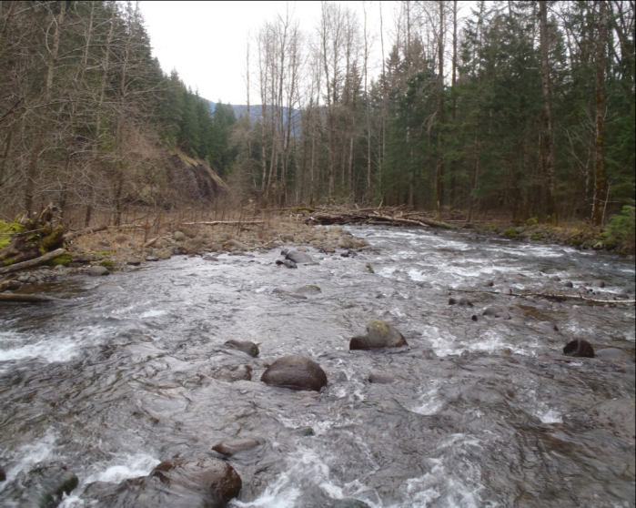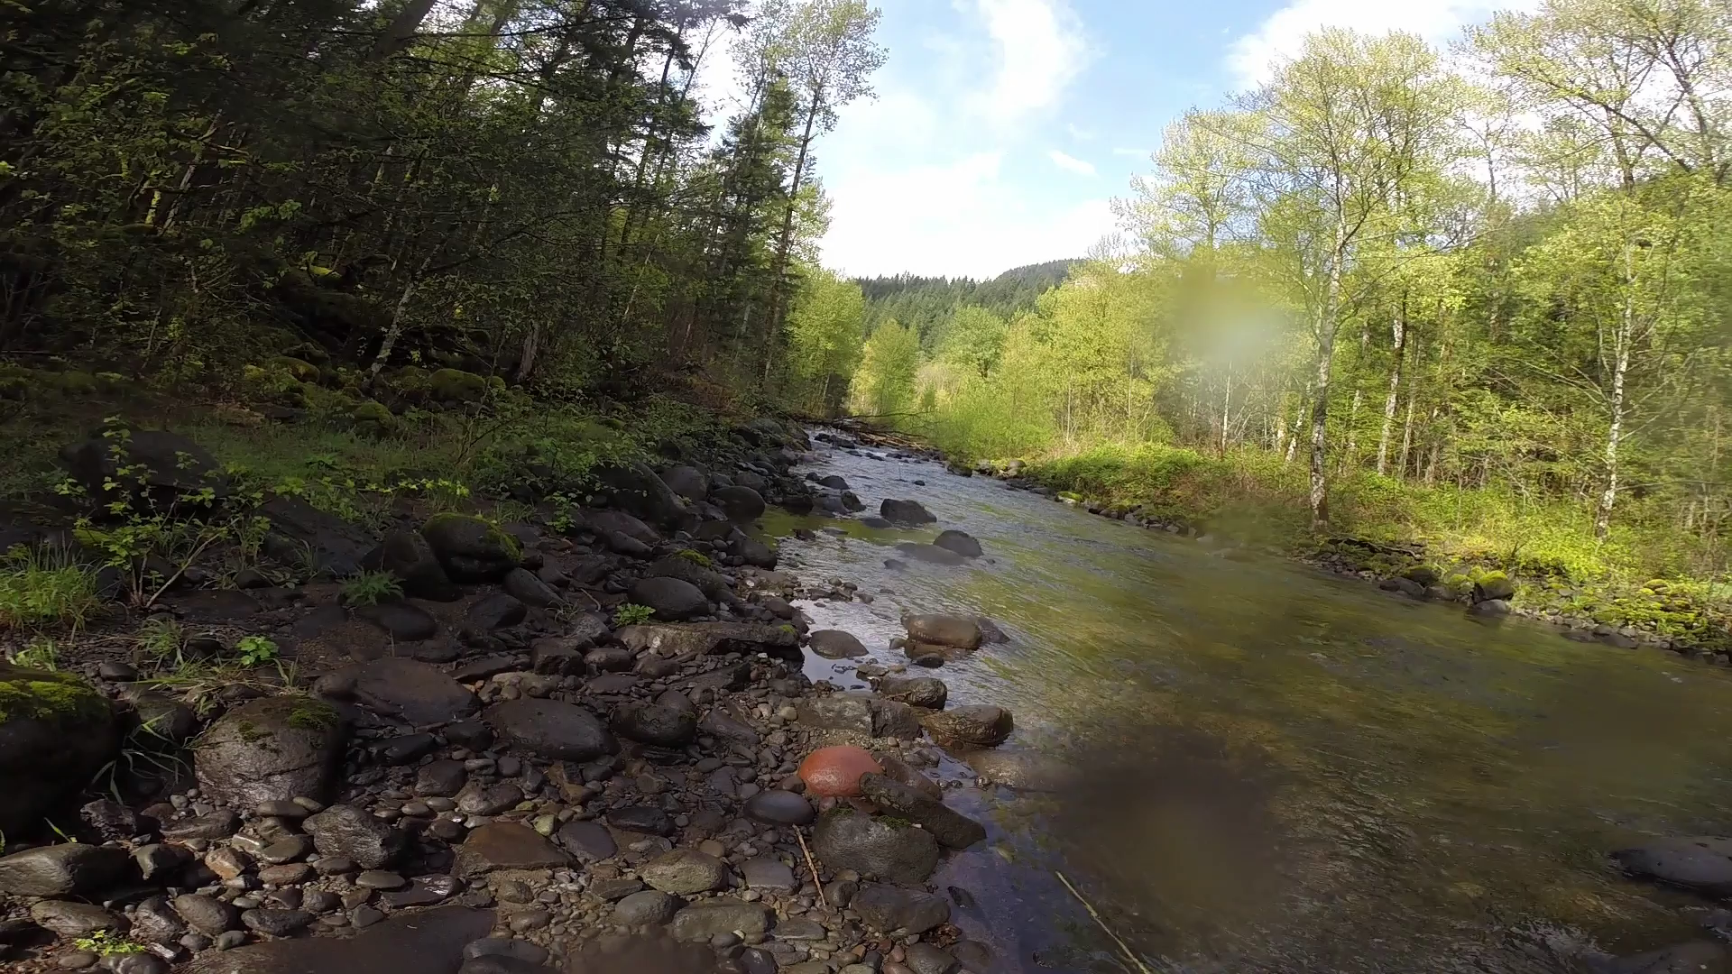
B
A
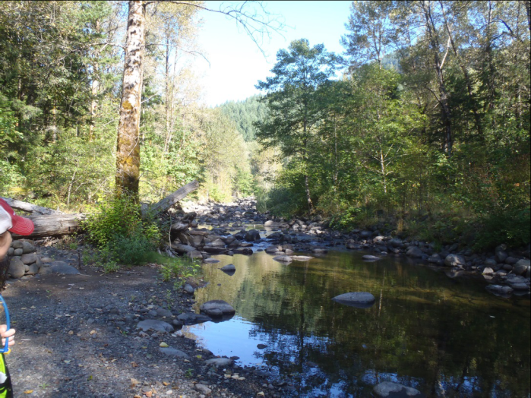
C

Figure 3. Canyon Section Photos: Photos D-F show typical site conditions within the canyon section of the site where wood placement will occur. The canyon section begins approximately around Cedar Creek and continues approximately 4 miles upstream. Photo D represents conditions in late spring at a side-channel site. Photos E and F represent typical summer conditions along the mainstem. Water depths during the summer construction period will be similar to Photo F. Summer water depths typically range from a few inches to 3-feet in the deeper pools.
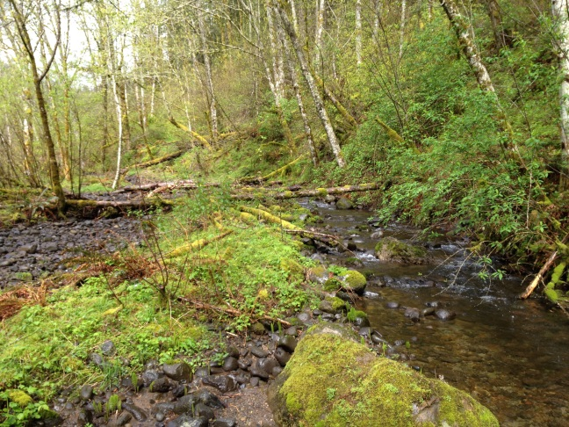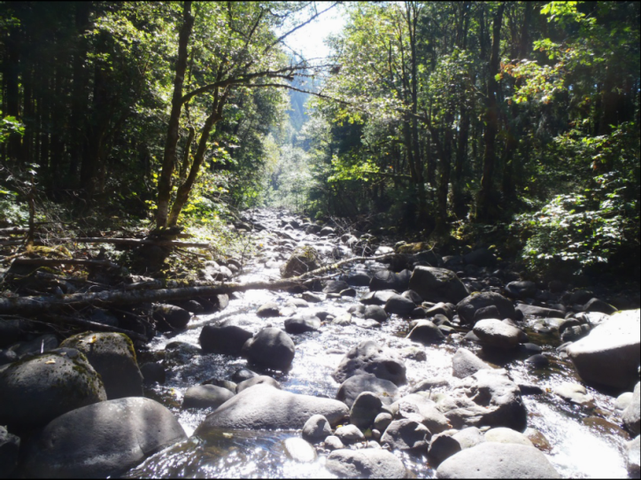
D
E
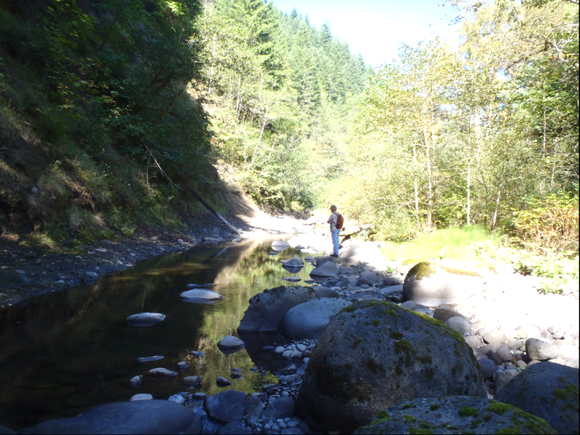
F

Attachment 2 – 30% Design Drawings Upper Hamilton Creek

Insert .pdf of 30% design drawings

Attachment 3 – 30% Design Report Upper Hamilton Creek

Insert .pdf of 30% design report
Attachment 4 – Sample Contract
The Contract template below and Exhibits A-F represent elements of a sample contract.

CONTRACT No. xx-20xx
CONTRACTOR  (“Contractor”) | Lower Columbia Estuary Partnership  (“Estuary Partnership”)
Organization:  Project Officer:  Title:  Address:  Phone: Fax:  E-mail:  Citizenship, if applicable:  Non-resident alien [ ] Yes [ ] No  Business Designation (check one):  [ ] Corporation [ ] Partnership [ ] Limited Partnership [ ] Limited Liability Company  [ ] Limited Liability Partnership  [ ] Sole Proprietorship [ ] Other  Tax ID# ________________________  Certified Minority, Women or Emerging Small Business Firm? [ ] No [ ] Yes  Number: ___________ | Project Officer: Debrah Marriott  Title: Executive Director  Address: Lower Columbia Estuary Partnership  811 SW Naito Parkway, Suite 410  Portland, OR 97204  Phone: (503) 226-1565 x227 Fax: (503) 226-1580  E-mail: dmarriott@estuarypartnership.org  Finance Manager: Tom Argent  Phone: (503) 226-1565 x242
This Contract is between the Lower Columbia River Estuary Partnership (“Estuary Partnership”), an Oregon nonprofit corporation, and ______________________ (“Contractor”).

Terms & Conditions

- Effective Date and Duration. This Contract shall become effective on the date it has been signed by Estuary Partnership. Unless terminated or extended, this Contract shall expire when Estuary Partnership accepts Contractor's completed performance. Expiration or termination shall not extinguish or prejudice Estuary Partnership’s right to enforce this Contract with respect to any breach of a Contractor warranty or any default or defect in Contractor performance that has not been cured.

- Statement of Work. The Statement of Work (the “Work”), including the delivery schedule for such Work, is contained in Exhibit A. Contractor agrees to perform the Work in accordance with this Contract.

- Damages for Delay. Owner and Contactor recognize that time is of the essence for this Contract and that Estuary Partnership will suffer financial loss if the Work is not completed within the times specified in Exhibit A. Contractor shall pay to Estuary Partnership liquidated damages in the amount of $250.00 (two hundred fifty dollars) per day for every day after Sept 15, 2017 that the Work is not completed and ready for final payment.

- Contract Documents. This Contract includes the attached Exhibits A through F, each of which is incorporated by this reference.

- Contractor’s Representations

Contractor has examined and carefully studied the Request for Proposal (RFP) and other related data identified in the RFP documents.

Contractor has visited the site and become familiar with and is satisfied as to the general, local, and site conditions that may affect cost, progress, and performance of the Work.

Contractor is familiar with and is satisfied as to all federal, state, and local laws and regulatory permit conditions and other miscellaneous conditions of work that may affect cost, progress, and performance of the Work.

Contractor is aware that funding for this project is provided by a variety of funders, and that such funders may impose certain employment and contracting requirements on contractors and subcontractors benefitting from these funds. Contractor agrees to abide by these and all other applicable laws, regulations, and procedures, and to require its subcontractors, if any, to abide by these laws, regulations, and procedures.

Contractor agrees to employ or otherwise hire only persons eligible to work in the United States and to comply with prevailing wage rates, as required by federal and/or state law. Further, Contractor agrees that it shall complete “Indemnity Agreement for Third Party Contractors” as a requirement for entering into this Agreement. Contractor agrees that it shall complete this form on the same day it signs this Agreement.

Contractor has obtained and carefully studied (or assumes responsibility for having done so) all examinations, investigations, explorations, tests, studies, and data concerning conditions (surface, subsurface, and Underground Facilities) at or contiguous to the Site that may affect cost, progress, or performance of the Work or that relate to any aspect of the means, methods, techniques, sequences, and procedures of construction to be employed by Contractor.

Contractor has correlated the information known to Contractor, information and observations obtained from visits to the site, reports and drawings identified in the RFP, and all additional examinations, investigations, explorations, tests, studies, and data with the RFP.

Contractor has given Estuary Partnership written notice of all conflicts, errors, ambiguities, or discrepancies that Contractor has discovered in the RFP, if any, and the written resolution thereof by Estuary Partnership is acceptable to Contractor.

- Amendments. No Term or Condition of this Contract, including the Work, shall be amended without review and written consent by Estuary Partnership. Such amendment shall be made through a formal written amendment, executed by both parties prior to the amendment being implemented.
There may be a one-time budget adjustment of less than 10% of Project Total, set forth in Exhibit B, per contract period, provided that Estuary Partnership receives documentation of and approves in writing the change prior to the adjustment. For consideration, Contractor’s written request for change or amendment must be received by Estuary Partnership at least thirty (30) calendar days before the task deliverable or final report is due as set forth in the Statement of Work.

- Payments and Consideration.
  - Estuary Partnership agrees to pay Contractor as stipulated in Exhibits A and B for accomplishing the Work.
  - Invoicing. For review and approval by Estuary Partnership, Contractor shall submit an invoice not more often than every fifteen (15) days. It shall itemize and explain all expenses for which reimbursement is claimed pursuant to Exhibits A and B, including itemization of any cost share expended. Invoices must be submitted within 30 days after the completion of the work being billed. Each invoice shall include:
    - Name, mailing address and phone number of Contractor
    - Estuary Partnership contract number, invoice date and number
    - Performance period
    - Itemized expenses by task and budget line (including units and unit cost, where applicable) as prescribed in Exhibit A and Exhibit B
    - Contract financial summary outlining the total amount of the approved contract budget, accumulative funds requested and the funds remaining in this Contract at the time the invoice is submitted
Contractor shall send invoices and all deliverables to the Finance Manager, Lower Columbia Estuary Partnership, 811 SW Naito Parkway, Suite 410, Portland, OR 97204.

  - Disbursement. If Estuary Partnership finds the invoice documentation is in accordance with requirements of this Contract and if Estuary Partnership accepts the completed work, Estuary Partnership shall disburse the payment to Contractor within forty-five (45) calendar days of acceptance. If Estuary Partnership determines that Contractor modified the Work without prior written approval or if the Work is otherwise unacceptable in Estuary Partnership’s reasonable judgment, Estuary Partnership is not be obligated to disburse the payment. If Estuary Partnership elects not to disburse the payment, Estuary Partnership shall notify Contractor in writing of the reason for nonpayment. Estuary Partnership may allow Contractor a reasonable time to address Estuary Partnership’s reason for nonpayment, and to resubmit a new invoice.

  - Excess or Untimely Invoices. Contractor shall not submit invoices for, and Estuary Partnership shall not pay, any amount in excess of the Maximum Award defined in Exhibit A and B. If Estuary Partnership increases the Maximum Award by amendment, the amendment must be fully effective before Contractor performs work subject to the amendment. No payment shall be made for activities performed before the Begin Date or after the End Date, regardless of the relationship of the activity performed to this Contract.

- Reports. Contractor shall prepare and submit a final report in accordance with Statement of Work. Contractor agrees to use recycled paper for all reports prepared in accordance with the Statement of Work and to print documents on both sides of paper, unless otherwise stipulated.

- Publicity, Release of Information and Work Citation. Contractor shall not hold press conferences, issue press releases, or otherwise make public statements regarding this Contract or the Work, release reports or make presentations without prior review and written approval from Estuary Partnership. Any such activities as approved by Estuary Partnership shall require the Contractor to indicate that the Work was made possible by Estuary Partnership.

- Termination for Convenience. Estuary Partnership, in its sole discretion, may terminate this Contract, in whole or in part, upon 30 days’ prior notice to Contractor.

- Termination for Cause – Estuary Partnership. Estuary Partnership may terminate this Contract, in whole or in part, effective immediately upon notice to Contractor, or at such later date as Estuary Partnership may establish in such notice, upon the occurrence of any of the following events:
  - Funding. Estuary Partnership fails to receive funding, or appropriations, limitations or other expenditure authority at levels sufficient, in its sole judgment, to pay for Contractor’s Work;
  - Laws Modified. Applicable laws, regulations or guidelines are modified or interpreted in such a way that either the Work is prohibited or of less value, or Estuary Partnership is prohibited from paying for such Work from the planned funding source;
  - License. Contractor no longer holds necessary license or certificate that is required to perform the Work; or
  - Contractor Failure. Contractor commits any material breach or default of any covenant, warranty, obligation or agreement under this Terms & Conditions, fails to perform the Work within the time specified in the Statement of Work or any extension thereof, or fails to pursue the Work as to endanger Contractor's performance in accordance with the Statement of Work, and Contractor fails to address the breach or default within 10 days of notice, or such other time as specified by Estuary Partnership in such notice.
  - Site Conditions. Conditions at the site (or surrounding area) change to the degree that the project is no longer beneficial to implement or benefits realized do not justify the costs required to implement the project.

- Termination for Cause – Contractor. The Contractor may terminate this Contract, in whole or in part, effective upon 60 days’ prior written notice to Estuary Partnership if Estuary Partnership commits any material breach or default of any covenant, warranty, obligation or agreement under the terms and conditions of this Contract and Estuary Partnership fails to address the breach or default within 10 days of notice, or such longer time as specified by Contractor in such notice.

- Remedies.
  - Contractor Remedies. Contractor's sole and exclusive remedy shall be a claim for the sum designated for accomplishing the Work multiplied by the percentage of Work completed and accepted by Estuary Partnership pursuant to Section 5, less previous amounts paid and any claim(s) which Estuary Partnership has against Contractor. If previous amounts paid to Contractor exceed the amount due to Contractor under this subsection, Contractor shall promptly pay any excess to Estuary Partnership upon demand.
  - Estuary Partnership Remedies. In the event of termination pursuant to Section 11, without limitation, Estuary Partnership shall have any remedy available to it in law or equity. If it is determined for any reason that Contractor was not in default under Section 9, the rights and obligations of the parties shall be the same as if this Contract was terminated pursuant to Section 10.
  - Contractor’s Tender Upon Termination. Upon receiving a notice of termination of this Contract, Contractor shall immediately cease all activities under this Contract, unless Estuary Partnership expressly directs otherwise in such notice of termination. Upon termination of this Contract or at the Estuary Partnership request, Contractor shall deliver to Estuary Partnership all documents, information, research, objects or other tangible components, works-in-progress and other property that are or would be deliverables had the Work been completed.

- Records. Contractor shall maintain all fiscal records relating to this Contract in accordance with generally accepted accounting principles. In addition, Contractor shall maintain any other records pertinent to this Contract in such a manner as to clearly document Contractor's performance. Contractor acknowledges and agrees that Estuary Partnership and its duly authorized representatives shall have access to such fiscal records and other books, documents, papers, plans and writings of Contractor to perform examinations and audits and make excerpts and transcripts. Contractor shall retain and keep accessible all such fiscal records, books, documents, papers, plans, and writings for a minimum of three (3) years, or such longer period as may be required by applicable law, following final payment or other termination of this Contract, whichever date is later.

- Lobbying and Litigation. Contractor agrees not to use this Contract to engage in lobbying the Federal Government or litigation against the United States.

- Relationship of Parties. Contractor and Estuary Partnership acknowledge and understand that (i) neither Estuary Partnership nor Contractor is the agent or partner of the other; (ii) this Contract shall not be construed as creating a joint venture between Estuary Partnership and Contractor; (iii) neither Estuary Partnership nor Contractor shall be responsible for the debts or obligations of the other; and (iv) neither Estuary Partnership nor Contractor has the authority to bind or act on behalf of the other.

- Indemnity. Contractor shall defend, hold harmless, and indemnify Estuary Partnership and its officers, directors, members, employees, agents, and other representatives from and against all claims, suits, actions, losses, damages, liabilities, costs, and expenses arising out of the acts of the Contractor and its officers, employees, contractors, agents, or other representatives in performing the Exhibit A Work. With respect to any of Contractor’s professional services rendered in performing the Exhibit A Work, these Section 17 Indemnity provisions shall apply only to the negligent acts of the Contractor and its officers, employees, contractors, agents, or other representatives.

- Confidentiality and Proprietary Information. Contractor shall use “Confidential Information,” as defined herein, only to perform the Work. Contractor, its employees and agents, shall not in any manner disclose Confidential Information except for the sharing of such information with its employees or agents (a) who require such information in conjunction with the performance of the Work (b) who agree in writing to be bound by the restrictions of this Section, and (c) for whose conduct Contractor shall be strictly responsible. Contractor shall maintain all Confidential Information in strict confidence and shall take all reasonable precautions to ensure that Confidential Information is not willfully or inadvertently disclosed by it or any of its employees or agents in a manner contrary to this Agreement. In no event shall Contractor or any of its employees or agents use any of the Confidential Information for personal benefit, to the detriment of the Estuary Partnership, to aid in the business of any rival concern or entity or for any purpose other than performing the Work. Notwithstanding the foregoing, Contractor may disclose Confidential Information to a governmental agency or regulatory body to the extent that disclosure is required by law, court order, or subpoena, provided that Contractor shall notify Estuary Partnership promptly after Contractor is notified that disclosure is required.

“Confidential Information” is all of Estuary Partnership’s business and operational plans; budgets; grant writing, grant application strategies and the results of research about funding sources; work plans and papers; work products; funding sources; contacts; specifications; strategies; methodologies; techniques; financial statements and projections; information that Estuary Partnership is legally or contractually obligated to keep confidential; and any other information that Estuary Partnership, in its reasonable discretion, considers to be confidential, proprietary or sensitive; in all instances regardless of whether such information is disclosed orally or in written or electronic form or is derived or prepared by Contractor.

- Attorney Fees. With respect to any dispute relating to this Contract, or in the event that a suit, action, arbitration, or other proceeding of any nature whatsoever is instituted to interpret or enforce the provisions of this Agreement, including, without limitation, any proceeding under the U.S. Bankruptcy Code and involving issues peculiar to federal bankruptcy law or any action, suit, arbitration, or proceeding seeking a declaration of rights or rescission, the prevailing party shall be entitled to recover from the losing party its reasonable attorney fees, paralegal fees, expert fees, and all other fees, costs, and expenses actually incurred and reasonably necessary in connection therewith, as determined by the judge or arbitrator at trial, arbitration, or other proceeding, or on any appeal or review, in addition to all other amounts provided by law.

- Governing Law. This Contract is governed by and construed in accordance with the laws of the State of Oregon without regard to principles of conflicts of law. Any claim, action, suit or proceeding relating to this Contract (collectively, a “Claim”) shall be brought and conducted solely and exclusively within the Circuit Court of Multnomah County for the State of Oregon; provided, however, if a Claim must be brought in a federal forum, then it shall be brought and conducted solely and exclusively within the United States District Court for the District of Oregon. CONTRACTOR, BY EXECUTION OF THIS CONTRACT, HEREBY CONSENTS TO THE IN PERSONAM JURISDICTION OF SAID COURTS.

- Independent Contractor; Responsibility for Taxes and Withholding
  - Contractor shall perform all required Work as an independent contractor. Although Estuary Partnership reserves the right (i) to determine (and modify) the delivery schedule for the Work to be performed, and (ii) to evaluate the quality of the completed performance, Estuary Partnership cannot and shall not control the means or manner of Contractor's performance. Contractor is responsible for determining the appropriate means and manner of performing the Work.
  - Contractor shall be responsible for all federal, state or other taxes applicable to compensation or payments paid to Contractor under this Contract and, unless Contractor is subject to backup withholding, Estuary Partnership shall not withhold from such compensation or payments any amount(s) to cover Contractor's federal, state or other tax obligations. Contractor is not eligible for any social security, unemployment insurance or workers' compensation benefits from compensation or payments paid to Contractor under this Contract, except as a self-employed individual.

- Subcontracts and Assignment; Successors and Assigns. Except as described and approved in Exhibits A and B, Contractor shall not enter into any subcontracts for any of the Work required by this Contract, or assign or transfer any of its interest in this Contract, without Estuary Partnership's prior written consent, which consent may be withheld in Estuary Partnership’s sole discretion. In addition to any other provisions Estuary Partnership may require, Contractor shall include in any permitted subcontract under this Contract a requirement that the subcontractor be bound by the terms of this Contract as if the subcontractor were the Contractor. Estuary Partnership’s consent to any subcontract shall not relieve Contractor of any of its duties or obligations under this Contract.

- No Third Party Beneficiaries. Estuary Partnership and Contractor are the only parties to this Contract and are the only parties entitled to enforce its terms. Nothing in this Contract gives, is intended to give, or shall be construed to give or provide any benefit or right, whether directly, indirectly or otherwise, to third persons unless such third persons are individually identified by name herein and expressly described as intended beneficiaries of the terms of this Contract.

- No Warranty by Estuary Partnership; Disclaimer. Any information provided by Estuary Partnership is provided As-Is, Where-Is, without representation or warranty of any kind. WITHOUT LIMITATION, THE IMPLIED WARRANTY OF FITNESS FOR A PARTICULAR PURPOSE AND THE IMPLIED WARRANTY OF MERCHANTABILITY ARE DISCLAIMED.

- Merger Clause; Waiver. This Contract and attached exhibits constitute the entire agreement between the parties on the subject matter hereof. There are no understandings, agreements, or representations, oral or written, not specified herein regarding this Contract. No waiver, consent, modification or change of terms of this Contract shall bind either party unless in writing and signed by both parties. Such waiver, consent, modification or change, if made, shall be effective only in the specific instance and for the specific purpose given. The failure of Estuary Partnership to enforce any provision of this Contract shall not constitute a waiver by Estuary Partnership of that or any other provision.

- Notice. Except as otherwise expressly provided in this Contract, any communications between the parties hereto or notices to be given hereunder shall be given in writing by personal delivery, e-mail, facsimile, or mailing the same, postage prepaid, to Contractor or Estuary Partnership at the address or number set forth on the signature page of this Contract, or to such other addresses or numbers as either party may hereafter indicate pursuant to this Section 26. Any communication or notice so addressed and mailed shall be deemed to be given five (5) days after mailing. Any communication or notice delivered by facsimile shall be deemed to be given when receipt of the transmission is generated by the transmitting machine. To be effective against Estuary Partnership, such facsimile transmission must be confirmed by telephone notice to Estuary Partnership’s Finance Manager. Any communication or notice by personal delivery shall be deemed to be given when actually delivered.

- Severability. The parties agree that if any term or provision of this Contract is declared by a court of competent jurisdiction to be illegal or in conflict with any law, the validity of the remaining terms and provisions shall not be affected, and the rights and obligations of the parties shall be construed and enforced as if this Contract did not contain the particular term or provision held to be invalid.

- Counterparts. This Contract may be executed in several counterparts, all of which when taken together shall constitute one agreement binding on all parties, notwithstanding that all parties are not signatories to the same counterpart. Each copy of this Contract so executed shall constitute an original.

Certification: The individual signing on behalf of Contractor hereby certifies and swears under penalty of perjury: (a) the number shown at the top of this form is Contractor’s correct taxpayer identification; (b) Contractor is not subject to backup withholding because (i) Contractor is exempt from backup withholding, (ii) Contractor has not been notified by the IRS that Contractor is subject to backup withholding as a result of a failure to report all interest or dividends, or (iii) the IRS has notified Contractor that Contractor is no longer subject to backup withholding; (c) Contractor is a U.S. person (including a U.S. resident alien); (d) Contractor is an independent contractor as defined in ORS 670.600; and (e) the above Contractor data is true and accurate.

CONTRACTOR | Estuary Partnership
By: | By:
Title: | Title: Executive Director
Date: | Date:
Exhibit A

Statement Of Work, Budget Narrative And Deliverables
Contractor: _______ Contract #
Principal Project Manager: _______

Begin: On the date this Contract is fully executed and approved by all parties.
End: When Contractor's completed performance has been accepted by Estuary Partnership or on xxxxx, 20xx, whichever is sooner.

project title: Hamilton Creek Final Design and Construction

Project Description: The Upper Hamilton Creek Restoration Project will address critical and declining fish resources in Hamilton Creek. Current production of naturally spawning salmonids is “far below historical numbers” (LCR Subbasin Plan, Lower Columbia River Fish Recovery Board). The overall objective of this project is to address degraded instream and riparian conditions by developing management actions that balance ecological enhancement, i.e., addressing the limiting factors identified above. The project will place LWD structures and plant conifers along a 1- mile section of Hamilton Creek. The LWD will be strategically placed to address limiting factors, primarily improvement of rearing and holding habitat, creation of spawning habitat and high-flow and off-channel refugia through activation of side channel habitat. The plantings would re-establish the conifer component of the site’s riparian forests, which was lost due to timber harvest and wildfires. Reestablishment of native conifers has been patchy within the riparian zones. New conifers will provide critical functions, such as shade and a source of long-term LWD recruitment to the creek

Project Total $______

Cost Share Required
[ ] Yes, please provide detail in Exhibit A: Task Description and Exhibit B: Budget Detail [X] None Required

Allowable Sources of Cost Share, if required above. Not required.
[ ] Federal [ ] Non-Federal

Source of Estuary Partnership Funds
[X] Federal [ ] State [ ] Private [ ] Other
If federal funds are the source of Estuary Partnership funds or the source of required cost share, then procurement processes must meet Federal Contracting Rules, defined in Exhibit E.

Ownership of Work Product
The indicated provision applies to ownership of the work product resulting from this Contract:
All of the Work product/deliverable of Contractor, its employees, agents and contractors that results from this Contract is the exclusive property of Estuary Partnership and Estuary Partnership is deemed the author and as such protected by the copyright law. As such, the Work in whole in or in part may not be reproduced without the expressed written consent of Estuary Partnership and must be cited using generally accepted citation standards. Contractor, its employees, agents and contractors, forever waive any and all rights relating to the Work, including without limitation, any and all rights arising under 17 USC §106A or any other rights of identification of authorship or rights of approval, restriction or limitation on use or subsequent modifications.
The Contractor may upon written approval of Estuary Partnership use the scientific data, conclusions and recommendations of the Work product(s) pursuant to this Contract for noncommercial educational purposes, including publishing scientific papers. Estuary Partnership must receive recognition in writing as described in Section 7 above for such use or publication; written citation shall follow generally accepted citation standards.
The work product/deliverable of Contractor, its employees, agents and contractors that results from this Contract is the result of shared funding and consequently Estuary Partnership and Contractor shall co-own the work product. Each party is considered a co-author and as such be protected by the copyright law. As such, the Work in whole in or in part may not be reproduced without using generally accepted citation standards.
Ownership clause does not apply.

Note: See Section X of the RFP for description of anticipated statement of work.

Exhibit B
Budget Detail

Contractor: _________ Contract # xx-2013

Project Title: __________

See budget template provided in RFP.
Exhibit C
ADDITIONAL INDEMNITY PROVISIONS FOR WORK FUNDED THROUGH
WASHINGTON STATE RECREATION AND CONSERVATION OFFICE AWARDS

The Contractor shall defend, indemnify, and hold the State of Washington (“the State”) and its officers and employees harmless from all claims, demands, or suits at law or equity arising in whole or in part from the actual or alleged acts, errors, omissions or negligence of, or the breach of any obligation under this Agreement by, the Contractor or the Contractor’s agents, employees, subcontractors, or vendors, of any tier, or any other persons for whom the Contractor may be legally liable. Provided that nothing herein shall require a Contractor to defend or indemnify the State against and hold harmless the State from claims, demands, or suits based solely upon the negligence of the State, its employees, and agents for whom the State is vicariously liable.

Provided further that if the claims or suits are caused by or result from the concurrent negligence of (a) the Contractor or the Contractor’s agents, employees, subcontractors or vendors, of any tier, or any other persons for whom the Contractor is legally liable, and (b) the State, its employees, and agents for whom it is vicariously liable, the indemnity obligation shall be valid and enforceable only to the extent of the Contractor’s negligence or the negligence of the Contractor’s agents, employees, subcontractors or vendors, of any tier, or any other persons for whom the Contractor may be legally liable.

This provision shall be included in any Agreement between Contractor and any subcontractors and vendors, of any tier.

The Contractor shall also defend, indemnify, and hold the State and its officers and employees harmless from all claims, demands, or suits at law or equity arising in whole or in part from the alleged patent or copyright infringement or other allegedly improper appropriation or use of trade secrets, patents, proprietary information, know-how, copyright rights or inventions by the Contractor or the Contractor’s agents, employees, subcontractors or vendors, of any tier, or any other persons for whom the Contractor may be legally liable, in performance of the Work under this Agreement or arising out of any use in connection with the Agreement of methods, processes, designs, information, or other items furnished or communicated to the State, its agents, officers, and employees pursuant to the Agreement; provided that this indemnity shall not apply to any alleged patent or copyright infringement or other allegedly improper appropriation or use of trade secrets, patents, proprietary information, know-how, copyright rights, or inventions resulting from the State’s, its agents’, officers’ and employees’ failure to comply with specific written instructions regarding use provided to the State, its agents, officers, and employees by the Contractor, its agents, employees, subcontractors, or vendors, of any tier, or any other persons for whom the Contractor may be legally liable.

The Contractor specifically assumes potential liability for actions brought by the Contractor’s own employees or its agents against the State and, solely for the purpose of this indemnification and defense, the Contractor specifically waives any immunity under the state industrial insurance law, RCW Title 51.

The Recreation and Conservation Office is included within the term “the State,” as are all other agencies, departments, boards, or other entities of the government of the State of Washington.

DATED this ___________ day of __________, 20_____.

CONTRACTOR:

Signature: ____________________ Firm/DBA: ________________

Name & Title: _____________________________ CCB#: ____________________

Phone: ______________________

DISTRICT:

Signature: ________________________________________

Name & title: ______________________________________________

Exhibit D
Insurance

During the term of this Contract, Contractor shall maintain at its own expense each insurance noted below marked with an “X”:

1. Required by Estuary Partnership of contractors with one or more workers, as defined by ORS 656.027.
Workers' Compensation insurance in compliance with ORS 656.017, which requires subject employers to provide Oregon workers' compensation coverage for all their subject workers. Estuary Partnership shall not assume workers’ compensation coverage for contract employees, and CONTRACTOR AGREES TO INDEMNIFY AND DEFEND ESTUARY PARTNERSHIP FROM AND AGAINST CLAIMS, LOSSES, OR LIABILITY OF ANY GOVERNMENT ARISING FROM OR RELATED TO CONTRACTOR’S FAILURE TO PROVIDE SUCH INSURANCE COVERAGE.

2. Required by Estuary Partnership Not required by Estuary Partnership.
Professional Liability insurance with a combined single limit, or the equivalent, of not less than $200,000, $500,000, $1,000,000, or $2,000,000 each claim, incident or occurrence. This is to cover damages caused by error, omission or negligent acts related to the professional services to be provided under this Contract.

3. Required by Estuary Partnership Not required by Estuary Partnership.
General Liability insurance with a combined single limit, or the equivalent, of not less than
$200,000, $500,000, $1,000,000, or $2,000,000 each occurrence for Bodily Injury and Property Damage. It shall include contractual liability coverage for the indemnity provided under this Contract. It shall provide that Estuary Partnership, OPRD, and ODFW officers and employees are Additional Insureds but only with respect to the Contractor's services to be provided under this Contract.

4. Required by Estuary Partnership Not required by Estuary Partnership.
Automobile Liability insurance with a combined single limit, or the equivalent, of not less than Oregon Financial Responsibility Law (ORS 806.060), $200,000, $500,000, or $1,000,000 each accident for Bodily Injury and Property Damage, including coverage for owned, hired or non-owned vehicles, as applicable.

5. Government Agency – Self Insurance Permitted

6. Notice of cancellation or change. There shall be no cancellation, material change, reduction of limits or intent not to renew the insurance coverage(s) without 30 days prior written notice from the Contractor or its insurer(s) to Estuary Partnership.

7. Proof of Insurance. As evidence of the insurance coverages required by this Contract, Contractor shall furnish acceptable insurance certificates to Estuary Partnership prior to commencing the work. The certificate shall specify all of the parties who are Additional Insureds, including, but not limited to, the Estuary Partnership, and USFS. The Contractor shall be financially responsible for all pertinent deductibles, self-insured retentions and/or self-insurance.
Exhibit E
Compliance with Federal Contracting Rules

Contracts whose funding is identified in Exhibit A of Contract as federal must comply with each provision below.

Payment. Estuary Partnership shall disburse funds in accordance with the terms and conditions of this Contract and the cost principles of OMB Circular A-122 (Non-Profit Organizations), as applicable.

Compliance with Laws. Contractor shall comply with all other local, state, and federal laws, rules, regulations, and guidelines to which it or this Contract may be subject (the “Laws”), including but not limited to the applicable provisions of 40 CFR Chapter 1, Subchapter B, applicable Office of Management and Budget (“OMB”) circulars. The inclusion of any specific legal requirements under any of the Laws in these Terms & Conditions does not relieve the Contractor of any of its other obligations under any of the Laws. Contractor further agrees to keep current on any changes in any of the Laws.

Property. Contractor agrees to comply with all applicable provisions of OMB Circular A-110 relating to property, equipment, and supplies acquired with this Contract. Contractor is subject to all provisions of OMB Circular A-110 relating to intangible property rights, including but not limited to, the provision relating to the reservation by the EPA of a royalty-free, nonexclusive and irrevocable right to reproduce, publish, or otherwise use any copyrighted work produced by this Contract for federal purposes, and to authorize others to do so.

Procurement Responsibilities. Contractor agrees to comply with the procurement requirements mandated by the EPA in its Cooperative Agreement with Estuary Partnership, and the procurement procedures listed in OMB Circular A-110. Contractor shall ensure that the applicable contract provisions listed in Appendix A of OMB Circular A-110 are included in any contract awarded by Contractor.
Exhibit F
CONDITIONS OF WORK

- The Contractor shall access project work areas using access routes specified in the design drawings. If the Contractor desires to access work areas using other access routes, the Contractor is solely responsible for coordination with USFS and the Estuary Partnership.
- The Contractor shall notify Estuary Partnership and USFS staff when Contractor, any subcontractors, or any employees of such shall be on the project site.
- Contractor is advised that the site is located within a public recreation facility that will remain open to the public during the construction period. The Contractor shall coordinate with USFS and Estuary Partnership staff to provide for public safety during construction. The Contractor shall conduct job hazard assessment prior to project and ensure Contractor’s work protects visitors, environment, and staff with use of appropriate signs/barricades. Contractor shall conduct tailgate or pre-shift safety meetings.
- No pets are allowed on site during construction.
- Construction operations shall be allowed 7 am to 7 pm or as approved by USFS staff. Construction operations are prohibited during weekends and holidays.
- The Contractor shall maintain areas free of waste materials, debris, and rubbish and maintain the site in a clean and orderly condition. The Contractor shall remove waste materials, debris, and rubbish from the site immediately upon such materials becoming unfit for use in the work. In the event this material is not removed, Estuary Partnership and USFS staff reserve the right, but do not have the duty, to have the material removed and the expense shall be charged to the Contractor.
- The Contractor shall provide toilet and wash-up facilities for the work force at the site. These shall comply with applicable laws, ordinances, and regulations pertaining to public health and sanitation.
- The Contractor shall stage equipment and materials in designated areas only, and all refueling shall occur on paved surfaces and in the presence of appropriate spill containment equipment. The Contractor may stage LWD along the creek; however, the Contractor shall not stage LWD in piles or log decks but rather as individual logs. The Contractor shall be responsible for protecting logs from firewood cutting.
- No fires will be allowed on site.
- Smoking by employees of Contractor or subcontractor is strictly prohibited on USFS properties.
- Contractor shall maintain supply of fire suppressing equipment (shovels, burlap bags, etc.) on site at all times.
- Within areas specified for ground disturbance, there are no known locations of historic or prehistoric sites, buildings, objects, and properties related to American history, architecture, archaeology and culture. However, USFS and the Estuary Partnership may modify the Contract or temporarily stop work to protect any areas, objects of antiquity, artifacts, or similar objects discovered during the project that are or may be protected by cultural and historic resource regulations regardless of when the area, object or artifact is discovered or identified. Discovery of such areas or objects by either party shall be immediately reported to the other party. An USFS archaeologist will be on-site during construction.
- All equipment to be brought onsite that will be operating beyond existing roads shall be cleaned prior to arrival to prevent noxious and non-native seed contamination of the site. Mud, dirt, seeds, plant parts, and other debris shall be removed from equipment before moving it into the project area. This requirement also applies to service trucks, water trucks, pickup trucks, cars and other passenger vehicles used in the daily transport of personnel if they will travel off the existing road surface. Contractor shall certify in writing that all off-road vehicles and equipment are free of noxious weeds prior to the start of operations. Contractor shall employ whatever cleaning methods are necessary to ensure that equipment and vehicles are free of noxious weeds. Disassembly of equipment components or specialized inspection tools is not required. Visual inspections will be conducted without warning during operations.
- Soil disturbance shall be minimized to the extent practical, consistent with project objectives.
- Only native plant materials shall be used for seeding and tree and shrub planting.

Attachment 5 – Wood Collection & Transport, Locations and Photos

A. Wood Collection & Transport
The section below gives details about wood collection and transport from each of the four areas. A map of the four wood collection areas, and representative photos of the wood, can be found in Attachment 5.
1. Area 1: The Contractor shall utilize 5 large cottonwoods with rootwads from this area for the project. The 5 cottonwood trees are already on the ground. The Contractor will collect and transport the trees to the project site. See Figure 4 for an example of one of the cottonwood trees that will be harvested from the area.
2. Area 2: The Contractor shall harvest approximately 60 trees from Area 2. Area 2, which is located to the west of the creek, is a largely flat area comprised of a relatively dense Douglas fir canopy. The USFS will mark trees for harvest. The USFS will mark and the Contractor will harvest a maximum of 60 trees (cut logs and full trees with rootwads) from Area 2. The USFS will select trees for cutting and/or tipping in a way that ensures open areas created by harvest in the stand will not exceed 0.5 acres. See Figure 5 for an example of one of the smaller trees that will be harvested from the area.
The Contractor may need to create short trails for off-road excavator travel to harvest/tip trees and transport them to the creek. The Contractor shall follow these guidelines for off-road travel:
  - Cut the small non-merchantable trees. Leave the stumps of these small trees intact and use the wood for slash to support equipment and cover exposed mineral soils.
  - Where possible select trees for tipping or cutting along routes to other selected rootwad extraction trees to minimize the number of trails needed and streambank erosion.
The Contractor shall remove approximately 15 trees with rootwads from this location. The Contractor shall excavate the root area of trees and push over the trees to maintain as much of the rootwad as possible. The Contractor shall also prepare areas and directionally fell trees to minimizing breakage and damage to the harvested tree and surrounding trees. The Contractor shall harvest trees in the following manner:
  - For all timber that will be felled by standard methods, the Contractor shall keep stumps as low to the ground as possible and not more than 12 inches in height. The Contractor shall not limb or buck trees whenever possible. The Contractor shall fell or tip trees in Areas 2 and 3 in a manner suitable for subsequent transport.
  - If the Contractor determines a tree to be unsafe to harvest, then the USFS may identify and approve replacement tree(s).
  - Contractor shall provide at a minimum one excavator of 50-65,000 GVW for harvesting trees with rootwads.
  - The Contractor shall shake rootwads to remove as much dirt on the rootwad at the site of harvest as possible. The Contractor shall preserve the roots and root structure of the rootwad to the greatest extent possible; The Contractor shall grab the roots with the excavator bucket and thumb only on a very limited basis.
- The Contractor shall use the limbs and tops from tipped trees as slash to cover any ground disturbance created from rootwad extraction. The Contractor shall use slash from the tipped trees and from brushing the roads to cover 100% of exposed soils.
3. Area 3: The Contractor shall harvest approximately 40 trees from both sides of the creek. Area 3 has steep banks and extremely limited site access (off road machinery travel will not be allowed), which will require the Contractor to harvest trees without heavy machinery. USFS will mark 40 trees for harvest. Of the 40 trees, the Contractor shall harvest 5 with rootwads attached. Rootwad extraction will occur at this location for approximately 5 trees. The USFS will select trees for cutting and/or tipping in a way that ensures open areas created by harvest in the stand will not exceed 0.5 acres. For trees that will require rootwad extraction the guidelines outlined above under Area 2 (Alluvial Fan) should be followed.
4. Area 4 Wyeth Wood Deck: The Contractor shall transport approximately 100 pieces of wood from the Wyeth Deck to the project site. Area 4 wood will include 50 pieces of dry wood that has been stockpiled at the site for several years. Approximately 15-20 pieces of this wood will have rootwads attached. The USFS will harvest another 50 pieces of wood from Herman Creek during the winter of 2016-2017 and transport and stockpile it at Area 4. The Herman Creek wood will be extremely large, and of size class larger than all other project wood. Approximately 15-20 pieces of the wood will have rootwads attached. See Figures 6 and 7 for an example of the wood that has been stockpiled at the site for several years and Figure 8 for an example of the wood that will be harvested from Herman Creek.

If necessary, the Contractor shall temporarily stockpile wood from Area 4 at project-site locations that will be identified by the Estuary Partnership and USFS. One stockpile location will likely be Area 1. This area is approximately 200 feet from the creek and due to a wind storm has been largely cleared. Other stockpile locations may include locations within the creek floodplain.

Area 4 is accessible to logging trucks and is largely clear with a turnaround area (Figures 3, 6 & 7). Area 4 is approximately 10 miles from Hamilton Creek via the Bridge of the Gods. Bridge information (toll and height/weight restrictions) for logging trucks can be found on the Port of Cascade Locks website- http://portofcascadelocks.org/bridge-of-the-gods/.

Figure 1. Location of on-site and off-site wood sources. On-site wood collection will occur at Areas 1-3 located near North Bonneville, Washington and off-site wood collection will occur at Area 4 near Wyeth Oregon.
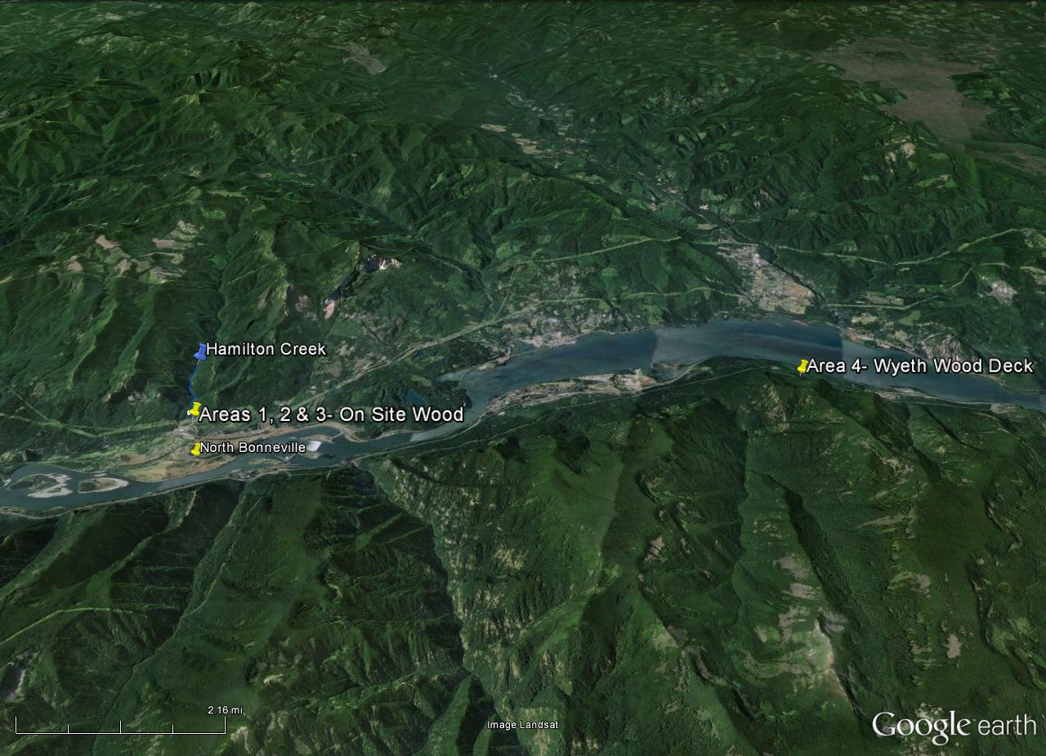

Figure 2. Location of wood collection Areas 1-3 along Hamilton Creek. Area 1 represents a location where wood from the Area 4 can be stockpiled. The Estuary Partnership will additional stockpile areas at a later date.
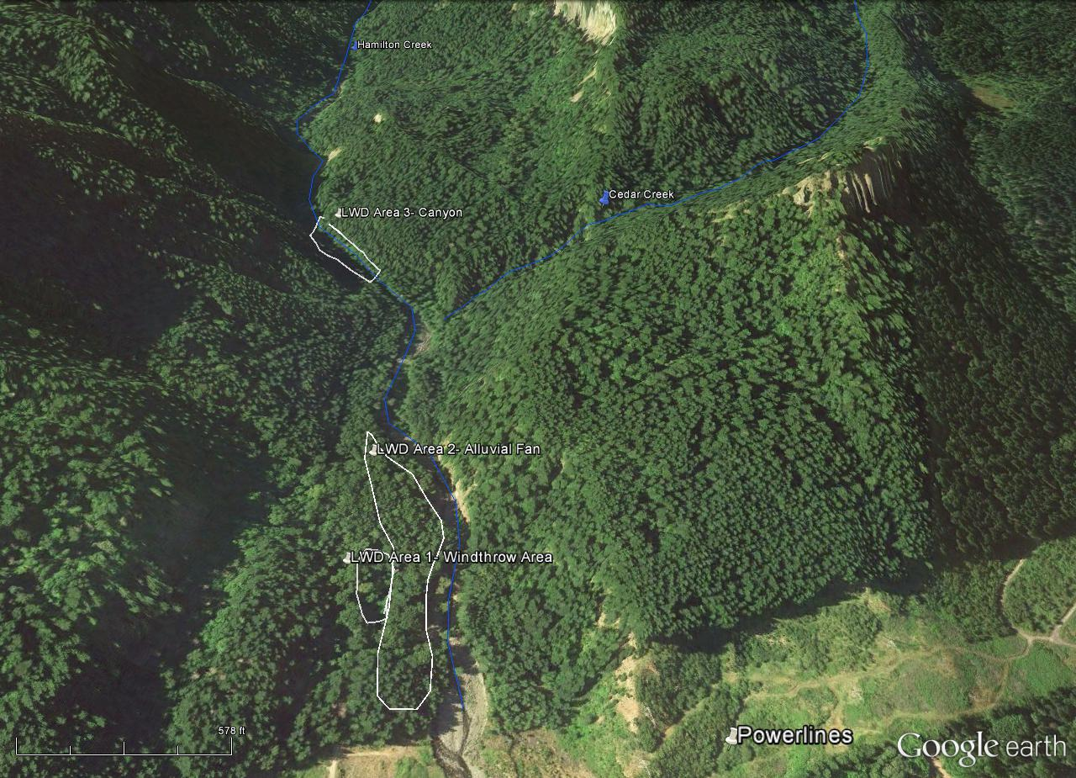

Figure 3. Location of Area 4 – the wood stockpile and collection area near Wyeth, Oregon. This site is approximately 10 miles from the Hamilton Creek project location.
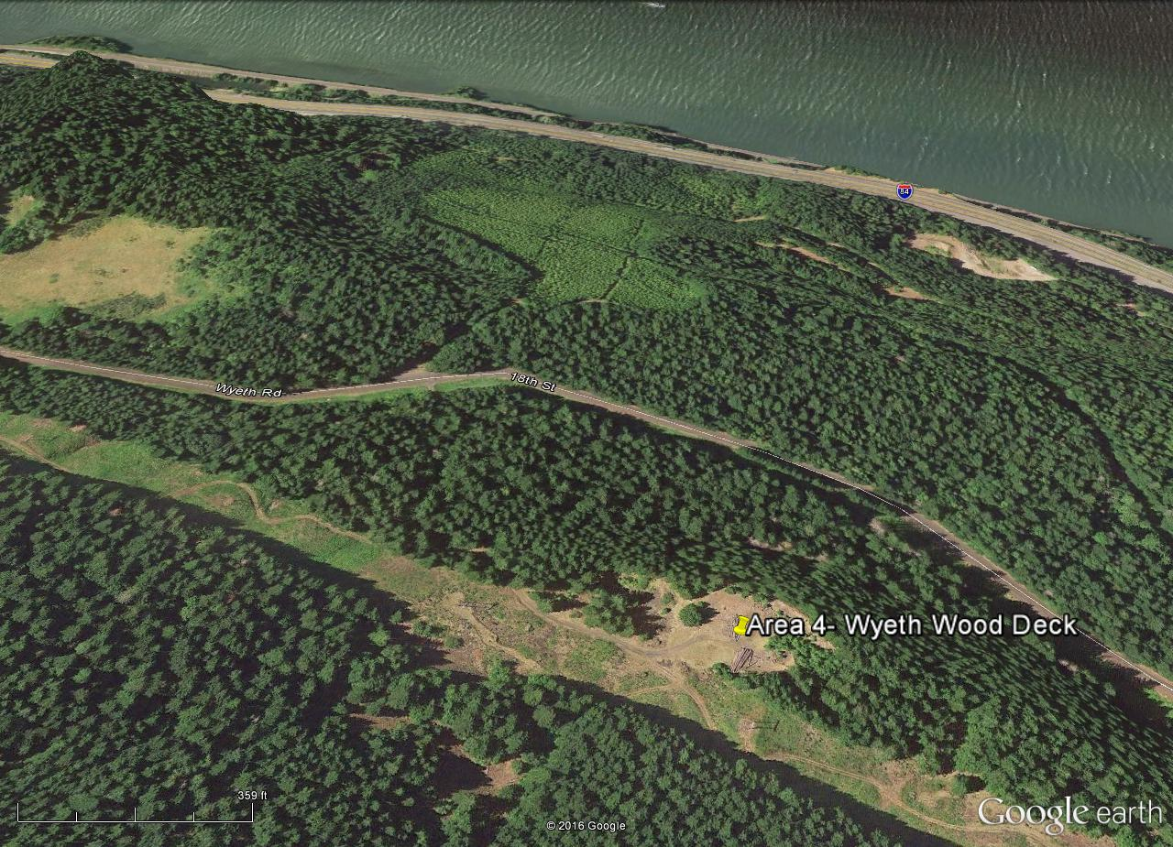

Figure 4. Area 1: One of the five overturned cottonwood trees with rootwads located along Hamilton Creek that will be used for the project. The Contractor shall leave limbs and branches intact to the greatest extent practical.
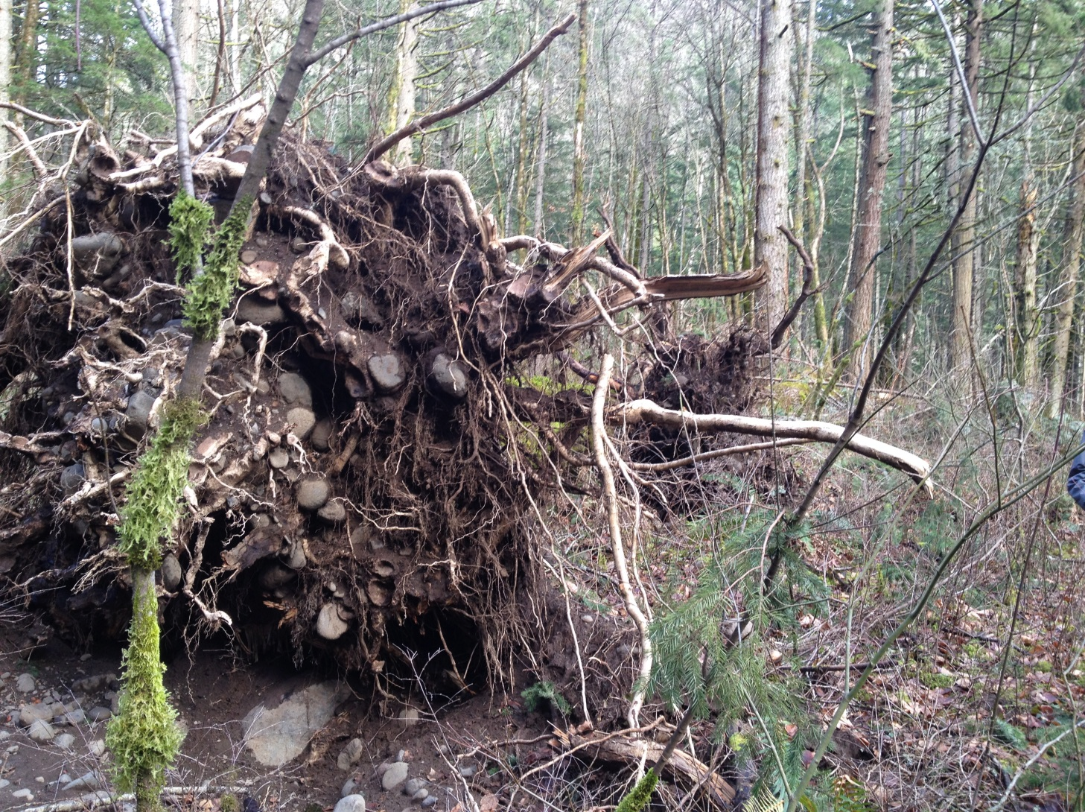

Figure 5. Area 2: An example of the smaller wood class (16-18 inch DBH – 40-70 feet long) in Area 2. The Contractor will source approximately 60 pieces of wood from Area 2. The Contractor shall leave limbs and braches intact to the greatest extent practical.
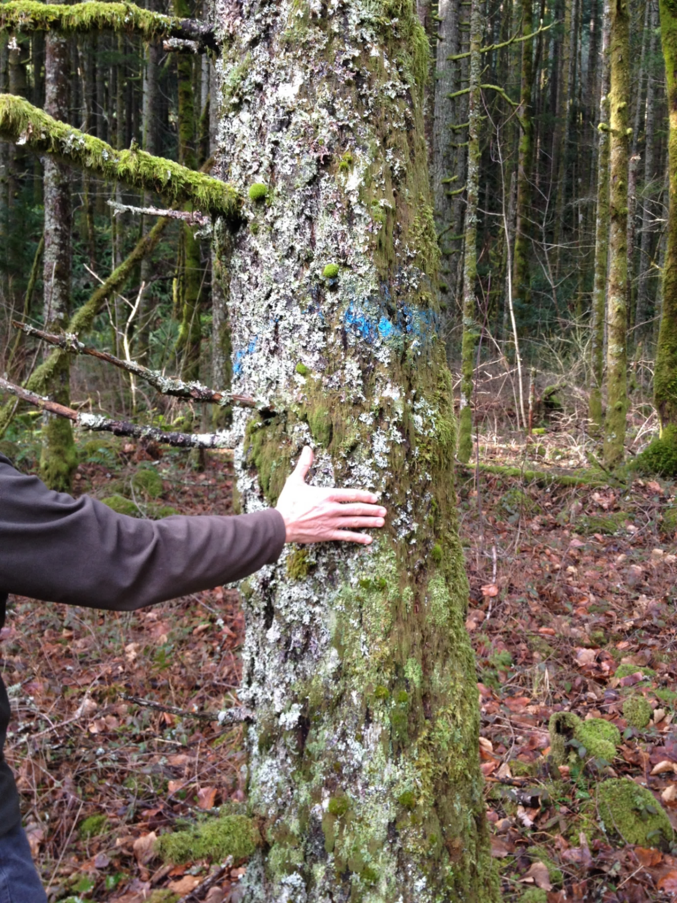

Figure 6. Area 4: A view, looking east, of the 50 logs, (approximately 15 with rootwads) currently stockpiled at Area 4. There is enough room to turn a logging truck around. The Contractor will not need to sort the logs. All 50 pieces will be used in the project.
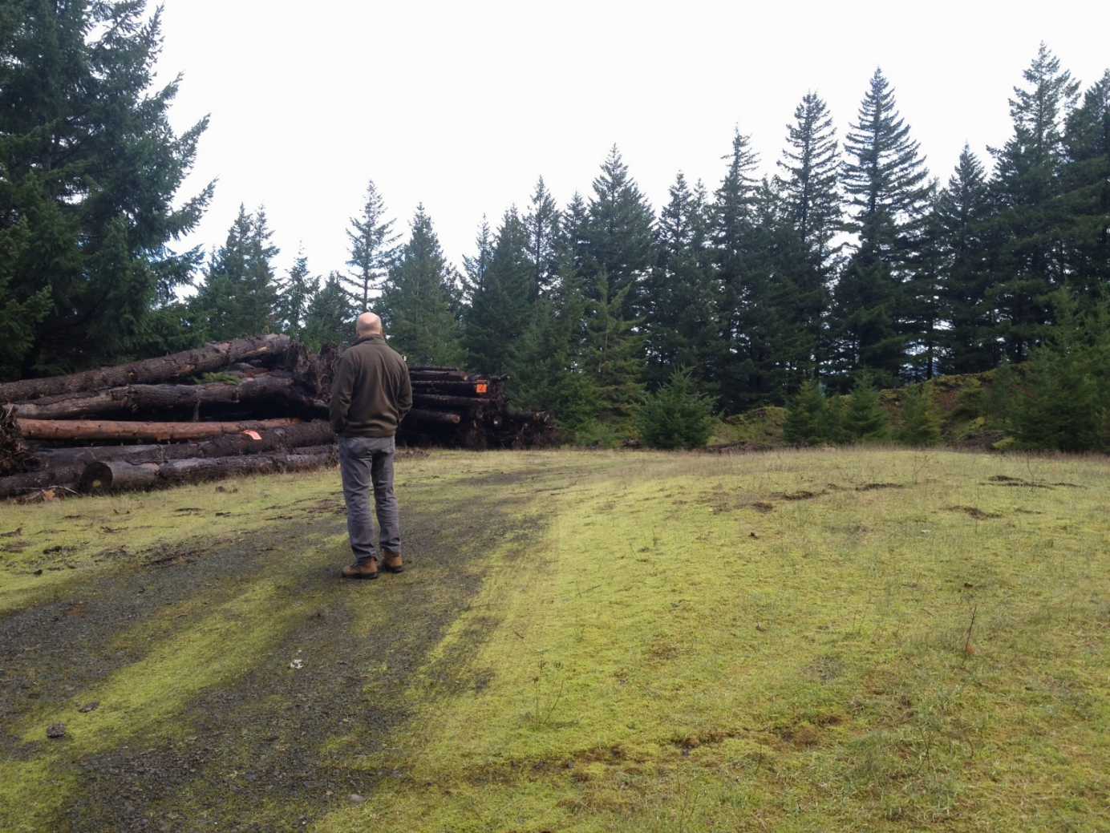

Figure 7. Area 4: Another view of the logs, looking west, at Area 4.

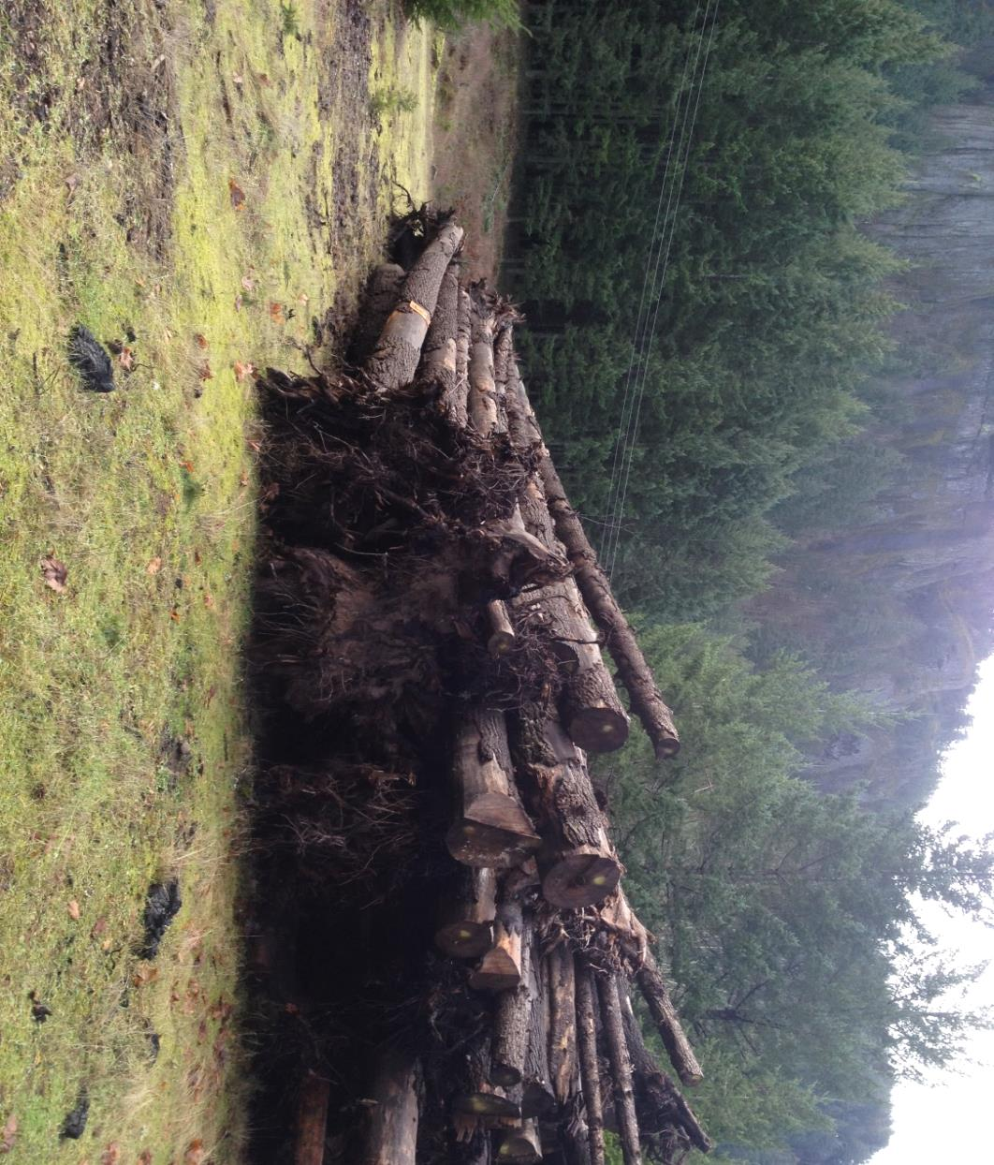

Figure 8. Typical size of wood from the Herman Creek Area. Approximately 50 large pieces of wood will be sourced from here and transported to Area 4 by the USFS. Approximately 20 pieces will have rootwads attached to them. The Contractor shall leave limbs and branches intact to the greatest extent practicable.
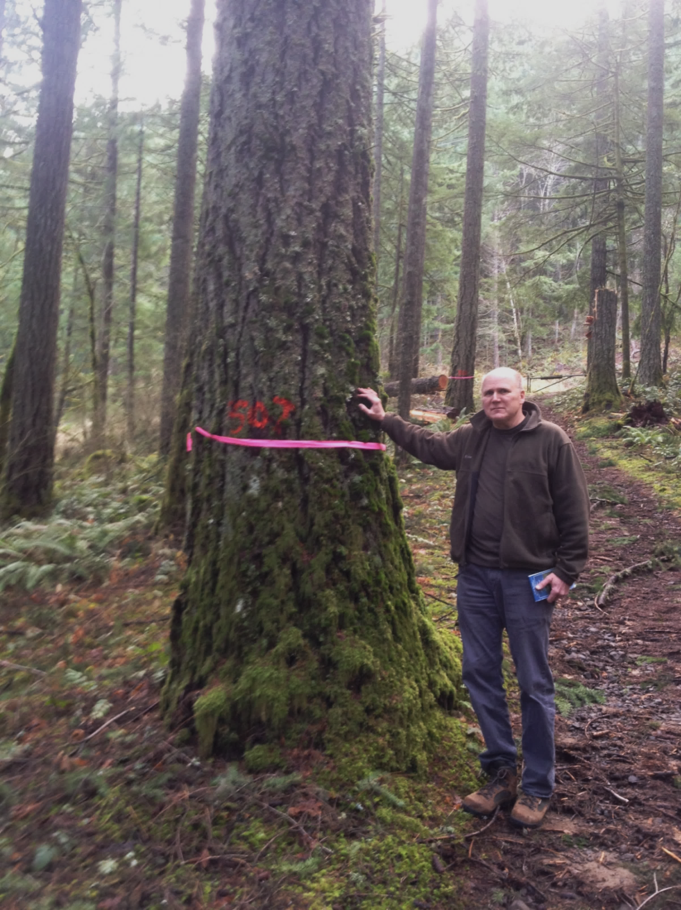

ATTACHMENT 6 – ADDITIONAL CONSTRUCTION DETAILS
A. Construction – Contractor shall provide all equipment, operators, and materials (except provided materials outlined in Attachment 5) to implement the project as designed and specified, including, but not limited to, mobilization, access, control of water, erosion control, site security, implementation, and site reclamation. The following sections below outline construction actions.
1. Equipment and Equipment Access
- Equipment: The Contractor shall provide at least one (1) tracked excavator for instream work. The Contractor shall use the excavator(s) to pioneer and construct puncheon trail access routes, to transport trees to LWD installation sites, to construct LWD structures, to open up and decommission access routes, and to rehabilitate wood collection areas. The Contractor will be required to work with very large trees (up to 60-80 feet), while minimizing disturbances to the creek and streamside vegetation.
- Access: There is an existing decommissioned, abandoned road that parallels Hamilton Creek up to Cedar Creek. The road surface should be relatively clear of larger alders and small conifers and it will be possible for heavy equipment to utilize this road, with some improvements. The Contractor shall improve the road as necessary and may brush aside or side-cast material to enhance equipment access. The Contractor will be required to create several short trails (50-150 feet) to transport wood from Area 1 and 2 to the creek. The Contractor shall create Puncheon trails only as necessary and only to transport wood from stockpile locations to LWD installation locations. The USFS will flag the trails and mark the maximum width. The maximum width of the trails will be flagged before project commencement. The Contractor shall keep the width of the trail and vegetation removed to the minimum necessary for safe excavator travel.
- Equipment crossings: The Contractor may need to cross the wetted stream channel to access and construct a portion of the log jams. The Contractor shall incorporate mitigation measures into the project in order to minimize potential impacts to water quality. The Contractor shall ensure all heavy equipment (i.e., excavator) operating within the active stream channel utilizes an approved non-toxic, biodegradable hydraulic fluid. The Contractor shall follow these heavy equipment use requirements:
i. The Contractor shall power-wash any heavy equipment entering the stream channel prior to mobilization onto USFS lands.
ii. The Contractor shall ensure that excavators working in the stream channel use an approved non-toxic biodegradable hydraulic fluid. The Contractor will be required to verify that the hydraulic fluid conversion has taken place.
iii. The Contractor shall ensure that all heavy equipment (working terrestrially or aquatically) carries a supply of oil absorbent pads capable of containing a failed hydraulic line or fitting and a method of affixing pads. All heavy equipment shall also carry two oil absorbent booms, each long enough to cover the width of the wetted channel. The Contractor shall deploy booms downstream during all excavator instream activity.
iv. The Contractor shall ensure that the tracks of the excavator, upon each entry to the stream channel during the project duration, in consultation with the Forest Service, is shoveled free of excessive upland soil accumulation.
- Site Improvements: The Contractor shall de-compact (fluff) the main road and puncheon trails upon completion of the instream work. The Contractor shall repair any access routes into the creek steeper than 1:3(vertical to horizontal) that have been disturbed. The Contractor shall seed any removed vegetation cover, as well as any slopes and fill areas with an approved seed mix.

2. LWD Construction and Instream Travel
- The Contractor shall construct approximately 25 instream LWD structures of varying size and approaches (streambank, bar and apex jam). The Contractor shall use the largest pieces of wood as anchor pieces when possible. Prior to construction, the Contractor shall flag the locations of all LWD structures. The Contractor shall ensure that all instream LWD structures designated to be built by a tracked excavator, heavy machinery or other equipment are built as follows:
i. The Contractor shall strategically locate each of the log structures to accomplish specific restoration objectives. The Contractor shall construct most of the structures along the edges of the current stream channel or in the middle of the channel. If necessary, the Contractor may at times work equipment in or around flowing water up to three feet deep.
ii. The Contractor shall move heavy machinery between LWD structures within the stream channel (on the hard gravel and cobble stream bed). The Contractor shall not allow heavy machinery to leave the streambed or to travel on stream banks without USFS approval. Unless otherwise identified in the field by the USFS, the Contractor shall only utilize the puncheon trail stream access sites for travel over stream banks to complete the work.
iii. The Contractor shall use approximately 7 to 12 pieces of wood per LWD structure, depending on the structure type and location. The Contractor shall design and construct all of the log jams to remain stable during large flood events. The Contractor shall anchor each structure. The Contractor shall use appropriate anchoring methods based on location, material availability, and permitting requirements. Where feasible, the Contractor shall bury logs below the streambed or trench them into the stream bank. When appropriate the Contractor shall also utilize large logs and place them in channel spanning positions.
iv. The Contractor shall use site assistance by a ground crew. The Contractor’s ground crew will hand manipulate or place logs via excavator. The Contractor shall provide the following at a minimum:
- Multiple chainsaws with required bars/chaps/eye protection/ear protection/hard hat
- Multiple chokers
- Ground working tools including shovels, Pulaskis, pry bars, etc.

ATTACHMENT 7 – UPDATED PLANTING LOCATIONS
In April 2016 Estuary Partnership staff visited Hamilton Creek to develop a greater understanding of planting site locations. Based on that field visit, the Estuary Partnership has updated the planting plan locations. The Contractor will install the majority of plantings above Cedar Creek in areas where young conifer trees have been observed colonizing benches above Hamilton Creek. The area above Cedar Creek is within the canyon section and travel is difficult. The Contactor shall consider this information as supplemental to the design report and design drawings found in Attachments 2 and 3. The purple dots in Figure 1 below represent areas where planting efforts could occur. These areas have been obtained using a handheld GPS and the points will be provided to the Contractor.
Figure 1. The areas marked on the map below represent potential planting locations along benches adjacent to Hamilton Creek. Each location represents a minimum area of approximately 150x100 feet (along the right streambank and/or left streambank) where planting could occur. Most of the suitable planting locations are above Cedar Creek. The Estuary Partnership will provide these GPS points to the Contractor.
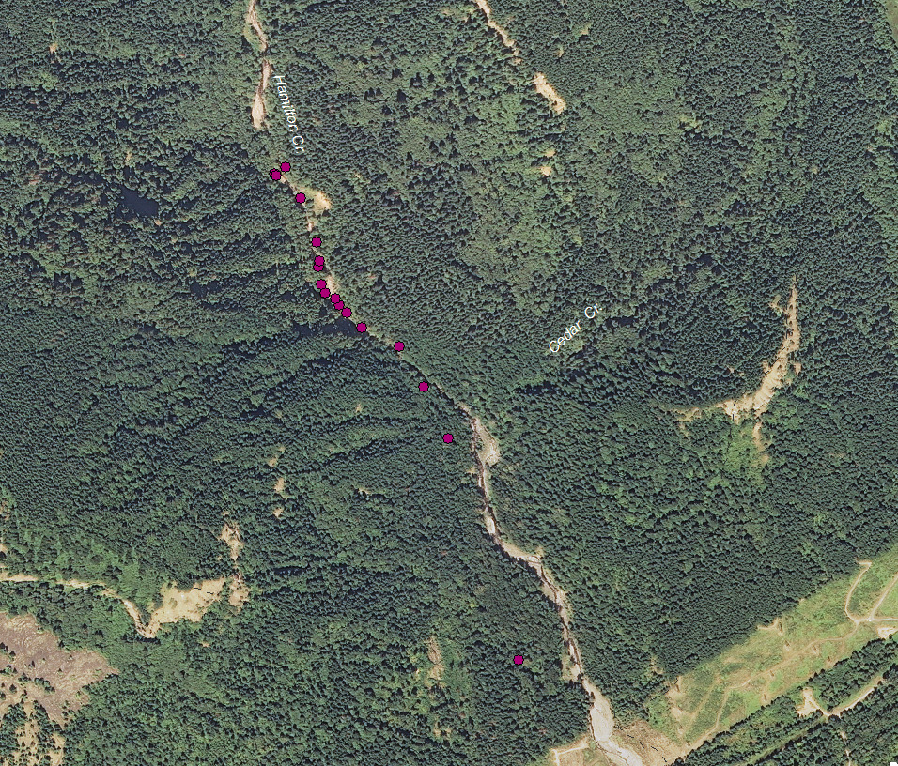

ATTACHMENT 8 – U.S. FOREST SERVICE (USFS) CONDITIONS OF WORK

General:
1. Construction operations shall be allowed from 6:00 am to 7:00 pm or as approved by USFS all days
of the week.

2. No habitation or overnight dwelling by employees of Contractor will be permitted on USFS land without advance written approval from the USFS.

3. Blasting is not allowed.

4. The Contractor shall notify the USFS when Contractor, any subcontractors, or any employees of such shall be on the project site with 48 hours notice.

5. The Contractor shall maintain areas free of waste materials, debris, and rubbish and maintain the site in a clean and orderly condition. The Contractor also shall remove and dispose of upon completion of the construction, all stakes, flagging, and similar debris within the project area. All debris shall be disposed of off USFS land and in accordance with Federal, State, and Local disposal requirements. In the event this material is not removed, the USFS reserves the right, but do not have the duty, to have the material removed, and any expense shall be charged to the Contractor.

6. The Contractor shall make every reasonable attempt to preserve the scenic and natural environment associated with this construction project. The Contractor shall not remove, deface, injure, or destroy trees, shrubs, or natural features not designated for treatment. The Contractor shall confine operations to within the clearing limits and other areas designated in the Contract Documents, and prevent the depositing of rocks, excavated materials, stumps, or other debris outside of these limits. Material which falls outside of designated project limits shall be retrieved, disposed of, or incorporated in the work as directed by the USFS, or Engineer.

7. The Contractor shall at all times limit migration of dust, dirt, and mud away from the project site and shall be responsible for meeting all abatement requirements as may be required by WSDOT, Engineer, or the USFS. In order to minimize traffic hazards and public nuisance arising out of the Contractor's operations, Contractor shall ensure that adjacent properties and improved surfaces stay free and clean of silt, tracked mud, dust, etc., coming from or in any way related to construction. The USFS or Engineer may determine that such a traffic hazard or public nuisance requires an immediate cleanup. Such corrective measures shall be at the expense of the Contractor.

8. The Contractor shall clean of weeds and seeds all earth moving equipment (loaders, excavators, dump trucks, etc.) moved to the job site prior to each entrance onto, and exit from, USFS lands. The Contractor shall ensure the cleaning shall consist of the removal of all dirt, grease, debris, and materials that may harbor noxious weeds and their seeds. The Contractor shall use a pressure hose/power washer. The Contractor shall make the equipment available for visual inspection by the USFS prior to entering USFS lands. The Contractor shall advise of proposed dates for mobilization and demobilization. Inspections will take place prior to entry and exit from Forest Service lands. The Contractor shall use seed and mulch certified by the Supplier as being weed free. The Contractor shall ensure any rock products needed come from a certified weed free source approved by the USFS.

9. The Contractor follow federal regulations related to use and maintenance of existing roads. Federal Regulations contained in 36 CFR 261.12; except vehicle weight will not exceed that of AASHTO HS20-44 and/or U80 Loading. Regulations prohibit damaging a road or blocking a road open to use by others, except as otherwise provided in Special Project Specification 104. The Contractor is responsible for and will perform road maintenance on USFS roads in the construction area commensurate with use. The Contractor shall perform road maintenance at such intervals that prevent deterioration of the roadway, or as directed by the USFS Contracting Officer. The Contractor shall maintain the existing roadbed by blading and shaping the traveled way and shoulders. The Contractor shall not undercut the roadbed banks. The Contractor shall maintain established drainage structures and/or berms, and place additional drainage structures/berms where necessary to protect embankments.

10. No pets are allowed on site during construction.

Access to Site and Other Areas:
1. Contractor shall access project work areas using access routes specified in the design drawings. If the Contractor desires to access work areas using other access routes, the Contractor is solely responsible for coordination with the USFS to obtain permission each time the Contractor, subcontractors, or employees of either enter the site. Contractor is required to maintain roads during the contract period, and repair all roads to pre-contract condition after use. The Contractor shall not park or store any vehicles or materials at other locations without permission.

2. The Contractor shall notify the USFS at least 5 working days prior to retrieval of LWD from stockpile locations.

Public Use of Site and Surrounding Area:
1. Contractor is advised that, while the proposed construction site shall be closed to the public during construction, the site is still within a public recreation area. The Hamilton Creek recreational area shall remain open for the duration of the project.

2. The Contractor shall conduct activities so that interference with the public shall be kept at a minimum. Specifically, the Contractor shall use measures and precautions necessary to warn and protect the public during work at the project site. Such actions include, but are not limited to, furnishing and maintaining barricades and signs at key access points and roping off or flagging active construction areas (see Special Provisions for additional detail/requirements). The Contractor shall submit an overall plan at least two weeks prior to starting work and coordinate with the Estuary Partnership and the USFS as adjustments are made during the construction work.

3. The Contractor shall implement a hiker and trail user control plan that has been approved by the USFS. The plan shall include signage informing the public of the trail user control plan, the project dates and location, and any other information required by the USFS. The Estuary Partnership shall be responsible for creating, placing and maintaining the sign(s) at the trailhead.

Contamination/Spill Prevention:
1. The Contractor shall take special care to prevent contamination of water at the work sites with any petroleum residues from mechanical equipment operations. The Contractor shall furnish equipment of modern design and in good operating condition with no fuel or oil leaks, and conduct daily inspection, and if necessary cleaning. The Contractor should keep a log of the daily inspections, and that log shall be available for review by the USFS and/or Estuary Partnership.

2. If the Contractor maintains storage facilities for oil or oil products on site, the Contactor shall take appropriate preventive measures to insure that any spill of such oil or oil products does not enter any stream or other waters of the United States or any of the individual states. If a spill of petroleum product should occur in water, the Contractor shall take immediate action to clean up or contain the spill, then immediately notify the USFS, and the Washington Emergency Response System, telephone 1-800-562-6108 or 1-253-512-7000.

3. Contractor shall have a spill response kit on site whenever equipment is operating. The Contractor shall ensure the spill kit is sufficient to absorb 34 gallons of oil, and designed to float on the surface while absorbing oil and repelling water. The kit shall meet or exceed the physical properties of “New Pig Products Spill Kit #408”. Such material will be furnished by Contactor and approved by the USFS or Engineer.

4. The Contractor shall place oil absorbing mats under all stationary equipment, or equipment being serviced to prevent leaking or spilled petroleum base products from contaminating soil and water resources. The Contractor shall furnish such material for approval by the USFS or Engineer.

5. The Contractor shall service all equipment, including refueling, only in the areas approved by the USFS. If the total oil or oil products storage exceeds 1320 gallons or if any single container exceeds a capacity of 660 gallons, the Contractor shall prepare a Spill Prevention Control and Countermeasures (SPCC) Plan for approval by the USFS. The Contractor shall ensure the plan meets applicable EPA requirements (40 CFR 112) including certification by a registered professional engineer.

Sanitation Requirements:
1. Unless substitute measures or equipment are authorized in writing by the USFS, the Contractor shall protect air and water quality by providing approved chemical toilets for use by all persons engaged in the project. The Contractor shall furnish chemical toilets in quantities and at locations approved by the USFS. The Contractor shall ensure all chemical toilets comply with applicable laws, ordinances, and regulations pertaining to public health and sanitation.

Protection of Cultural Resources:
1. Within site boundaries, there are potentially cultural resources, protected by, or that may be entitled to protection under, American Antiquities Act of 1906 (16 U.S.C. 431-433), National Historic Preservation Act of 1966 (16 U.S.C. 470) and the Archaeological Resources Protection Act of 1979 (PL 96-95 and 36 CFR 261.9(e)). The USFS may unilaterally modify or cancel this Contract to protect any areas, objects of antiquity, artifacts, or similar objects discovered during the project that are or may be protected by the above Acts regardless of when the area, object or artifact is discovered or identified. Discovery of such areas or objects by either the Contractor, the USFS, or the Estuary Partnership shall be immediately reported to all parties.

Fire Protection:
1. The Contractor shall adhere to operational requirements specified in the Industrial Fire Precaution Level (IFPL) precautions. The USFS may change the IFPL to other values upon revision of the National Fire Danger Rating System and may change the specific IFPL when such changes are necessary for the protection of USFS lands. The Contractor is responsible for checking the IFPL daily.

2. The USFS may require emergency measures, including the necessary shutting down of equipment or portions of operations in the project area during periods of fire emergency created by hazardous climatic conditions.

3. The Contractor shall, independently and in cooperation with the USFS, take all reasonable actions to prevent and suppress fires in the project area. The Contractor’s independent initial action shall be prompt and shall include the use of all personnel and equipment available in the project area.

4. Contractor shall take the specific fire precautionary measures outlined below. Listing of specific fire precautionary measures herein is not intended to relieve the Contractor in any way from compliance with the State Fire Laws covering fire prevention and suppression equipment, applicable to operations under this Contract, permit or license.
  - The Contractor shall not allow open fires on the project area without advance permission in writing from the USFS. Unless restricted by State Law or Federal Regulation, smoking shall be permitted only in such portions of the project area that are free of flammable material. Smokers shall sit down to smoke in such a position that any burning material will fall within a cleared area, and shall extinguish and press out in mineral soil all burning material before leaving the cleared area.
  - All power-driven equipment operated by the Contractor on USFS land shall be equipped with one fire extinguisher having a UL rating of at least 5 BC, and one "D" handled or long handled round point shovel, size "O" or larger. The Contractor shall keep equipment readily available and in serviceable condition.
  - The Contractor shall ensure each internal combustion engine shall be equipped with a spark arrester meeting either (1) USDA Forest Service Standard 5100-la, or (2) appropriate Society of Automotive Engineers (SAE) recommended practice J335(b) and J350(a) as now or hereafter amended unless it is: (1) Equipped with a turbine-driven exhaust supercharger such as the turbocharger. There shall be no exhaust bypass. (2) A passenger-carrying vehicle or light truck, or medium truck up to 40,000 GVW, used on roads and equipped with a factory-designed muffler complete with baffles and an exhaust system in good working condition. (3) A heavy duty truck, such as a dump or log truck, or other vehicle used for commercial hauling, used only on roads and equipped with a factory designed muffler and with a vertical stack exhaust system extending above the cab. The Contractor shall ensure exhaust equipment described in this subsection, including spark arresters and mufflers, shall be properly installed and constantly maintained in serviceable condition.
  - Contractor shall provide a tank truck or trailer, containing not less than 300 gallons of water. The Contractor shall ensure the tank, pump and at least 250 feet of hose and nozzle shall be connected and ready for use at all times. The Contractor shall ensure the tank truck shall be maintained in a serviceable condition and located within 10 minutes, round trip, from each project area from the start of work to the end of the Fire Watch / Fire Security, service consistent with IFPL.

5. Fire Plan: Before starting any operations on the project, the Contractor shall prepare a Fire Plan in cooperation with the USFS providing for the prevention and control of fires in the project area. The Contractor shall be subject to un-announced fire equipment inspections. In addition to the items 1-4 above, the Contactor shall provide a Fire Plan to the USFS for approval prior to start of work that addresses the following USFS requirements for the Fire Plan:

A. Fire Period and Closed Season
Specific fire prevention measures are listed below and shall be effective for the period April 1 to October 31 of each year. The USFS may change the dates of said period by advance written notice if justified by unusual weather or other conditions. The Contractor shall keep required tools and equipment in serviceable condition and immediately available for initial attack on fires.

B. Fire Plan Compliance
The Contractor shall certify compliance with fire protection and suppression requirements before beginning operations during the fire period and closed season, and shall update such certification when operations change.

C. Substitute Measures
The USFS Contracting Officer may by written notice authorize substitute measures or equipment or may waive specific requirements during periods of low fire danger.

D. Emergency Measures
The USFS may require emergency measures, including ordering the Contractor to shut down equipment or portions of operations in the project area during periods of fire emergency created by hazardous climatic conditions.

E. Fire Control
The Contractor shall, independently and in cooperation with the USFS, take all reasonable action to prevent and suppress fires in the project area. The Contractor’s independent initial action shall be prompt and shall include the use of all personnel and equipment available in the project area.

For the purpose of fighting forest fires on or in the vicinity of the project which are not caused by Contractor operations, the Contractor shall place employees and equipment temporarily at the disposal of the USFS. Any individual hired by the USFS will be employed in accordance with the Interagency Pay Plan for Emergency Firefighters. The USFS will compensate the Contractor for equipment rented at fire fighting equipment rates common in the area, or at prior agreed to rates.

F. Compliance with State Forest Laws
Listing of specific fire precautionary measures herein is not intended to relieve the Contractor in any way from compliance with the State Fire Laws covering fire prevention and suppression equipment, applicable to operations under this contract, permit or license.

G. Fire Precautions
Specific fire precautionary measures are as follows:
    - Smoking and Open Fires: The Contractor shall not allow open fires on the project area without advance permission in writing from USFS. Unless restricted by State Law or Federal Regulation, smoking shall be permitted only in such portions of the project area that are free of flammable material. Smokers shall sit down to smoke in such a position that any burning material will fall within a cleared area, and shall extinguish and press out in mineral soil all burning material before leaving the cleared area.
    - Fire Extinguishers and Equipment on Trucks, Tractors, etc: All power-driven equipment operated by the Contractor, except portable fire pumps, shall be equipped with one fire extinguisher having a UL rating of at least 5 BC, and one "D" handled or long handled round point shovel, size "O" or larger. In addition, the Contractor shall ensure each motor patrol, truck and passenger-carrying vehicle shall be equipped with a double-bit axe or Pulaski, 3-1/2 pounds or larger. The Contractor shall keep equipment in a serviceable condition and readily available.
    - Power Saws: The Contractor shall ensure each gasoline power saw operator is equipped with a pressurized chemical fire extinguisher of not less than 8-ounce capacity by weight, and one long-handled round point shovel, size "O" or larger. The Contractor’s power saw operator shall possess the extinguisher at all times. The Contractor’s power saw operator shall be able to access the shovel within one minute.
    - Extinguishers: The Contractor shall ensure that one refill for each type or one extra extinguisher sufficient to replace each size extinguisher required on equipment is safely stored in the fire tool box or other agreed upon place on the project area that is protected and readily available.
    - Spark Arresters and Mufflers: The Contractor shall ensure each internal combustion engine is equipped with a spark arrester meeting either (1) USDA Forest Service Standard 5100-la, or (2) appropriate Society of Automotive Engineers (SAE) recommended practice J335(b) and J350(a) as now or hereafter amended unless it is:
(1) Equipped with a turbine-driven exhaust supercharger such as the turbocharger. There shall be no exhaust bypass.
(2) A passenger-carrying vehicle or light truck, or medium truck up to 40,000 GVW, used on roads and equipped with a factory-designed muffler complete with baffles and an exhaust system in good working condition.
(3) A heavy duty truck, such as a dump or log truck, or other vehicle used for commercial hauling, used only on roads and equipped with a factory designed muffler and with a vertical stack exhaust system extending above the cab. Exhaust equipment described in this subsection, including spark arresters and mufflers, shall be properly installed and constantly maintained in serviceable condition.
    - Emergency Fire Precautions- The Contractor shall restrict operations in accordance with the Industrial Fire Precaution Levels listed below. The USFS may change the Industrial Fire Precaution Levels to other values upon revision of the National Fire Danger Rating System and may change the specific Industrial Fire Precaution Levels when such changes are necessary for the protection of the National Forest. When sent to the Contractor, the revised Industrial Fire Precaution Levels will supersede the attached levels.

INDUSTRIAL FIRE PRECAUTION LEVEL (IFPL)

I. Closed season - Fire precaution requirements are in effect. A fire watch/security is
required at this and all higher levels unless otherwise waived.

II. Partial hoot owl - The following may operate only between the hours of 8 p.m. and 1
p.m., local time:
a. power saws, except at loading sites;
b. cable yarding;
c. blasting;
d. welding or cutting of metal.

III. Partial shutdown - The following shall be prohibited except as indicated:

Cable yarding - except that gravity operated logging systems employing non-motorized carriages may be operated between the hours of 8 p.m. and 1 p.m., local time, when all block and moving lines, except the line between the carriage and the chokers, are suspended 10 feet above the ground;

Power saws - except power saws may be used at loading sites and on tractor/skidder operations between the hours of 8 p.m. and 1 p.m., local time. In addition, the following are permitted between the hours of 8 p.m. and 1 p.m., local time:
a. tractor/skidder operations;
b. mechanized loading and hauling of any product or material;
c. blasting;
d. welding or cutting of metal;
e. any other spark-emitting operation not specifically mentioned.

IV. General shutdown - All operations are prohibited.

The following definitions shall apply to these Industrial Fire Precaution Levels:

Cable yarding systems: A yarding system employing cables and winches in a fixed position.

Closed season (Fire Precautionary Period): That season of the year when a fire hazard exists as declared by the responsible agency official.

Contracting Officer: The person executing the contract, permit or license on behalf of the Government and includes that person's designated representative, acting within the limits of their authority or the duly appointed successor to the individuals.

Loading sites/woods site/project area: A place where any product or material (including but not limited to logs, firewood, slash, soil, rock, poles, posts, etc.) is placed in or upon a truck or other vehicle.

Low hazard area: Means any area where the responsible agency representative (USFS) determines the combination of elements reduces the probability of fire starting and/or spreading.

Tractor/skidder operations: include a harvesting operation, or portion of a harvesting operation, where tractors, skidders, or other harvesting equipment capable of constructing fire line, are actively yarding forest products and can quickly reach and effectively attack a fire start.

Waivers, written in advance, may be used for any and all activities. Activities for which waivers may be issued include, but are not limited to:
  - mechanized loading and hauling;
  - road maintenance such as sprinkling, graveling, grading and paving;
  - cable yarding using gravity systems or suspended lines and blocks, or other yarding systems where extra prevention measures will significantly reduce the risk of fire;
  - powers saws at loading sites or in felling and bucking where extra prevention measures will significantly reduce the risk of fire;
  - maintenance of equipment (other than metal cutting and welding) or improvements such as structures, fences and power lines.

Such waiver, or substitute precautions will prescribe measures to be taken by the Contractor to reduce the risk of ignition, and/or the spread of fire. The Contracting Officer shall consider site specific weather factors, fuel conditions, and specific operations that result in less risk of fire ignition and/or spread than contemplated when precaution level was predicted. Consideration shall also be given to measures that reduce the precaution levels above. The Contractor shall assure that all conditions of such waivers or substitute precautions are met.

The Contractor shall obtain the predicted Industrial Fire Precaution Level daily, prior to the start of work, from the appropriate Ranger District headquarters. If predictions made after 6:00 p.m., local time, are significantly different than the original prediction, the USFS will inform the Contractor when changes in restrictions or industrial precautions are made.

Where hauling involves transit through more than one shutdown/regulated use area, the precaution level at the woods loading site shall govern the level of haul restriction, unless otherwise prohibited by other than industrial precaution level system.

H. Fire Tools
The Contractor shall furnish serviceable fire fighting tools in a readily accessible fire tool box or compartment of sound construction with a hinged lid and hasp so arranged that the box can be secured or sealed. The box shall be red and marked "Fire Tools" in letters one inch high. It shall contain a minimum of:
- 2 axes or Pulaskis with a 32-inch handle;
- 3 adze eye hoes. One Pulaski may be substituted for I adze eye hoe;
- 3 long-handled, round point shovels, size "O" or larger.

I. Fire Security
When the Industrial Fire Precautions Level is "I" or higher, unless a waiver is granted, the Contractor shall designate a person who shall perform fire security services listed below on the project area and the vicinity. The designated person shall be capable of operating the Contractor's communications and fire fighting equipment specified in the contract, excluding helicopters, and of directing the activities of the Contractor's personnel on forest fires. In lieu of having the designated person perform the required supervisory duties, the Contractor may provide another person meeting the qualifications stated above to direct the activities of Contractor's personnel and equipment during all fire fighting activities.

Services described shall be for at least 1 hour from the time the Contractor's operations are shut down. For the purposes of this provision, personnel servicing equipment, and their vehicles, who are not engaged in cutting or welding metal are excluded.

Fire security services shall consist of moving throughout the operation area or areas constantly looking, reporting, and taking suppression action on any fires detected.

J. Blasting
Whenever the Industrial Fire Precaution Level is "II" or greater, a fire security person equipped with a long-handled, round point, No. "O" or larger, shovel, and a five-gallon backpack pump can filled with water will stay at location of blast for I hour after blasting is done. Blasting may be suspended by Forest Service in writing, in an area of high rate of spread and resistance to control.

Fuses shall not be used for blasting. Explosive cords shall not be used without written permission of the USFS, which may specify conditions under which such explosives may be used and precautions to be taken.

Additional Fire Precautionary Measure 1 - Tank Truck

K. The Contractor shall provide a tank truck or trailer, containing not less than 300 gallons of water at the site while working on the project. The Contractor will not be required to provide a tank truck or trailer if power saw falling and bucking is the only operation. The Contractor shall maintain such tank truck or trailer in a serviceable condition and in a location within 10 minutes, round trip, from each project area during fire period and closed season.

The Contractor shall ensure the tank truck or trailer is equipped with a pump capable of discharging 20 gallons of water per minute, using a 1/4 inch nozzle tip, through a 50 foot length of rubber line hose. In addition, the Contractor shall provide for immediate use as necessary, 500 feet of serviceable fabric jacket rubber lined hose of not less than 1 inch outside diameter, fitted with a nozzle capable of discharging a straight stream of 1/4 inch diameter and a spray pattern. The Contractor shall ensure the tank, pump and at least 250 feet of hose and nozzle shall be connected and ready for use at all times.

If the Contractor uses a trailer, it shall be equipped with a hitch to facilitate prompt movement. The Contractor shall ensure a serviceable tow vehicle is immediately available for attachment to the trailer and that it meets the time requirements stated above. The Contractor shall ensure such truck or trailer shall be equipped to operate for a minimum of 8 hours. The Contractor shall ensure the tank truck or trailer is available from the start of work to the end of the Fire Watch / Fire Security service.

Additional Fire Precautionary Measure 2 – Communications

L. The Contractor shall provide adequate two-way communication facilities to report a fire to Forest Service within 15 minutes of detection. FCC Regulations prohibit commercial use of Citizen Band (CB) radios. (CB's are not considered adequate two-way communications). The Contractor shall ensure such communications are operable during periods of operation of power-driven equipment, including the time fire security is required.

Electrical Lines

1. The Contractor shall comply with all conditions of work under and around the BPA power lines at the site, per the approved BPA Right of Way Use permit (# insert approval case file # when it is returned from BPA).

2. The Contractor shall provide qualified safety watchers for the protection of workers and BPA facilities for the phases of the work near the powerlines or where BPA considers them to be necessary. A safety watcher’s main responsibility is to limit the movement of personnel or equipment to prevent contact with energized overhead electrical facilities. The Contractor shall ensure safety watchers shall take a suitable location and give undivided attention to ensure that no action on the part of the workers being watched can result in violation of the minimum approach distances. The Contractor shall empower the safety watchers with the authority to halt the work operation whenever any unsafe act or condition is imminent.

3. The following are terms and conditions stipulated by the BPA for work conducted under or near
BPA power lines:
- The Contractor shall maintain a minimum distance of 20 feet between construction equipment and transmission line conductors (wires).
- The Contractor shall not store flammable materials or refuel vehicles/equipment under or near BPA Power lines.
- The Contractor shall restore BPA's right-of-way to its original condition, or better following construction. The Contractor shall not change grades to facilitate disposal of overburden. If the design of the road requires cutting or filling, the Contractor shall ensure the elevations of the proposed finished grade and original ground grade are submitted to BPA for final approval.
- Grade changes to existing ground elevations are not permitted. If grade changes are required, the Contractor must submit grading plans to BPA for further approval by BPA. The Contractor should clearly indicate proposed finished elevations as well as existing ground elevations on the plans.
- Nuisance shocks may occur within the right-of-way when touching ungrounded metal objects. It is suggested that road building equipment be grounded with a drag chain. After the road is in service, only emergency parking of logging trucks is allowed. To protect an unknowing user of the road pertaining to the electrical hazards, BPA recommends the installation of signs stating "Emergency Parking Only" at the road intersection within the right-of-way.
- The Contractor shall use safety chains on all equipment that have potential to come within 20 feet of conductors. The safety chain shall be attached to the boom and body of the machine.
- A BPA certified safety watcher will be required to be on site while equipment is working underneath the conductors and within the right-of-way. A list of BPA certified safety watchers can be obtained by calling Teresa Street at 360-418-2730. To guarantee availability, it is recommended the contractor call her at least 2 weeks in advance.

4. The Contractor shall comply with all requirements for grading, erosion control, floodplain development and in-water work incorporated in the design plans and specifications. (Note there is no in-water work associated with the project). The USFS regulates these elements of the project on the USFS owned property.

5. The Contractor shall protect and leave undisturbed as required by the USFS all existing improvements at the site not specifically designated to be affected by the project or identified for removal in the project plans.

6. The USFS shall be named as an additional insured party for the project.

Information in the Contractor Block must be provided prior to Contract approval. This information shall be reported to the Internal Revenue Service (IRS) under the name and taxpayer identification submitted. (See IRS 1099 or 1099-MISC for additional instructions regarding taxpayer ID numbers.) Information not matching IRS records could subject Contractor to 31 percent backup withholding.
Ownership of work product is addressed in Exhibit A. To the extent Contractor co-owns work product, the rights and obligations set forth in this Section shall be interpreted to be consistent with such co-ownership.

